How the needs of children and young people (age 0-25) with Special Education Needs and/or Disabilities (SEND) are met in Newcastle’s education settings.
November 2023
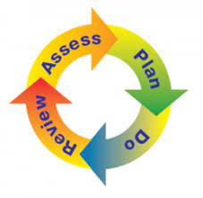 | - The government says that if a child has extra needs, sometimes called SEND, extra support must be put in place.  - This support must be reviewed regularly so we all know that we are doing the right things.  - This extra support is called SEN support.  - This helps us all to learn together what works for that individual child.  - The Local Authority puts support in place for settings to access.  - This is known as the graduated approach or response.
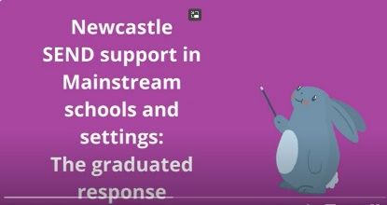 | - Take a look at our biteable video that gives more information about the graduated response and support available in mainstream schools and settings:  https://www.youtube.com/watch?v=jxHyR2HiE0w
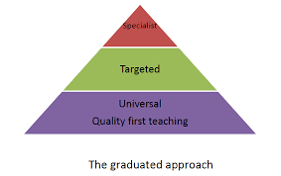 | - The support available at different levels is often shown as a triangle.  - Most children and young people will have their needs met at tier 1.  - A smaller number of children and young people will need an Education, Health and Care (EHC) Plan.  - At all levels services will work with Health/ Social Care/ Early Help services and other external agencies where it is needed.
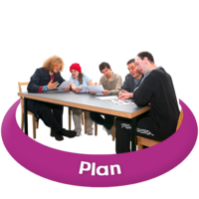 | - The diagram on the next page is not a route or pathway for SEN support for individual children.  - It outlines the support available at various levels of the graduated response.  - For example, a child or young person may have an EHC plan without needing specialist support or a placement in an additionally resourced provision (ARP).  - It is also possible for a child or young person with an EHC plan to access support via the SEND Advice, Support Allocations Panel (ASAP).
- The SEND world is confusing and so a glossary has been added at the end to explain some of the words.
- Have a look at the web page links to find out more information.
Descriptors of need guidance to help identify individual needs and advise on level of provision.
EHCP
SEN Support
SEN Support /EHCP
SEN Support /EHCP

Education Health and Care (EHC) Panel: A group of people, from across education health and care who make decisions about whether to carry out an EHC assessment, whether to issue an EHC plan and whether the plan sets out appropriate provision for the child/young person.
https://www.newcastlesupportdirectory.org.uk/sites/default/files/Local%20Offer/SEND%20Portal/EHC%20Panels%20and%20Complex%20cases%20Terms%20of%20Reference%20October%202023.docx

Requesting a new Education, Health and Care Plan
Quality First Teaching: High quality, inclusive teaching for all pupils in a class: ‘Assess, Plan, Do, Review’.
SENCO: The Special Educational Needs Co-ordinator, is the teacher who is responsible for assessing, planning and monitoring the progress of children with special educational needs and disabilities (SEND).
Additionally Resourced Provisions (ARP): Specialist provision based in a mainstream schools. They provides teaching and support staff with specialist knowledge, skills and expertise in a particular area.
https://www.newcastlesupportdirectory.org.uk/newcastle-schools-provision

of SEND.
Newcastle Schools Provision

SEN support: Is what settings use to find and meet the needs of children with special educational needs (SEN). They should change support where necessary for each child. Settings record needs and the support on a SEN support plan.
.
Core offer: Council services such as educational psychology, specialist teachers and training, that schools can access for free.

Descriptors of Need: A framework for all practitioners working with children and young people to help assess and identify the needs of children and young people, and to put in place appropriate support. https://www.newcastlesupportdirectory.org.uk/send-descriptors-need

SEND Descriptors of Need
Inclusion Quality Framework (IQF): The IQF is Newcastle’s tool to support schools in evaluating their inclusive practice.
Link TBA

Settings: Includes early years, schools and post 16 education providers
Notional school budget: Mainstream settings are notified each year of a clearly identified notional budget, within their overall budget allocation, towards the costs of fulfilling their duty to use their ‘best endeavours’ to secure special educational provision for their pupils with SEN.
SEND ASAP: This stands for Advice and Support Allocation Panel. Settings can make requests to this panel for specialist teacher support, including outreach support from specialist settings or individual pupil support funding and early years inclusion funding.
https://www.newcastlesupportdirectory.org.uk/newcastle-send-advice-and-support-allocation-panel-send-asapNewcastle SEND Advihttps://www.newcastlesupportdirectory.org.uk/newcastle-send-advice-and-support-allocation-panel-send-asapce and Support Allocation Panel (SEN ASAP)
School Effectiveness SEN (newcastlesupportdirectory.org.uk)
Universal Available Provision Guidance: Documents for the early years and school years that sets out how children and young people who have SEND should be provided with SEN support in mainstream settings. https://www.newcastlesupportdirectory.org.uk/sites/default/files/Local%20Offer/School%20Effectiveness/Universally%20Available%20Provision%20October%202023.pdf
www.newcastlesupportdirectory.org.uk/sites/default/files/Local%20Offer/Early%20years/Universally%20Available%20Guidance%20Version%202%20Updated%20September%202022.pdfhool Effectiveness SEN (newcastlesupportdirectory.org.uk)
Education Health and Care (EHC) Plans: A legal document which describes a child/young person’s needs, what provision will meet those needs and which school or education setting they should attend.
https://www.newcastlesupportdirectory.org.uk/what-education-health-and-care-plan-and-how-do-i-request-one

