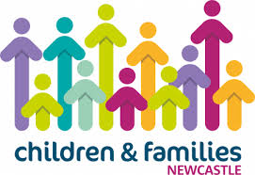 Early Health SEND Notifications Process
Pre-school age child with probable special educational needs or disability (SEND) is identified by health professional

If child is taking up an early education place, EY inclusion panel will contact EY setting SENCO to discuss the child’s needs, and identify any support needed from LA

If child is eligible for an early education place but not taking it up, EY inclusion panel will contact parents/carers to explore reasons for this and identify any support needed from LA

EY inclusion panel check if child is eligible for an Early Education place and if so if child is taking up the place.

Health professional logs SEND notification by following link
https://newcastlecc-self.achieveservice.com/en/AchieveForms/?form_uri=sandbox-publish%3A//AF-Process-ded6d4a8-2557-4347-9b07-cccc08247bde/AF-Stage-5a6abd5a-d932-40e6-a72d-de070dd34493/definition.json&redirectlink=/en&cancelRedirectLink=/en&consentMessage=yes

Identifying professional discusses with parents/carers and gains consent to inform LA. Ensuring child has access to appropriate support as early as possible.

EY Inclusion Panel receive SEND notification

EY inclusion panel share information with LA SEND Placement Planning Officer to allow strategic forward planning

Notifications will be reviewed each term to check Early Education entitlements

