

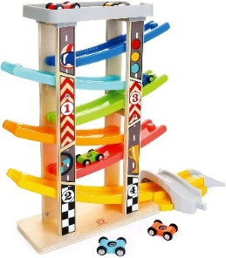

**Click Clack Track**

**EXPLORE:** allow your child to explore the track and cars.

A click clack track will help your child to develop their fine motor skills, hand to eye coordination, attention and listening and turn taking.

* **Modelling** – show child how to place the cars on the top of the track and release the car to show them how the car moves down to the bottom.
* **Anticipation** –See if they can anticipate when you are going to release the car? Take your time and pause before releasing the car to watch for your child’s reaction. *Ready, steady…… go!*
* **Use hand over hand** – if they are unsure at first place their hand on the car then put your hand over, lift the car to the top of the track then release together, use simple language ‘*go go go’* making the *brum brum* or *beep beep* sound of the car as it moves down the track.
* **Offer choices**: Hold up two different coloured cars and say ‘*choose*’ or ‘*red or blue’*. Your child may indicate their choice by reaching out to take a car, tapping your hand or the car, saying the colour name or by looking at one car for a longer period of time.

**EXTEND:** now that your child has had time to explore the toy, support and extend their play, here are some ideas:

* **Can you find the…?** – name the car colour and encourage them to find that car and place it on the track. You could extend this further by adding numbers to the cars and asking them to find car 1, 2, 3.
* **Turn Taking:** Encourage your child to take turns with you or an older sibling “my turn, your turn”. Encourage waiting for the car to reach the bottom before the next person takes their turn.
* **Language:** again, more, wait, top, bottom, car sounds, car colours, finished.