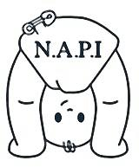
Newcastle Action for Parent and Toddler Groups Initiative (N.A.P.I)

Toy Library Membership (Playgroups and Private Day Nurseries)

Name of Organisation

Name
Address
Postcode
Telephone

Name of Contact

Name
Position
E-Mail Address
Name of Insurer

Agreement and Signature
The information I have supplied is true and complete. I agree to abide by the toy library terms and conditions.

Name (printed)
Signature
Date

To be completed by N.A.P.I.

Level of membership
Membership number
Date joined
Member signed terms and condition sheet
Fee paid

Thank you for completing this application form.

