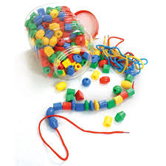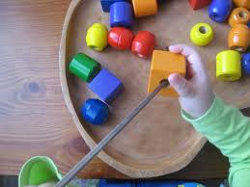

**Bead Threading**

**EXPLORE:** allow your child time to explore the beads and string. Use large beads with a thick string to begin with making it easier for your child to manipulate them. When they are familiar with the beads help them to thread them onto the string. At the start they will need lots of hand over hand support to guide the string through the hole.

* **Pass the string through the hole** holding your child’s hand help them to pass the string from one side of the bead to the other.
* **Hold the bead and encourage your child to pass the string through the hole** at this stage they will still need you to help them pull the string all the way through.
* **Taking turns** you hold the bead as they thread, then they hold the bead as you thread, use ‘your turn, my turn’ to encourage turn-taking and sharing.
* **Make it fun –** pretend you are making a snake and once complete they can move it around and scare you.

**EXTEND:** now that your child is familiar with the beads and threading you can support and extend their play with them.

* **Provide a wide range of beads:** this will help your child develop creative skills, what colour, shape, size do they need?
* **Use dry pasta as beads:** you can also have fun painting the pasta.
* **If your child is motivated by food:** use cheerio’s, you can also thread them onto pipe cleaners to make bird feeders.
* **Sorting:** thread all the red beads or the blue beads.
* **Counting:** how many beads are on the string? Can they thread 5 beads? How many more do they need?
* **Size:** find the big bead or the smallest bead. Make a pattern using different sizes. Is your string long or short?
* **Make a bead tree:** go on a nature walk to find a branch with lots of smaller thin branches. Use playdough as a base and thread coloured beads onto the branches.
* **Follow a pattern:** can they copy your pattern of beads or a pattern drawn on a card?

Threading will help your child to develop fine motor skills, improve their visual perception, hand eye coordination, concentration, social and communication skills.