[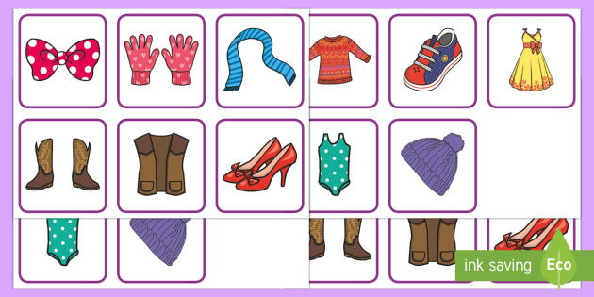](https://www.google.com/url?sa=i&url=https%3A%2F%2Fwww.twinkl.co.uk%2Fresource%2Fus-t-2548699-clothes-pairs-matching-game&psig=AOvVaw1USJsjuPCDchy7-cGDQKGJ&ust=1589450442565000&source=images&cd=vfe&ved=0CAIQjRxqFwoTCLjekLrKsOkCFQAAAAAdAAAAABAT)

**Picture matching games/lotto**

**EXPLORE:** allow your child to play with the pictures. Help them to learn the names of the objects or animals by naming them every time they pick up a card. When they are familiar with them you can begin to introduce matching games.

* **Place 2 pictures in front of your child** then give them one picture to match, if they are unsure help them to choose the correct one. Give them the second picture to match themselves. Give them lots of praise when they succeed.
* **Gradually increase** the number of pictures they can match
* **When you are sure they are able to match 3 or 4** you can introduce lotto games with 4 or more pictures – allow your child to explore the pictures before playing the game and help them to identify all the pictures on their lotto board.

**EXTEND:** now that your child has had time to become familiar with the picture sets, support and extend their play with them, here are some ideas:

* **Make your own lotto game using family photos.**
* **Find the matching pairs** – spread the cards on the table and encourage them to find ‘the same’. Start by holding up one card and ask them to find the matching card. As they develop this skill they will be able to find the pairs independently.
* **Taking turns -** share a lotto board with your child and take turns to choose a picture to match. Encourage them to wait by telling them ‘my turn, your turn’.
* **Memory games –** show your child 2 picture cards and turn them face down. Hold up a picture and ask them to find the matching card. When they are able to remember where they are you can gradually introduce more cards, showing them where they are each time before turning them over.
* **Matching object to picture –** use pictures of everyday objects and ask your child to find an object to match.

Matching and memory games will help your child to develop concentration and focus, visual memory, similarities and differences, fine motor, and support language development.