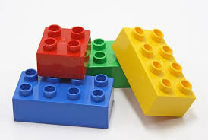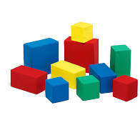 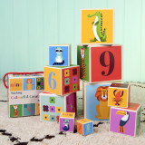

**Building Blocks**

**EXPLORE:** allow your child to explore the blocks. They will manipulate them in lots of ways by banging them together, mouthing, putting them in and out of containers, dropping them and looking to see where they have gone. These are all valuable learning activities.

When they are familiar with the blocks, they will begin to use them in several ways:

* **Knocking them down** - Play a game of building them up so that they can knock them down again**.**
* **Ready steady go** - Use simple language and encourage them to wait before knocking down the tower. When they have achieved this, you could say ‘ready steady……….’ then wait for them to indicate ‘go’, with a look, sound or gesture.
* **Stacking** – they will begin to build simple towers. Use large blocks to begin with which are easier for your child to manipulate. You can support them with this by modelling building a small tower and asking for their help to add the final piece, then the last two pieces etc.

**EXTEND:** now that your child has had time to play with the blocks, support and extend their learning using the following ideas:

* **Turn-taking** – encourage your child to take turns adding a block to the tower ‘my turn, your turn’.
* **Cooperative play –** work together to build and explore.
* **Construction –** start with simple ideas such as placing the blocks in a row to make a road for their cars. They will gradually begin to use their imagination to make more complex models.
* **Use a variety of bricks –** start to introduce different sizes, shapes and colours which will help to extend your child’s learning. With lots of repetition your child will begin to learn the differences between the blocks. At this point you could begin to ask your child to find a block you ask for e.g. ‘find the big one’ or ‘find a red block’.
* **Problem solving** – through play your child will learn to solve problems when a block doesn’t fit, or their model falls down – which size or shape of block do they need to fix it.
* **Sorting** -can your child find all the blue blocks or all the small blocks?
* **Counting** – encourage your child to join in when you count the blocks. Can they give you 2 blocks? You could then extend this by asking them to find ‘2 red blocks”.
* **Imagination –** introduce figures to add a role-play element to their games. Encourage your child to chat about what the characters are doing. Introduce simple language such as up/down and in/out.

Playing with blocks will help to develop your child’s hand to eye coordination, fine and gross motor abilities depending on the size of the blocks, maths skills using colour number and size, similarities and differences, problem solving, co-operative play, concentration, and language skills.