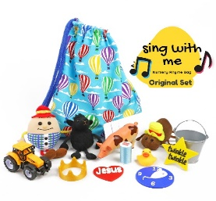



**Nursery Rhymes**

Begin by singing to your child whenever you have the opportunity. Keep it short and simple to begin with and you will quickly see which rhymes they are interested in. Keep it fun with tickling rhymes such as ‘round and round the garden’ or ‘this little piggy went to market’ as well as introducing your child to the actions for the songs.

As your child becomes familiar with the rhymes, they may start to join in with some of the actions and they will begin to request them again, this can be by making a sound, taking your hand, lots of eye contact, smiling or telling you ‘more’ or ‘again’.

Here are a few ideas on how to use rhymes throughout the day:

* **Daily routine**: choose a simple rhyme to accompany a daily routine such as going for a walk. ‘the ants went marching 1 by 1’ or ‘the grand old Duke of York’ would be good choices.
* **Craft activities:** you could link rhymes or songs to what you are making e.g. ‘incey wincey spider’ or ‘baa baa black sheep’.
* **Musical books**: books with buttons to press can encourage your child to join in and you could take turns to choose a rhyme.
* **Picture books:** encourage them to point to the characters and talk to them about what happens in the rhyme.
* **Use a rhyme bag**: fill the bag with things that relate to the rhymes then encourage them to put their hand in the bag and pull out an object. You can then sing the rhyme together. You could extend this by taking turns to choose.
* **Use symbols:** lay out the nursery rhyme symbols and encourage your child to choose a song to sing.
* **Makaton:** using Makaton or gestures will encourage they to join in with the actions if they are not yet able to join in the singing.
* **Finger puppets:** puppets are fun to use and are great to use with ‘5 little ducks went swimming one day’ or ‘5 little speckled frogs’.
* **Action rhymes:** songs such as ‘row row row your boat’ or ‘5 little monkeys jumping on the bed’ are great fun and are something you can do together.
* **Maths songs:** rhymes are a great way to introduce a child to number, size, shape, and colour.

Rhymes will help to develop sharing and turn-taking, early maths skills, development of memory, communication and language skills, rhythm and patterns of language, non-verbal communication skills, listening skills, and both fine and gross motor skills.