**Involving Everyone Photography Project and Exhibition   
Note of Interest**

**What is your name?**



**Address?**

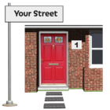

**How should we contact you?**



**Phone number:**

**Email:**

**Other:**

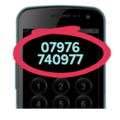

**What is the name of the person with a profound and multiple learning disability that will be part of the project with you?**

**Name:**

**Relationship to you:**

**Contact details:**



**Why do you want to be part of this project?**



**Why do you think the person with a profound and multiple learning disability that is joining you for the project, would like to be part of this project?**



**Is there anything else you would like to tell us?**



If you would like to speak to someone about the project please contact:

Kirsty Morgan

Project Support Coordinator

[Kirsty.morgan@inclusionnorth.org](mailto:Kirsty.morgan@inclusionnorth.org)

07539 06346

**Please return your Note of Interest to us by 30th May 2022**

[Kirsty.morgan@inclusionnorth.org](mailto:Kirsty.morgan@inclusionnorth.org)

Inclusion North

Suite 12A

Unity Business Centre

26 Roundhay Road

Leeds

LS7 1AB

