Collaborative Newcastle
Children and Young Peoples Mental Health and Wellbeing Plan
Easier Read Version –March 2023
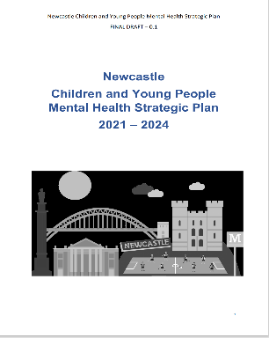 | What this plan is about
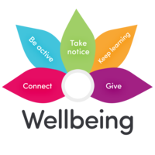  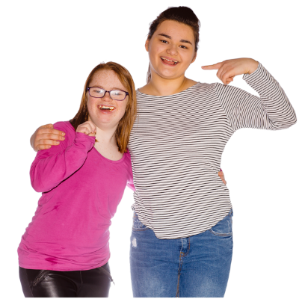 | This plan is about improving the mental health of children and young people in Newcastle, making it easier to get help and support when it’s needed.  In Newcastle we want everyone to work together to make sure children and young people get the best start in life.
 | What is Mental Health?
     | Mental Health is about emotions, feelings, and thoughts and how we manage our daily life.  Sometimes people feel sad or worried and this is normal  When people feel like this too often it might become a problem  Mental health can affect your body too. Everyone needs to look after their mental health.
 | What children and young people have already told us
   | We think the best way to make things better is to ask children and young people what they think. We know we need to get better at this. This is what people have already told us  - Friends are important  - We need help for anxiety to be available  - Support should be in the right place when we need it  - We need support with employment  - We don’t want to have to tell our story lots of times  - Help with building confidence is important  - Schools are important
 | Facts about Newcastle
 | About 70,000 children and young people live in Newcastle  About 14,000 school age people are from a black or minority ethnic background  About 1,000 children and young people have a mental health need
 | Plans
  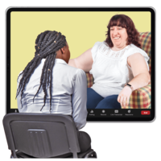  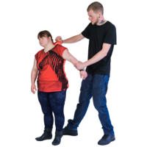  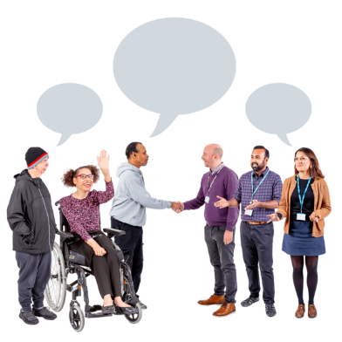 | We are working hard to provide more support in Newcastle, but we know there is more to do.  Our plans include  - Making sure that people can get help when they need it, and are not waiting too long when its urgent  - Making it easier to get help using digital ways eg through a phone or computer  - Making sure that there are skilled staff to offer support  - Understanding how people’s bad experiences can affect their mental health and making sure the right help is available  - Getting better at listening to children, young people and their families, and their ideas for improving services
 | TO FIND OUT MORE OR GET INVOLVED  E MAIL US AT  nencicb-ng.newcastlecypmentalhealth@nhs.net

