AUTISM HUB – EVALUATION: QUARTER 2
1st June –31st August 2022

100% of families rated the service 5 stars
9 Home visits carried out
29 Families attended our hubs

HUB OVERVIEW
Over this evaluation period, 29 family members attended the hub to attend one to one sessions and/or supporting your autistic child workshop.
At the start of each session a registration form is completed which enables the capturing of key data. This data follows:
Age of child Diagnosis status
Age | No’s
7 | 1
8 | 4
9 | 4
10 | 4
11 | 8
12 | 4
13 | 0
14 | 1
15 | 0
16 | 0
17 | 1
18 | 2
Diagnosis | No’s
On the autism pathway | 3
Autism diagnosis | 20
Dual diagnosis (with autism) | 4
Autism (with more than two other conditions) | 2

Postcode | No’s
NE1 | 3
NE2 | 0
NE3 | 2
NE4 | 5
NE5 | 8
NE6 | 5
NE7 | 1
NE9 | 0
NE12 | 0
NE13 | 2
NE15 | 3
NE21 | 0
NE26 | 0
Unknown | 0

Area of residence

Referred from
Age | No’s
Family partner | 8
Internet | 3
Social media | 7
School | 2
Friend | 2
Doctor/hospital | 2
Other charity | 1
Social services | 3
SALT | 1

ATTENDANCE
Nunsmoor Hub
Date | Participants
1st June 22 | 3
6th July 22 | 1
3rd August 22 | 2

Galafield
Date | Participants
8th June 22 | 4
13th July 22 | 4
10th Aug 22 | 5

Byker
Date | Participants
15th June | Cancelled
20th July 22 | 2
17th Aug 22 | 3

Fawdon
Date | Participants
22nd June 22 | 2
27th July 22 | 2
24th Aug 22 | 1

CASE EXAMPLES OF FAMILIES THAT ATTEND THE HUB
Background | Support given
A is a twelve-year-old autistic boy who attends a mainstream school in Newcastle.  A’s parent attended the hub, and she was finding her son’s behavior very difficult to manage.  He engages in lots of physical behavior, directed towards his mother and swearing.  The parents felt at a loss what to do next and were struggling to understand why their son does the things he does. | As a first point, A’s mother attended a family workshop to gain a better understanding of Autism. She expressed that this session had put a lot into perspective for her and made her view things a bit differently. For example, understanding that the way A responds to her is not a personal attack but his response to challenging situations, such as overwhelming sensory stimuli.  We then asked her to complete a diary of behaviour which she was finding the most difficult to understand, which she did. A one-to-one session then took place to help her reflect on some of the situations and draw conclusions for why her child may be behaving a certain way. It seemed through this process that the reason for A’s behaviors were multifaceted, with some seeming to be a way to gain a reaction, others seemed to be of a sensory seeking nature. Some strategies around both were given including understanding A’s need for proprioceptive input.  A follow up conversation took place with school to see what support was in place to see if this is something that could be replicated at home.  Observation within school will be completed next and insight will be given at the planned EHCP meetings that are due to take place in the coming months.
B is an 8-year-old autistic boy living in Newcastle with his family.  The family are asylum seekers which places additional complexities on the family. They struggle financially as they are unable to claim disability benefits, and they have been told they can get no support from school.  The family have been waiting to be granted permanent residency by the home office for seven years and are concerned they will be relocated.  Although B is managing academically in school, his father is worried about his emotional wellbeing. B can become teary and emotional particularly after school. | Initially, the Father attended a family workshop to help increase his knowledge about Autism and find out what other support was on offer. He expressed that he found this workshop useful and took some of the strategies particularly around communication to try at home.  Letter of support for housing outlining B’s needs for ongoing support as an autistic child.  Application to Sunshine fund was made for an IT device for B, this was granted.  Collection of art materials and resources were collected and dropped off at the family home, as the family were struggling to keep B entertained during the school holidays. Ideas were shared on activities the family could get B to try in the home. Information was also shared about local centre that offer activities specifically for children with SEND.  Visit to the family home to meet B, and to give specific strategies to support at home.

FEEDBACK ON THE HUB
At the end of each session participants are asked to complete an evaluation form.
Data from these forms follow:
Question | Response
How useful was the hub?  (not useful at all, a little bit useful or very useful) | 39 participants (100%) rated the hub very useful
Did you learn anything new about Autism? (I did not learn anything new; I learnt a little bit, I learnt a lot) | 39 participants (100%) stated that they learnt a lot
If you did learn anything new, what was it? | Answers included:  - Monotropism  - Double empathy,  - Where else to get support for my child  - Hyper and hypo and how you can be both  - How to support dysregulation  - Spoons theory  - Alexithymia  - Why my child finds it difficult at school  - Masking  - Shutdowns and meltdowns  - Language  - Autistic identity  - The importance of understanding why my child behaves that way
How will you apply what you learnt to your life? | Answers included:  - Knowing how I can better support him at school  - Taking more time to do things to find joy  - Understanding myself as a parent and how I might be autistic too  - I will share this with my child’s school  - I learnt so much, so many lightbulb moments  - So much of what I see now makes sense  - I have some ideas for new activities  - I didn’t know what help was available to me  - Ideas for transition  - Toothbrushing tips  - Autism friendly hairdressers  - Sensory activities  - Ideas to support his siblings
From a rating of 5 stars ( 5 being excellent and 1 being poor) how would you rate the hub? | 29 participants (100%) rated the hub 5 stars

HOME VISITS
In addition to the hub, we also carried out 9 home visits.
Home visits are carried out in the following situations:
- When travelling to a hub was a barrier
- When attending a hub caused stress/anxiety
- In cases where it was useful to meet the child and observe within the family environment
- Joint visit with another professional
Examples (names changed for confidentially reasons)
BACKGROUND INFO

John and Paul are living with their Grandmother, due to an ongoing court case. The Grandmother is completely new to Autism and feels out of her depth. She has her own health needs and is finding it difficult to understand the needs of the children.

ACTIONS

- Supported to plan activities with the children
- Ideas around developing a calming space in the home
- Shared information around other NEAS services
- Talked about sensory and communication differences

BACKGROUND INFO

Tom attends and specialist school and resides at home with his Father, who is the sole carer. Tom’s Father works full time and is often cared for by grandparents. Tom’s Father feels they all need more support to understand Tom and his needs.
ACTIONS

- Information shared about Autism with wider family
- Observation of play activities and information shared about sensory differences
- Tips shared for setting up a sensory space
- Discussed proprioceptive input in more detail
- Discussed ideas for emotional regulation
- Information about alerting and calming activities on a weekend

ADDITIONAL SUPPORT
This quarter we have attended events in the local community to wide our reach. These include an event at Heaton Mosque, which provided an opportunity for families to find out about NEAS services, and gain information and advice.
This event was attended by eight families who wanted to gain further information to support their family member. The families that we spoke to felt it was very a very beneficial event as they didn’t feel confident to attend one of the hubs. One of these families has since attended our hub. Work will continue within the community to raise the profile of NEAS and to offer support to families with the intention of a second event taking place at Newcastle Central Mosque in Elswick.
The second event was a workshop for families at the Newcastle Women and Girls’ group, this was attended by 12 family members.
ADDITIONAL RESPONSIBILITY
It is important to note that many of the interactions with families, whether at the hub or in the family home, often result in additional case work which include:
- Compiling reports
- Follow up emails
- Referrals into other agencies
- Contacting other professionals
- Attendance at MDT meetings (for example CTM, EHCP, TAF, Case conferences)
To give an example this quarter the team have attended three Care Team Meetings (CTM) and five Team around Family (TAF)
The nature of this work is flexible and dependent on the needs of the family, so it can be difficult to estimate the time involved.

Some final thoughts from our families

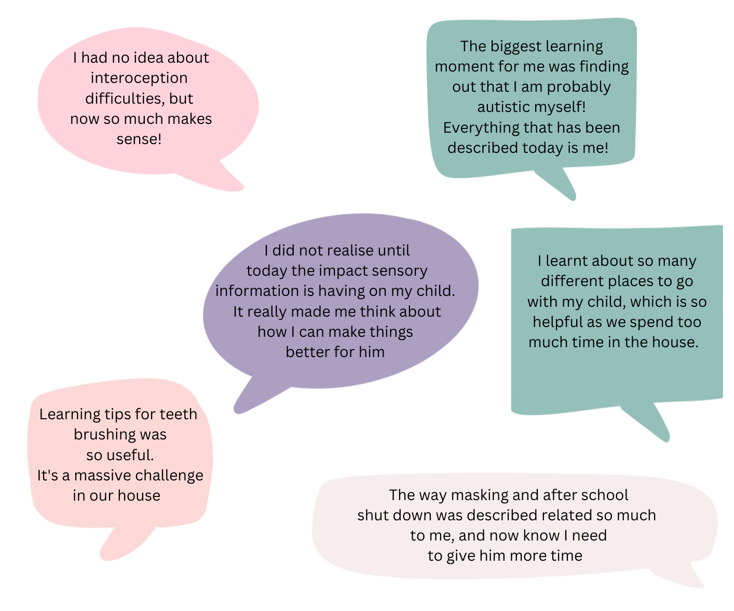
Report compiled by Kerrie Highcock (Family Development Manager) 8TH November 2022

