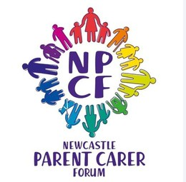NEWCASTLE PARENT, CARER FORUM NEWSLETTER

Summer 2023

Welcome to the first Newcastle Parent, Carer Forum newsletter. We will be sharing Summer, Autumn, Winter and Spring editions to show what support is available in Newcastle and bust some myths.

The Parent, Carer Forum has heard about confusion for both families and professionals on pre and post diagnostic support available in Newcastle as well as the role of the Single Point of Access (Getting Help) and CYPS (Getting more help). We'll cover these topics in this first newsletter which focuses on autism.

We'd love it if you'd let us know if this newsletter has helped, what else you want to find out about or what information would be helpful. E-Mail us at [**contact@newcastlepcf.co.uk**](mailto:contact@newcastlepcf.co.uk)



**MYTH BUSTING**

**AUTISM HUBS - NORTH EAST AUTISM SOCIETY**

There are Autism Hubs in Newcastle for parents/carers of children (0-18) who are waiting for an autism assessment, or have a diagnosis of autism.

The hubs run webinars and workshops on topics like sensory needs, sleep, toileting and behaviours that challenge. They offer peer support and also have 1:1 appointments you can book.

The sessions are held in the 4 locality hubs in Newcastle.

**Nunsmoor Centre** - 1st Wed of the month **Galafield Centre** - 2nd Wed of the month **Byker Sands** - 3rd Wed of the month

**Fawdon Community Building** - 4th Wed of the month

You can find more information, and the contact info to book a place at **w ww.ne-**

**as.org.uk/family-development-autism-hubs**

## "You can only get support after an autism diagnosis"

NEAS Autism Hub is available for families pre- diagnosis who are on the autism assessment waiting list.

**WAITING FOR AN ASSESSMENT OR TREATMENT WITH A HEALTH SERVICE IN NEWCASTLE?**

Tell us what support you'd like while you're waiting for an assessment from one of our Health Services e.g. Speech and Language Therapy, Neurodevelopmental pathway or Children and Young People's Service.

Please complete our survey at

[**eu.surveymonkey.com/r/NY9T637**](https://eu.surveymonkey.com/r/NY9T637)

**NEURODIVERSE KICKS - NEWCASTLE UNITED FOUNDATION**

These sessions combine football and mental wellbeing and are delivered by staff with autism specific training. They are for young people aged 11-18 who either have a diagnosis of autism or are awaiting it.

First Thurs every month - 6pm - 7pm **NUCASTLE, Diane Street, Newcastle Upon Tyne, NE4 8QB**

You can register here

[**www.nufoundation.org.uk/get-involved/premier-**](http://www.nufoundation.org.uk/get-involved/premier-)

**league-kicks**

**MYTH BUSTING**

"Waiting for an autism assessment now will take 5 years"

The waiting time for an autism assessment in Newcastle is around 18months - 2 years. We are working to get better at this and let families know what support is available while they wait.

**MENTAL HEALTH SUPPORT LINE FOR PARENTS AND CARERS**

North East Counselling Service runs a free phone line for parents who's children are struggling with their mental health.

The line is operated by a call back system, you can ring the number below and request a call back and one of the members of the team will be in touch. They will be able to

offer support, advice and signposting.

You can access this line by calling **0333 358**

**3040**

**TRUE COLOURS THEATRE GROUP**

True Colours is an inclusive theatre school for children and young people living in the North East. They run classes designed to build confidence and celebrate diversity in a safe and nurturing environment. **w ww.truecolourstheatre.co.uk/class-time-table**

The class timetable on their website, linked above, details the sessions they run, from an introduction to performance classes to faster paced classes with lots of confidence building, dance and singing.

Just to note, there is a charge for this service.

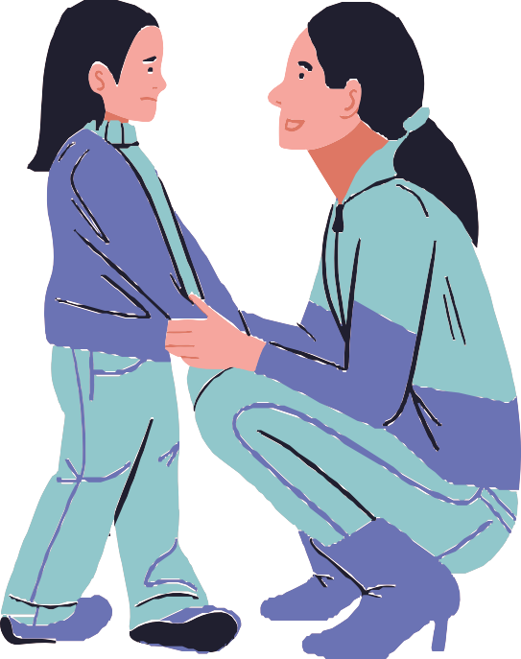

# MASQUER-AID - CHILDREN NORTH EAST

Masquer-Aid is a programme for young people 11-25 years old who have recently found out they're neurodivergent or are waiting for a diagnosis (neuro pathway). Young people will take part in a 12-week programme where they learn about what it means to be Neurodivergent, talk about their shared experiences. After the programme they are eligible to join one of our SEND and Neurodiversity Peer Support groups, where there is space in a group. All of the group times are as follows:

The 12 week programme runs in line with the school term: Thursdays: 2:30-4pm for 11-15 year olds

Thursdays: 4:30-6pm for 16+

Venue: The Young Womens Outreach Project, 12 Gladstone Terrace, Gateshead

### SEND and Neurodiversity Peer Support Groups available following the programme:

**"The Blyth Group":** A social Peer Support youth group for young people with any SEND need. We play games, watch movies, do cooking and sometimes enjoy and enclosed outdoor play space.

Mondays 4:30-6pm: Blyth Central Children's Centre 101 Wright Street, Blyth

### Friday afternoon Neurodiversity Peer Support Groups at the Children North East Young Person Service in Graingerville, Westgate Road, Newcastle:

Fridays: 2:30-4pm- 18+ Chill out club. A quieter space for Neurodivergent adults to play relaxed games, chat and make friends.

Every other Friday: 4:30-6pm - 16+ Games Group. A gaming group for Neurodivergent young people, we usually have the Nintendo Switch out and/or play board games or Dungeons and Dragons.

Every other Friday: 4:30-6pm - 11-15 Games Group 4:30-6pm every other Friday: This group is similar to that above but for younger people.

Referrals are currently only being taken through CYPS (Getting Help) but we can

[take enquiries and answer questions via our email address at m](mailto:masquer-aid@children-ne.org.uk)

[aid@children-ne.org.uk](mailto:masquer-aid@children-ne.org.uk)

[asquer-](mailto:masquer-aid@children-ne.org.uk)

**FAMILY NETWORKING GROUP - NORTH EAST AUTISM SOCIETY**

The North East Autism Society run a Family Networking Group, a closed group on Facebook which aims to empower, educate and connect parents, families and carers by:

Increasing knowledge Sharing useful information Connecting people

You can find out more and join the group here **w ww.ne-**

**as.org.uk/family-networking**

**DID YOU KNOW**

The RISE Team, provides mental health support in Newcastle schools for children and young people who have anxiety, or worries. They also give advice to teachers about how best to support those young people.

**h ttp://rise.childrenssociety.org. u k**

**AMBITIOUS ABOUT AUTISM YOUTH NETWORK**

Ambitious about Autism has a rapidly growing online Ambitious Youth Network to help more autistic young people to have their voices heard.

Autistic young people between the ages of 16 to 25 can share experiences, connect with others, have their say on Ambitious about Autism’s projects as well as access a range of opportunities to advocate and improve services for autistic young people.

You can join here **w ww.ambitiousaboutautism.org.uk/what-we-do/connecting- young-people/online-youth-network**



**AUTISM PADLET - SUPPORT FOR CHILDREN AND FAMILIES**

The Padlet provides a source of information for schools, families and autistic young people. It's updated regularly with information and activities.

It provides specific provisions for autistic young people as well as those not specifically offered for autistic individuals, but that may still be useful.

The Padlet can be accessed by scanning the QR code.

**ELDON SQUARE AUTISM FRIENDLY GUIDE**

Eldon Square's autism friendly guide was developed in partnership with the North East Autism Society. The guide's aim is to support people with the early stages of planning their visit to enjoying the visit on the day.

The guide can be downloaded here **h ttp://eldonsquare.co.uk/centre-**

**information/accessibility** along with more information on their sensory bags for children, accessible toilets and changing and centre quiet hours.

**PARENT/CARER COFFEE MORNINGS - SKILLS FOR PEOPLE**

The Family Advice and Support Team at Skills for People run parent/carer coffee mornings at locations around Newcastle. They're a chance to find out more about support available in Newcastle and chat with other parents with shared experiences.

The Team also run drop in sessions and family meet ups. You can keep up to date with the group via their Facebook page,

or scanning the QR code to the right.

**INFORMATION AND RESOURCES - THE TOBY HENDERSON TRUST**

The Toby Henderson Trust has a comprehensive website **w ww.ttht.co.uk** with resources and information that they've collated from the topics they get asked about most frequently like;

Autism and mental health Sleep

Food issues Managing meltdowns Visual aids

Toileting

Social stories Sensory issues.

They also have an autism myth busting page where they have pulled together information on common misconceptions or widely held but false

beliefs about autism and autistic people.

**RELAXED SCREENINGS - TYNESIDE CINEMA**

The relaxed screenings at Tyneside Cinema are open to all, but are particularly mindful of neurodiverse audiences, with adjustments in place to be inclusive and relaxing.

Screenings take place on the first Sunday of every month in the Roxy screen on the 3rd floor

of the cinema.

Full details of adjustments can be found on their page here

[**http://tynesidecinema.co.uk/acc**](http://tynesidecinema.co.uk/acc)

**ess-cinema/relaxed-screenings**

# EXPLAINING - SINGLE POINT OF ACCESS (GETTING HELP) AND CYPS (GETTING MORE HELP)

There are multiple elements of the Children and Young People's Mental Health Service (often called CYPS for short). We've heard that both families and for professionals feel confused about what the difference is and what that means for the family.

### What is the Single Point of Access (Getting Help) offer?

Getting Help is the overarching service that oversees the Single Point of Access and provides short term interventions for things like anxiety, low mood and emotional or behavioural regulation.

Support from the Getting Help service will come in the form of help from one of the providers commissioned by CYPS that sit in the service, including:

Kalmer Counselling

Barnardo's Independence Project Streetwise

North East Counselling Barnardo's Orchard Mosaic Kooth

Children North East

### See back page for details

Or you could be signposted to another support service sitting outside of Getting Help, for example RISE.



**JUST TO CLARIFY**

When a child gets help from a Getting Help service (see above) this does not mean they are being assessed by Getting More Help (see box to the right) as these are separate services services.

**What does the Single Point of Access do?**

It is the referral point for young people (0-18) in Newcastle requiring support as described above in Getting Help, and they will decide whether or not your child needs Getting More Help (Tier 3 /

Tier 4) which includes assessments in:

Neurodevelopmental: ADHD and Autism Learning Disability: With mental health need Community Eating Disorder

Mental Health: Assessments and Interventions

For more information see

[**www.cntw.nhs.uk/services/children-young-**](http://www.cntw.nhs.uk/services/children-young-) **peoples-service-newcastle-gateshead**

# A BIT OF INFORMATION ABOUT THE GETTING HELP (SINGLE POINT OF ACCESS) SERVICES

**Barnardo's Orchard Mosaic**

Provides a counselling service for children and young people 5-18 who have experienced bereavement or sexual harm. They are a team of therapists who offer different types of support including talk therapy, messy play, art therapy, use of cognitive behaviour techniques and specialist support for young people diagnosed with PTSD.

Sessions can be face to face or virtual either from the Therapy building in Newcastle or in the Community such as School or Early Help settings.

The work is child directed which places the child or young person in the driving seat, the team help the child or young person think about positive people that can help them through tough times, helping the child or young person identify their strengths and each session will involve feedback from the child or young person to make sure they have been listened to and the sessions work for them.

**Barnardo's Independence Project**

Provide up to 6 month's worth of support to 12-18 year olds living in Newcastle, who are stepping down from Tier 3 Mental Health Services.

Offering a young person support with the transition out of these services, as well as aiming to prevent them returning back to them.

The support concentrates on emotional wellbeing through a social prescribing model and is tailored to wherever somebody feels most comfortable e.g. school, home or somewhere out in the community.

**Kalmer Counselling**

Kalmer are commissioned by CYPS to work with children and young people with a learning disability and learning difficulty but are also commissioned to work with those that are awaiting for a Neurodevelopmental assessment.

Provide counselling to children and young people, aged 9-25, with learning disabilities and difficulties in Newcastle.

**North East Counselling**

Deliver one to one counselling using a variety of therapy techniques. It's a counselling service for ages 4+ in relation to depression, anxiety, bullying, self-harming, loss and berevement.

**Children North East**

Provides a one to one counselling service for 9-25 year olds who are struggling with their mental health, utilising a variety of therapy techniques.

Some of the things they can support with are coping with depression, anxiety, bullying, self- harming, loss and bereavement.

The counsellors can meet wherever young people feel safe and are currently available evenings and Saturday mornings too.

**Kooth**

Offer online counselling services for young people aged 11-18 years, providing an early response to, and identification of emotional wellbeing and mental health problems.

The support is safe, online, anonymous, and self- referral based so there are no waiting lists or thresholds to meet. The offer is centered around therapeutic choice, offering a full mental health toolkit - giving users the opportunity to choose what kind of support works for them. This includes self help resources, community support & professional support.

**Streetwise**

Provides early help and support to young people who are experiencing mild to moderate mental health or emotional wellbeing difficulties, including anxiety, low mood, anger, stress, bereavement and low self-esteem.