Newcastle Local Area
Getting It Right Together
SEND Quality Assurance Framework

June 2023

Contents
1. Introduction 3
2. Overview of the Getting it Right Together Framework 4
3. Learning from the views and experiences of children and young people and their parents and carers 4
4. How we support children and young people with SEND 6
5. Learning from looking at SEN support 7
6. Learning from looking at EHCPs and annual reviews 10
7. Learning from complaints and compliments 15
8. Learning from data and insights 15
9. How we will learn and get better at what we do 18
10. Development Plan 18
11. Glossary 19

Introduction
The Newcastle Special Educational Needs and Disabilities (SEND) Executive Board brings together people from across Newcastle (the local area) to work together. We work together because we want to make sure that children and young people with SEND and their parent/carers have a good life, that we provide the right services and that the needs of children and young people are met.
We are committed to the principles of co-production and relational and restorative practice. This means we will build meaningful and respectful relationships, as opposed to focusing solely on process or policy. Our focus is on practitioners working ‘with’ children and families, instead of doing ‘to’ them or ‘for’ them. This allows us to provide high levels of support and challenge so that children and families are empowered to be involved in decisions that affect them. By working in this way people are more likely to make positive sustained changes in their lives.
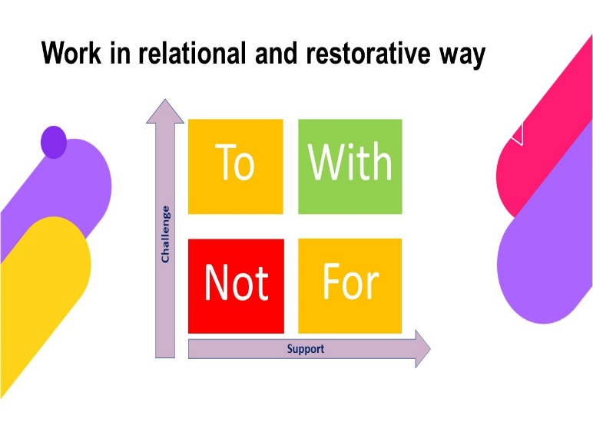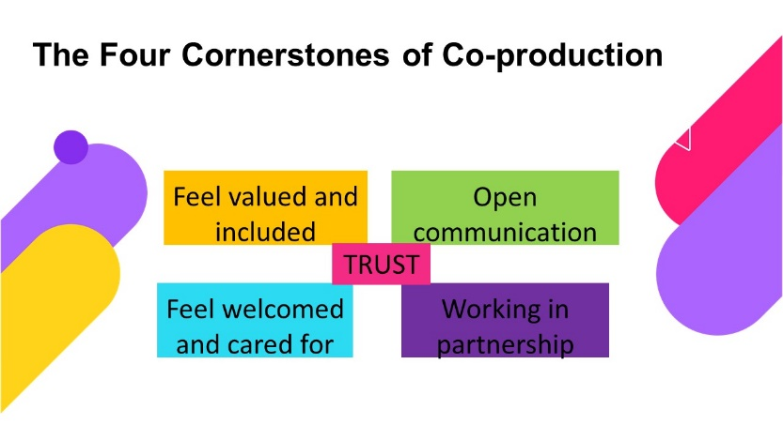
The Local Area SEND Strategy 2019-2022 explains how we are going to make sure that we have a SEND system that works for everyone. We are currently co-producing our strategy for 2023-2028 and as part of this we will agree our underlying principles and ways of working.

Overview of the Getting it Right Together Framework

The SEND Executive Board in Newcastle really like this Getting It Right Together Framework as they want to:
- make sure children and young people benefit from consistent high-quality person-centred support which meets their needs and is easily understood by everyone, through SEND Support or Education, Health and Care Plans (EHCPs)
- make sure we do things right for all our children and young people with SEND and their parent/carers
- make sure we all understand what good looks like
- improve the experiences of children and young people with SEND and their parents and carers
- improve outcomes for children and young people with SEND.
This document describes four areas of work that will help us to Get It Right in Newcastle, and how we will bring together the learning from all four aspects to be good at what we do.
An overview of the Getting it Right Together Framework:

Learning from the views and experiences of children and young people and their parents and carers

How we work together with children and young people
We are committed to making sure that everyone who works with our children and young people with SEND know that building in their voice is everyone’s business.
We will deliver staff briefings, have toolkits that can be used and peer educators with lived experience who can bring a passion to participation and involvement.
Being inclusive means that we will use a variety of ways to capture and embed voice from online tools and Apps to capture children and young people’s views and experiences to SEND Executive Board takeover days.
We have an annual diary of events as well as specific and targeted work with children and young people who may find it hard to participate in larger groups.

How we work together with children, young people and their families

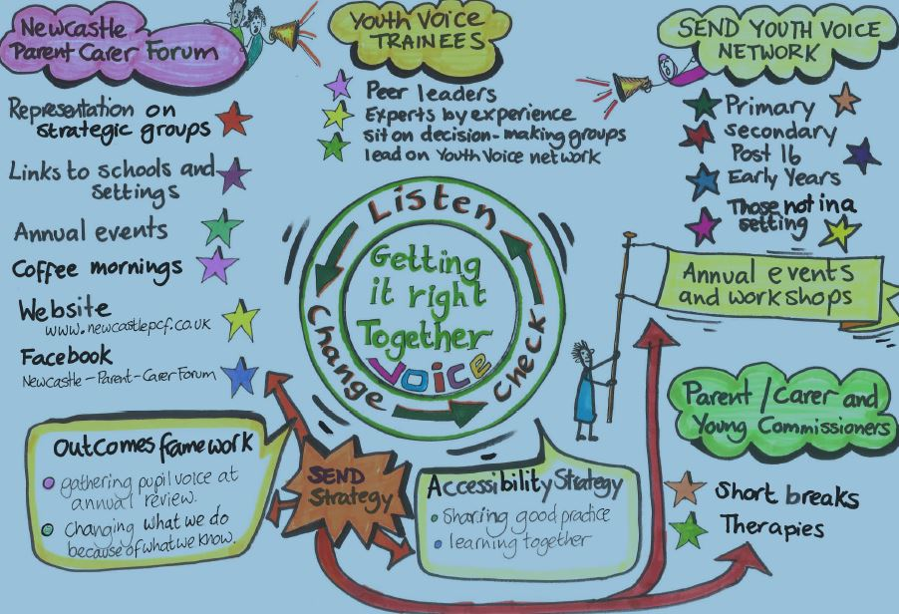

How we hear the views and experiences of parents and carers
We are grateful to the parents and carers who contribute their time and share their experiences. This contribution is critical to how we improve what we do and how we do it. The main ways we hear their voice include:
- The Newcastle Parent and Carer Forum a network for parents and carers of children and young people with SEND. They provide an informal support group, participate in planning and policy making and advocate on behalf of children with SEND and their families in the city. The Chair of the new parent/carer forum has a seat on the SEND Executive Board.
- Pass it on Parents is a Facebook page administered by Skills for People. It enables parents and carers to share ideas and information and advocate on behalf of children with SEND in the city.
- Parent representatives will also be partners in the Getting it Right Together workstream of the SEND Executive Board.
- Young people, parents and carers will be involved in every Getting it Right Together workstream meeting to discuss learning, actions and impact from all the different areas of the framework.
- We will talk directly with families every term to gather views of their experiences and we will respond by making changes to how we do things. We will feedback to them what changes we have made.
- We are working with children and young people to come up with a way of involving them through the Local Offer to comment and feedback their SEND experiences.
How does this improve the quality of what we do?
By building in a ‘working together’ value base, valuing the lived experience of our children and young people, listening, responding and changing what we can, will help us deliver services that work well for everyone.
We want to be a learning organisation putting real experiences at the heart of our delivery. We want to learn together, grow and be the best we can.

How we support children and young people with SEND
We must make sure that all children and young people with SEND get the support they need in their education setting. Needs vary from those requiring an EHC plan to those that need a little extra help. The different ways we provide support is described in the diagram below which we call the ‘Graduated response’.
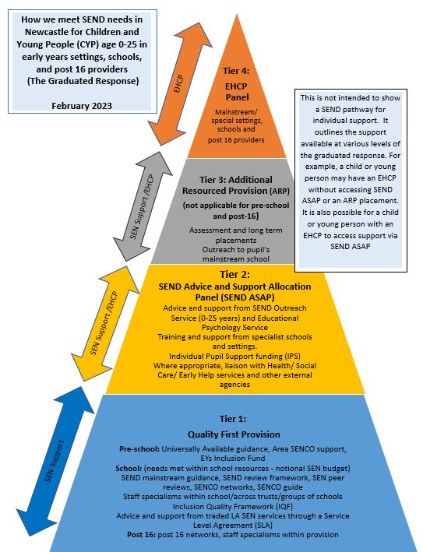

Learning from looking at SEN support
Context
Where a pupil is identified as having SEN, schools and settings should take action to remove barriers to learning and put effective special educational provision in place. This is referred to as SEN support, it can take many forms and will be different for each child to suit their needs. It is provided as tiers 1, 2 and 3 of the graduated response.
This section describes how we are going to look at SEN support in our area. This will help us make the SEND support processes work well for children, young people and their families. We want to listen to what they say, act on their comments and not be scared to try out new things. We really want to get better at what we do.
SEND Leaders in Newcastle think that we can be really good at what we do if:
- SEN Support is shaped by the views, wishes and feelings of children, young people, their families and carers
- We can demonstrate that the SEN support is totally person centred
- Settings consistently provide quality first provision
SEN Support Plan
SEN Support plans are developed through a robust ‘Assess, Plan, Do, Review’ cycle, including clear timelines of interventions, professional involvement and outcomes.
In Newcastle we have strengthened and improved the consistency of SEN support across the city by agreeing a standard SEN support plan for those children and young people who require access to Tiers 2 and 3 of the graduated response. We designed this with parents / carers, children and young people, early years settings, schools, post 16 providers and colleges.
The agreed format for a SEN support plan that is submitted to the graduated response panels will make sure that there is a consistent approach across settings. The SEN support plans will help us to recognise good practice that can be shared, as well as making outcomes, progress and levels of need easier to track.
Whole School SEND Reviews
We know that the most effective way for settings to achieve the best they can, is to closely look at what they do. A regular view of our strengths and weaknesses is important so that we can judge the quality of our work. We need to know the impact on children and young people’s learning and progress and quickly identify any areas that need further improvement.
The SEND Review Framework without ARP for schools is a tool to help reflection, self-evaluation and is the basis for targeted action planning for SEN development.
Since September 2017 the School Effectiveness SEN team have used the SEND review framework to develop SENCO peer to peer support across groups of schools. All SENCOs across the group of schools have the opportunity to be the host school and to act as a peer reviewer in at least one other school. For larger groups this process is planned to take place over a two- or three-year period. Good practice sharing and discussing concerns are really important in peer-to-peer support. The School Effectiveness SEN team have attended SEND reviewer training delivered by Whole School SEND / NASEN which helped us to know that this is the right way of working.
As part of the commissioning agreement for schools with ARPs they will be expected to use the SEND Review Framework with ARP to look closely at their provision an annual basis.
The School Effectiveness Adviser for SEN also looks at school Ofsted outcomes and provision for pupils with SEND. If there are any concerns from Ofsted or by the Head of School Effectiveness then the School Effectiveness team will support the school to identify strengths, areas for development and to produce an action plan for improvement. Ongoing support will be provided by the School Effectiveness SEN consultant and Lead SENCOs. We aim to develop similar self-evaluation frameworks for early years settings and post 16 providers and colleges. Quality Assurance should form a core part of the cycle of self-evaluation and can also provide support and focus for SENCOs.
SEND – ‘best practice’
We want to capture SEND ‘best practice’ for children and young people at SEND support which will add real life examples to the following documents:
- SEND Review framework without ARP
- SEND Review Framework with ARP
- Universally Available Provision for Schools: supporting children and young people who have special educational needs and disabilities at SEN support in mainstream schools and settings
- Universally Available Guidance for Early Years
The SEN ‘best practice’ and the peer-to-peer support and challenge will make sure we have a more consistent, robust and rigorous quality assurance process so that teaching and provision are improved. These improvements will be felt on the ground by our children and young people with SEN and improve their overall outcomes. As well as this, a stronger emphasis on continuous review and delivering improvements will also build expertise, confidence and skills within and between our school communities.
How does this improve the quality of what we do?
By listening to what families say and through looking carefully at how schools provide SEN Support, we will have a shared understanding of our strengths and areas we need to get better at. We will make sure that the families involved know what we do differently as a result of what they have told us. We will celebrate and share good practice and respond quickly to areas of concern.
SEND Descriptors of Need

We have co-produced SEND descriptors of need or ranges:
- to ensure a common language to describe the support that we'd expect to see for children with SEND
- to provide a core framework for all practitioners working with children, young people to help assess and identify the needs of children and young people, and to put in place appropriate support
- to give greater clarity for parents and carers about their child/young person’s needs and how their child should be supported at school.
Schools started to use the descriptors from September 2022. For more information look at our SEND
Local Offer Page: SEND Descriptors of Need | Newcastle Support Directory

Learning from looking at EHCPs and annual reviews
Context
Most children and young people with SEN or disabilities will have their needs met at SEN support in their local nursery, school or college. Some children and young people may need an EHC needs assessment, this will determine whether we need to make special educational provision for them through an EHCP, to help them to achieve the best possible outcomes, and help to prepare them for their next steps.
This section describes how we are going to look at EHCPs and annual reviews in our area. This will help us make the EHCP assessment and review processes work well for children, young people and their families. We want to listen to what they say, act on their comments and not be scared to try out new things. We really want to get better at what we do.
SEND Leaders in Newcastle think that we can be really good at what we do if:
- EHCPs are shaped by the views, wishes and feelings of children, young people, their families and carers
- We can demonstrate that the EHCP process and documents are totally person centred
- The EHCP looks at the child or young person’s dreams for now and the future and this can clearly be seen in all their reviews
- EHCPs are clear, concise, understandable and accessible to children, young people and their families
- EHCPs are specific, clearly show the need and what support and services are needed to achieve good outcomes
- Reviews are focused on the progress made by children and young people against their outcomes. People at reviews will listen to what might need to change and will be responsive to changing needs.
SEND Outcomes framework
Children and young people told us the outcomes that are important to them which are that they are:
- Safe
- Happy and feel included
- Healthy and well cared for
- Ready for next steps
- Heard in decisions

We have co-produced an outcomes framework which includes the performance indicators to measure progress in achieving the outcomes. This includes the information that partnership leaders need to evaluate how effectively education, health and care services are working together and ensures that leaders are clear about the challenges that children and young people with SEND and their families face.

Children are asked questions relating to these outcomes at their annual reviews. You can view the process we are working on in this you tube video: SEND Outcome - YouTube

The levels of our local area arrangements

Level One – Single Agency audits: What does good look like?
We want to learn together and get better at what we do across the local area. Our starting point is the arrangements that individual agencies have in place to make sure they are doing a good job of EHC assessment and review.
- In Education this means: Schools and other education providers have a way of making sure the quality of their contribution to EHC assessments and reviews is really good. They think about how to make sure that children, young people and their families are clearly central to the conversation. Schools and education providers will look at education advice during SENCO network meetings which take place throughout the year. This means they can share things that work well and are able to talk about areas that don’t work so well. Learning is shared through SENCO networks, as well as peer to peer support and reviews across groups of schools.
- In Education this means: The SEN support template will help schools and other education providers make sure the quality of the SEN support plans is good. The process will be the same as above for EHC assessment and review.
- In Health (the North East and North Cumbria ICB) this means: a termly look at health advice and EHCPs, focusing on the quality of the information, and that we can show how children, young people and their families are at the centre of the conversation.
- In Social Care this means: a termly look at social care advice and EHCPs, focusing on the quality of the information, and that children, young people and their families are at the centre of the conversation.
- In the Educational Psychology (EP) Service: Managers review EP advices to ensure they meet quality standards.
In addition, the SEND Support, Assessment and Review (SEND SAR) Team write the EHCPs. These EHCPs are considered at the fortnightly panel meetings, and feedback is given to individual EHCP writers. Good practice is shared, and we change things that don’t work well.
Level Two – Multi agency audits: How we work together - What does Good look like?
We want everyone to be really good at what they do with EHCPs and reviews across the local area. Alongside the single agency ‘What does Good look like?’ arrangements, partners have put in place multi-agency arrangements to look at the quality of EHCPs and the review process. This means:
- Representatives from education, health and social care will meet with LA officers and parent/carer representatives to talk about the EHCPs. This group of people are known as the Getting it Right Together workstream. This group will look at 10 EHCPs each term. It may be that the focus will be on EHCPs issued in the previous year alongside a recent review and the EHCP that was issued following review.
- Members of the SEND Service will also meet with children, young people, and families to discuss their experiences of EHCP assessment and review. We will contact 10 families every term and arrange to meet with them either face to face, through online video calls or using online feedback forms.
We want to make sure that central to our approach is making sure we involve ‘experts by experience’ the child or young person and parent or carers. We have a toolkit to use with them to help us find out:
- Whether EHCPs and review paperwork looks at progress and/or barriers to progress?
- Whether children and young people in Newcastle with EHCPs are making good progress?
- How well the voice of the child/ young person is clearly reflected in the plan.
- Do the parent/carer’s child/ young person understand what is written in the plan?
- Whether there have been conversations about planning for the future, dreams and independence?
We may want to look at certain themes to make sure we’re doing a good job in these areas. Themes may include children and young people at risk of permanent exclusion, looked after children, early help, preparation for adulthood, or children with specific types of need.
Our aspiration is for all EHCPs to be good practice and that they all clearly describe the views and experiences of children and young people. We assess each area of the plan and consider whether it is compliant with the SEND Code of Practice or not. In our Accelerated Progress Plan agreed with the Department for Education we set a target that 75% of plans will meet the expected standards by August 2022.

The Getting it Right Together Group is Chaired by the SEND Support, Assessment and Review Team Manager and includes parent/carer representatives, representatives from schools, post 16 education providers, the North East and North Cumbria ICB, Children’s Social Care, Education and Skills and SENDIASS. The group will meet termly to oversee the audit process.

The Getting it Right Together Group will produce an annual report of what they have learned and make recommendations to the SEND Executive Board.

The focus of our EHCP and EHCP Review ‘What does good look like?’ at Level 1 and 2
SEND Designated Social Care Officer (DSCO)

We have invested in a DCSO role, and an officer started in post in October 2022. A key focus of the role is to improve the interface between social care and SEND and improve the quality of social care advices in EHC planning.

Level Two - Themed multi-agency audit of EHCPs:
These audits will be carried out annually and will be determined by the results of the single agency and EHCP audits.
Auditing EHC plans – Data protection

To help ensure that we will improve quality of EHC plans it will be necessary to audit individual EHC plans. These plans will be selected at random. Auditors will be required to disclose whether they recognise the child/young person and recuse themselves accordingly. Families will not be informed that their EHC plan has been audited and will not be informed of the results. Should areas of the plan be deemed to be inadequate, action will be put in place to address the concerns raised and, in these cases, it may be necessary to inform the families of any improvements that will be made.

Summary of Level 1 and Level 2 arrangements for learning from EHCPs and annual reviews
Learning is recorded, shared and acted on

How does this improve the quality of what we do?
By listening to what families say and through looking carefully at EHCPs and the information and advice that is provided during assessment and review, we will have a
shared understanding of our strengths and areas we need to get better at. We will make sure that the families involved know what we do differently as a result of what they have told us. We will celebrate and share good practice and respond quickly to areas of concern.

Learning from complaints and compliments

Why complaints and compliments are important
This section describes how we will learn from feedback such as complaints and compliments to make improvements across the local area.
Complaints
Each member organisation of the SEND Executive Board have arrangements in place to log and respond to complaints that they receive:
- Within Newcastle City Council: All complaints and Ombudsman enquiries relating to SEND (EHCPs, practice and/or transport) are collated, analysed and reported on a termly basis. To aid learning, complaints are structured by theme, whether the complaint was upheld and what steps we are taking as a result.
- Within the North East and North Cumbria Integrated Care Board: Complaints will be managed through the existing complaints process with support from the Designated Medical Officer (DMO) and Designated Clinical Officer.
Building on these individual arrangements, partners have committed to sharing themed information about local area complaints with the SEND Executive Board every year. Doing so will highlight local area learning opportunities and will be included on the Local Area Learning Log. They may also determine the themed audits.
Compliments
Each member organisation of the SEND Executive Board have arrangements in place to collate and share compliments that they receive. This is an important step in celebrating and sharing what we do well. These compliments will be shared with the SEND Executive Board annually.
How does this improve the quality of what we do?
Complaints and compliments help us identify areas that we need to develop, and good practice that we can share. Training, learning and support opportunities will be provided to individuals and teams where required. Each complaint response or compliment is sent to the manager of the service, who discusses the learning with their teams or where appropriate the specific officers involved.

Learning from data and insights

Why data and insights are important
This section describes how we will use information across the local area to build a clear and shared understanding of what we do and when we do it and the children and young people that we are supporting. ‘Data and insights’ means looking at:
- the information we collect about when we complete assessments and reviews
- the information in EHCPs that tells us what services children and young people need
- whether the services that we commission are supporting children and young people to make progress
Keeping to Timescales
We want the experience of children and young people and their parents and carers to be positive. As a minimum this means doing what we say we will do in the timescales we are expected to do it. We will track local area timelines and completion of EHCPs and review processes, highlighting good practice and where we need to improve. We do this through our SEND Outcomes Framework which is shared with the Joint SEND Intelligence and Commissioning workstream and recommendations for improvement are progressed to the SEND Executive Board.
School SEND Profiles
We use local area information to create School SEND Profiles for all our primary schools, secondary schools and special schools. These profiles show us progress in learning as well as exclusions and absences from school. This helps us understand local needs and address areas of concern.
Outcomes Framework
The SEND Executive Board and parent/carer forum have co-produced a SEND Outcomes framework that it would like all its children and young people with SEND to achieve. The five outcomes are shown below:
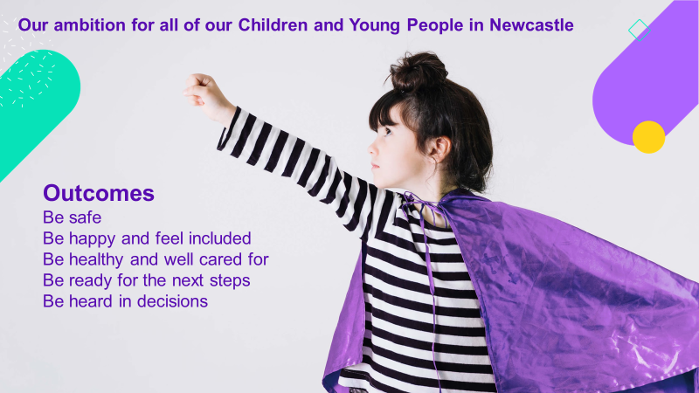
Together we have identified a series of aspirations for children and young people based on what they have told us during a series of consultation workshops in 2020/21.
To assess how well we are doing to achieve the aspirations we have identified a series of questions that we will ask at all stages of the EHCP and SEN Support process and a number of performance indicators that will demonstrate progress against the outcomes.
Our aspiration is that we will be able to assess progress against the outcomes for children and young people with an Education Health and Care (EHC) Plans, and those with SEN support, including the children and young people with SEND that may not have a diagnosis. However, there are some cases where data is only available for those with an EHC plan. We are working on expanding data sets to include those children and young people with SEN Support by matching data across public health, NHS, social care and education. Partners have worked together to provide data including number of contacts and waiting times for community health services and Children and Young People Service (CYPS) and access to secondary care services for those with an EHCP and SEN Support.
SEND Outcomes Framework

We have co-produced our SEND Outcomes framework and identified questions for schools to ask children and young people to determine how they are feeling against the outcomes. Schools started to use these questions at annual reviews from September 2022. For more information take a look at our SEND Local Offer Page SEND related policies and strategies (newcastlesupportdirectory.org.uk) It is about half way down on the outcomes framework link.

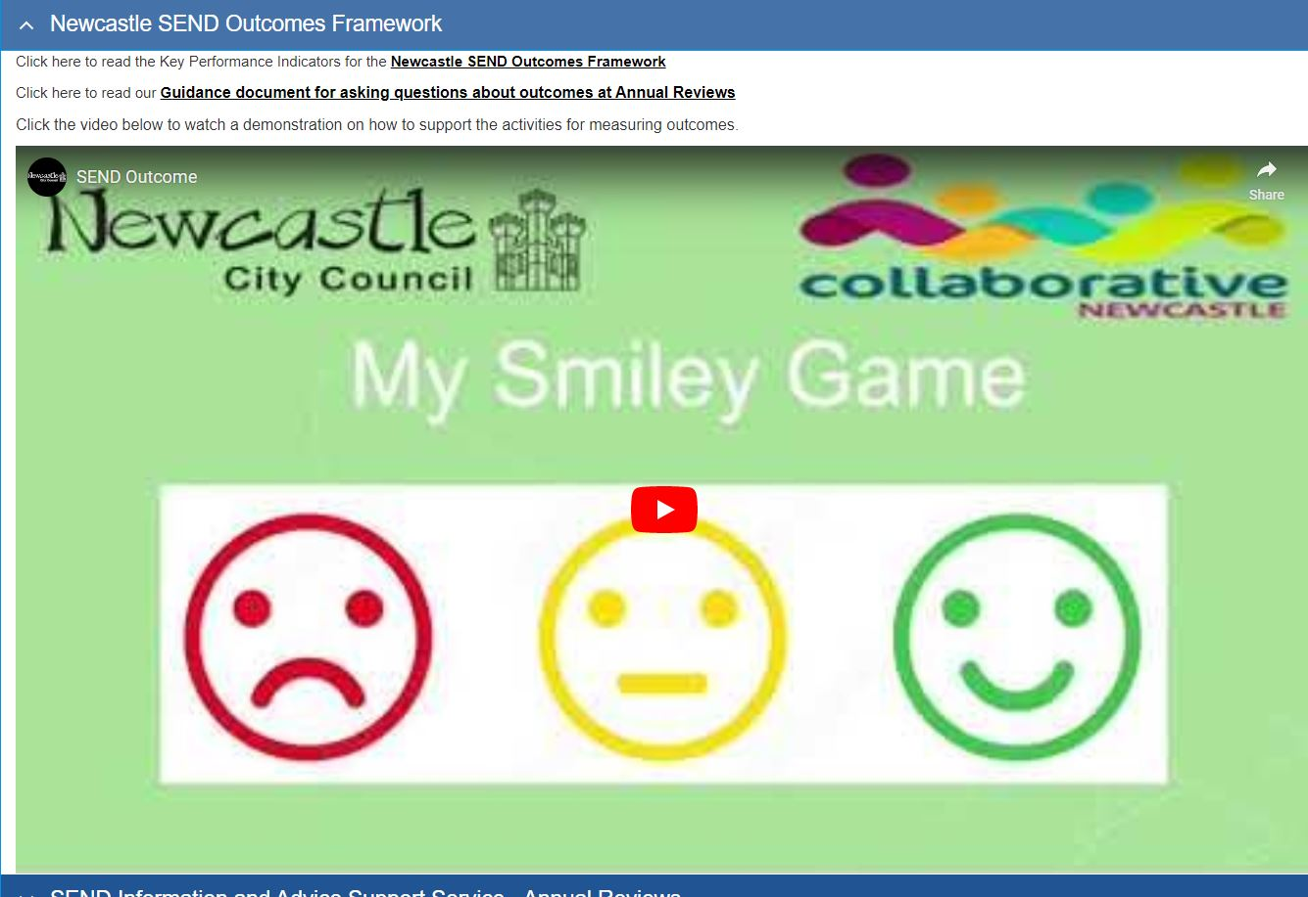

Service Quality
We want to ensure that children and young people receive the right services to support them to achieve positive outcomes.
We will use information in EHCPs about the what support children and young people need, how much and how often to inform our Joint SEND Commissioning Strategy, ensuring that we have the right services in place to meet need. We will collect information through the contracts we have with SEND services to monitor their quality and impact.
How does this improve the quality of what we do?
By looking at data and insights we have a clear and shared understanding of what we do, the impact that we have and how we compare with others. This allows us to celebrate and share good practice and swiftly address areas of concern.

How we will learn and get better at what we do
This section describes how we will bring together learning from all the areas described above and make sure that we work together to make changes that have a positive impact on children and young people with SEND.
The Getting it Right Together Group will oversee the Getting it Right Together Framework and have responsibility for sharing good practice, addressing areas of concern and making improvements where needed. The group will make sure that we can measure the impact that changes make, which will help us know if we are doing a good job, and what other changes we can make.
The Local Area Learning Log is a document that records what we have learned, what we will do to make improvements, who will do it, and when by. It will also record what impact these changes have. We will share what we have changed with parent/ carers, children and young people so that we demonstrate how we listen and act on what they are telling us. It will be overseen by the Getting it right together Group.
As well as learning from the experiences and views of children, young people, their parents and carers we will work with them to make changes, share what we have learned and what we are going to do about it.
Drawing together, sharing and acting on local area learning
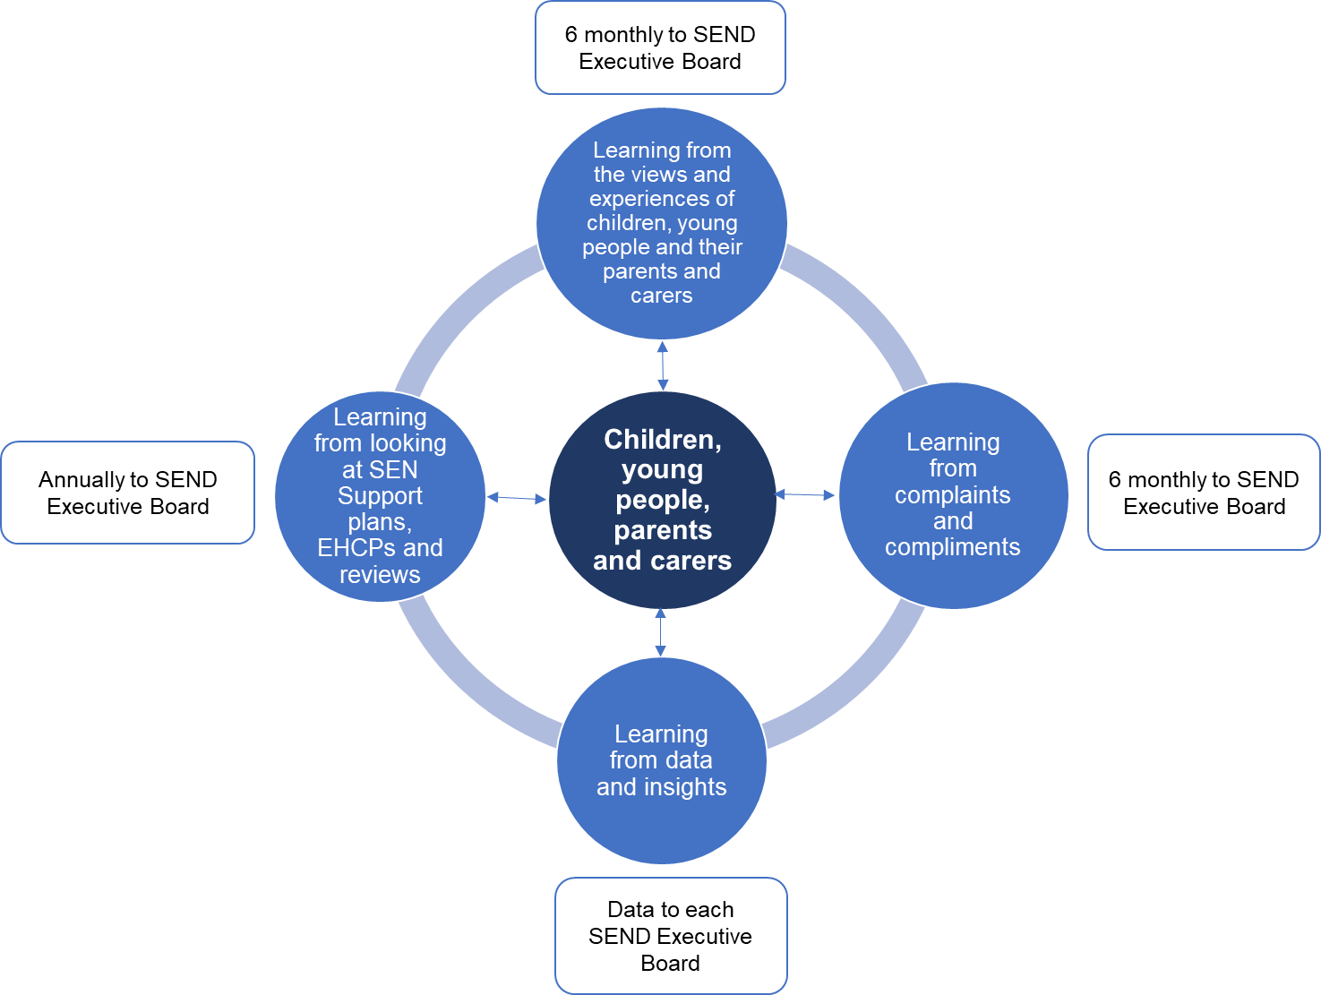

Development Plan
We will continue review the effectiveness of this framework and make any changes that will help improve SEND provision further.

11. Glossary

EHCP – an Education, Health and Care Plan the package of support in place to meet the identified needs, outcomes, views and wishes of a child or young person with Special Educational Needs.

EHC Needs Assessment – a detailed look at the special educational needs of a child or young person and the type of support required to meet them.

EHC Review – a review of progress against the outcomes and objectives described in the current EHCP. This includes the views and wishes of children and their families.

SENCO – a Special Education Needs Coordinator.

SMART outcomes – Outcomes that are Specific, Measurable, Achievable, Realistic and Timely

All strategies and polices are available on our SEND Local Offer: SEND related policies and strategies (newcastlesupportdirectory.org.uk)
For more information about the graduated response please see our SEND Local Offer: Newcastle SEND Advice and Support Allocation Panel (SEN ASAP) (newcastlesupportdirectory.org.uk)
This document is available on the School Effectiveness page of our SEND Local Offer: School Effectiveness SEN (newcastlesupportdirectory.org.uk)
All strategies and polices are available on our SEND Local Offer: SEND related policies and strategies (newcastlesupportdirectory.org.uk)
This Getting it Right together framework and the annual reports are available on our SEND Local Offer: SEND related policies and strategies (newcastlesupportdirectory.org.uk)
A summary of our SEND Outcomes framework and Joint Commissioning Strategy is available on our SEND Local Offer: SEND related policies and strategies (newcastlesupportdirectory.org.uk)
The Joint Commissioning Strategy is on the SEND Local Offer: SEND related policies and strategies (newcastlesupportdirectory.org.uk)

