Restaurant Deals and Vouchers

Top restaurant MoneySaving hacks & tricks
Meerkat Movies & Meals 2for1 cinema AND restaurants
How to get a year's 2 for1 from £1ish Meerkat Movies & Meals trick - MoneySavingExpert

McDonald's food hacks
Including £2.70 off 'McChicken sandwich' McDonald's MoneySaving hacks (moneysavingexpert.com)
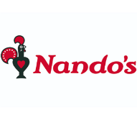
Nando's MoneySaving tips & hacks
It rarely does deals but we've a list of ways to help you save 10 'cheapy' Nando's MoneySaving tips & hacks (moneysavingexpert.com)

Other top restaurant deals
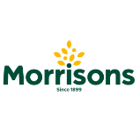  Feed a family of four for £10 at Morrisons Café - Including two adult meals, two kids meals and drinks Morrisons Discount Codes July 2022 - MoneySavingExpert | 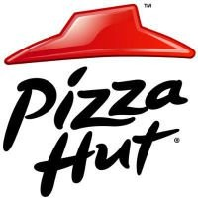  Pizza Hut £9 UNLIMITED lunch buffet - Eat as much pizza, pasta & salad as you like for a set price  Pizza Hut Discount Codes July 2022 - MoneySavingExpert
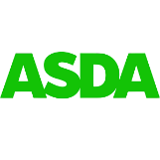  Asda Cafés kids eat for £1  No minimum spend required  Asda Discount Codes July 2022 - MoneySavingExpert | 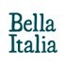  Bella Italia kids eat for '£1' - Valid when adult buys a main meal. Mon-Thu, 4pm-6pm only Bella Italia Vouchers, Discount Codes & Offers - MoneySavingExpert
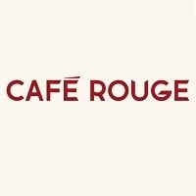  Café Rouge kids eat for '£1'  When a full-price adult main is purchased. Excludes Saturdays. Café Rouge Vouchers & Discount Codes - Money Saving Expert | Dobbies kids eat for ‘free’  Valid when an adult main meal is purchased Dobbies Discount Codes July 2022 - MoneySavingExpert
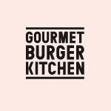  Gourmet Burger Kitchen kids eat for 'free' - Every day with the purchase of adult main meal GBK Discount Codes, Promo & Offers - Money Saving Expert | 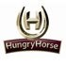  Hungry Horse 'free' kids' breakfast  When an adult buys a breakfast from £3.49 Hungry Horse Discount Codes, Promo & Offers - Money Saving Expert
Hungry Horse kids eat from £1  Mondays only. When adults buy a main meal Hungry Horse Discount Codes, Promo & Offers - Money Saving Expert | 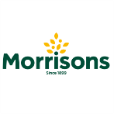  Morrisons Café kids eat 'free'  Every day with purchase of adult main meal Morrisons Discount Codes July 2022 - MoneySavingExpert
Sizzling Pubs kids eat for '£1'  Every Monday to Friday, 3 - 7 pm you can get a kids’ main for just £1 with the purchase of an adult meal.  Sizzling Pubs Discount Codes July 2022 - MoneySavingExpert | 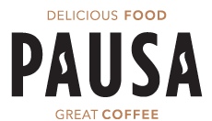  From June 27th 2022 children get 1 mini main, 2 snacks and a drink FREE with every £4 spend at Pausa Cafes at Dunelm stores.

Kids eat free all day, every day with paying adults at Preto. This offer is open to children up to 10 years old - This is an ongoing offer! | Purchase one great value £9.50 breakfast at any Whitbread Inns pub or restaurant and two kids under 16 eat for FREE
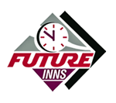  At Future Inns, under 5's always eat for free with any adult meal. During the school holidays, it's extended to under 12's. | Two children under 16 years old can get a free breakfast every day with one paying adult!
Two children get free breakfast with one paying adult! It has also been reported that if you sign up for their newsletter they send out a code for kids to eat free, but I haven't personally tried this. | The same as Beefeater, you can get two children free breakfast with one paying adult! It has also been reported that if you sign up for their newsletter they send out a code for kids to eat free, but I haven't personally tried this.
Kid’s eat free from 3pm-5.30pm, Monday to Thursday until 1st September 2022 | Kids eat FREE every Sunday for every £10 spent by an adult.
Kids under 10 can eat free from the children’s menu when grown-ups order mains from the main menu. Available every day 12pm - 5pm. | From 12th July to 3rd September, kids can enjoy any meal from the children's menu for 95p, or £1.50 for a combo meal which includes one hot meal, jelly, a soft drink, and a piece of fruit.

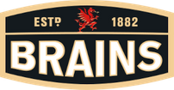
Children can eat for £1 with any adult main. The offer is valid Wednesdays only but all day.

Takeaway food & drink deals

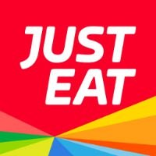  Just Eat 10%-30% off selected takeaways  Check for a red flag to see if your local is included Just Eat Discount Codes July 2022 - MoneySavingExpert | 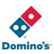  Domino's 2for1 pizzas (Tuesdays)  Order online, in-store or over the phone  Domino's Discount Codes July 2022 - MoneySavingExpert

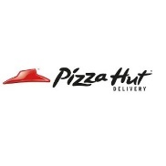
Pizza Hut Delivery 2for1 (Tuesdays)
Online or phone code for delivery or collection Pizza Hut Discount Codes July 2022 - MoneySavingExpert

Preto

Whitbread Inns

Future Inns

Table Table

Beefeater

Brewers Fayre

Morrisons
Kids eat free all day, every day in Morrisons cafes nationwide, daily from 3pm with every adult meal over £4.99.

YO! Sushi

The REAL Greek

Angus Steakhouse

Hungry Horse
Kids eat breakfast free when accompanied by a paying adult, all day every day through the school holidays from 9am - 12pm.

Restaurants where Kids eat for £1 during May Half Term 2022

IKEA

SA Brains Pubs

Bella Italia
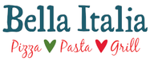
Children can eat for £1 with any adult main. The offer is valid between 4-6pm Monday to Thursday.

Sizzling Pubs

Café Rouge

