Special Educational Needs and Disabilities Outreach Service (SENDOS)

Communication and Interaction Team – Transition Support

Graduated support is provided **based on the needs** of the individual child / children. The support to be provided is discussed / agreed with school staff.

**Transition to a new year group**

This support tends to be provided to children who are already known to our team, or as part of a bigger piece of work.

Support could include:

* General advice and information about transition to a new year group.
* Individual advice / recommended strategies to support transition for an individual / small group.
* Advice / support to develop materials to support transition e.g. transition booklet, social stories / photo books.
* Attendance at transition meetings.
* Allocated support from SEN Support Worker.

**Transition to a new setting**

Support could include:

* General advice and information about transition (e.g. ‘Top tips’ for transition information sheet).
* Individual advice / recommended strategies to support transition for an individual / small group.
* Advice / support to develop materials to support transition e.g. transition booklet, social stories / photo books.
* Attendance at transition meetings.
* Allocated support from SEN Support Worker.
* Individual / small group sessions with pupils in their current / new school (e.g. discussion of worries and questions about new school, co-produced pupil profile to be shared with new school).
* 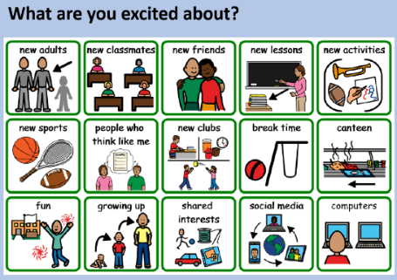Transition ‘programme’ to be delivered by school, to small groups / whole classes (series of lesson plans / suggested content to be covered).

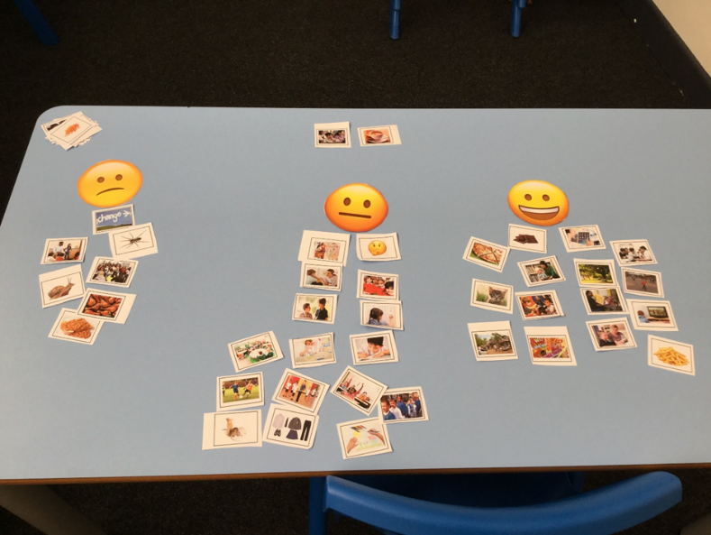

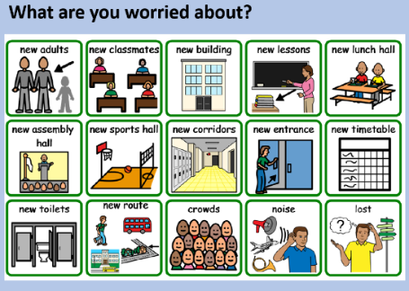

**Case Study – Imran, moving from first school to middle school**

* Autistic, anxious around friendships and relationships with school staff (especially with any perception that he might be ‘doing the wrong thing’).
* Challenges around executive function – planning, organisation, finding way round school
* Sensory needs – consideration of noise, busy corridors, lunch hall.
* Worried about break and lunch time in terms of socialising with peers - ‘I’m not sure what to do at breaktime’.

**Support from Communication and Interaction Team**

* Initial discussion with first school staff – Imran identified as a child likely to need direct support from a specialist teacher.
* Specialist teacher liaison with middle school – together, developed a transition booklet (see example). Specialist teacher provided template and advised on content – middle school staff wrote content specific to their school.
* Specialist teacher delivered transition sessions in first school – talking mat to identify strengths and challenges, discussion around what Imran was excited about / what Imran was worried about, transition booklet (e.g. learn how to use timetable, map and planner; discussion of unstructured times and how these work; photos of new school areas; photos / map / instructions showing how to get into school each morning; prompt cards to problem solve some common worries).
* Development of pupil profile based on strengths, challenges and worries. This was shared with staff in Imran’s new school.
* Attendance at transition meeting with current school staff, new school staff and parents
* Visit from specialist teacher in new school – use of talking mat and AET Pupil Consultation on What Makes a Good School document to scaffold discussion around experience of new school. Identification of what was going well, and any challenges for Imran. Information / suggested strategies shared with school staff.

**Impact**

* Imran felt more prepared and less anxious about going to middle school; he felt listened to and like his concerns were addressed.
* At his follow up session in his new school, Imran rated school as 5 / 5; he was able to identify what was going well for him, and what he found challenging in his new setting, which allowed these things to be addressed early on in his new school experience.

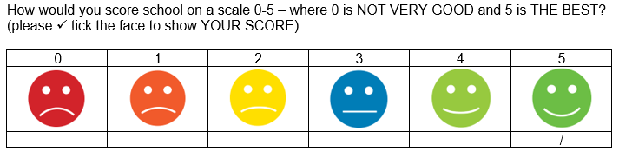

* Staff in Imran’s new school had a good understanding of Imran’s strengths and challenges and the appropriate support needed to address these.