Case Study – Secondary school Communication and Interaction (Autism) Needs
Amy Anderson (SEND Outreach Service/recent secondary school SENCo experience)
Transition
Working with a child who has high levels of anxiety related to transition to high school. Child has a very supportive family who have a good working relationship with school and communicate regularly.
Presenting concerns for school:
- Academically able and sets very high standards for themselves but at present cannot always access learning in the classroom due to anxiety
- Is not always able to attend school
- Worries about using strategies e.g. pass to leave lessons in case they get into trouble.
- Concern they may become a school refuser during the transition period
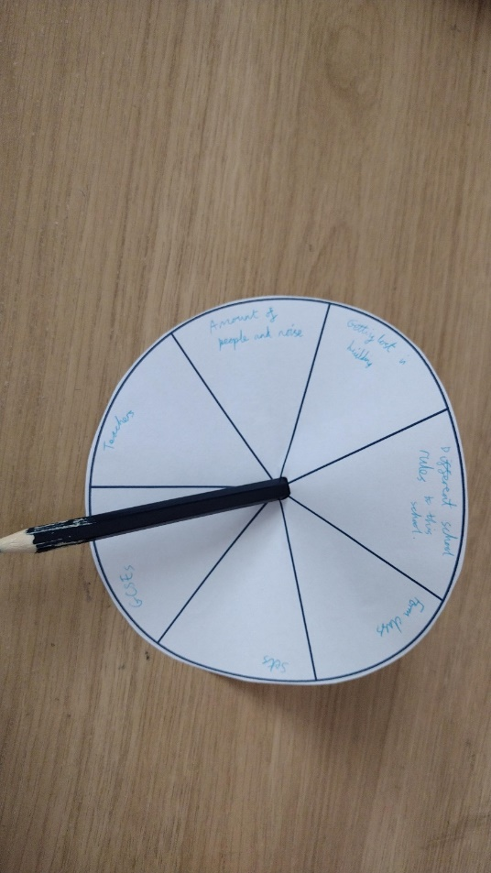
An important aspect of transition was to collect views – this highlighted some unknowns about the new school which were causing anxiety. We created a worry wheel where the child wrote down the things they were worried about or had questions about, and we spun it and discussed each section. These worries were then unpicked further, and information could be gathered from the new school about each topic. The information gathered was then shared with the child alongside being clear about what support would be in place in September (agreed with the child) and what the visits to the new school would look like.

How I used the service previously - Case study one
- Child presenting with SEMH needs. Significant deterioration in presentation after initial transition to our school.
- Already identified in primary school is requiring support round SEMH
- Quickly developed behaviours we had not experienced e.g. unable to leave older brother, fixing on other students and sitting in their class, walking a route around the school building repeatedly. When interested in the topic could access learning with little support.
- Bespoke provision made in school, e.g., referral to CYPS, safe space, mentor first and last lesson and available throughout the day, reduced demands, LSA support, fostered positive peer role models, thrive and wrap approaches, focus on relationships with adults in school.
- Presentation did not improve, and child began to become isolated. We felt we needed it expertise in the areas of social, emotional, mental health.
- Applied for IPS which was granted. Used IPS funding to partly fund a commissioned short-term placement at Newcastle bridges school whilst EHCP was applied for.
- Placement provided the young person for the first time in a long time with success. They thrived in the environment they had staff who helped them unpick their current needs and what was not working in our environment in order to support the transition back. On a visit to the young person, they smiled for the first time in a long time they talked passionately about the work that they were doing in forest school, for example. We now feel we have a better understanding of their needs and can approach the support from a structured and nurturing way moving forward. We also have a better understanding of how to structure conversations to collect views form the child using the strategies employed in Newcastle Bridges School.

How I used the service previously – Case study two
- Child with history of anxiety and school-based avoidance.
- Provision was created to re-engage back in school, but child struggled to articulate reasons why. Created a bespoke offer within our internal SEMH provision where staff had expertise and trauma informed responses, WRAP and THRIVE. Incorporated art, which was a passion, offered reduced hours initially, structured activities based on interests and developed relationships.
- Had good relationship with attendance officer which resulted in three weeks attendance. Initially presented very well in school but presentation deteriorated, and child was becoming distressed during transition from home to the car.
- Made referral to ASAP and we were allocated Educational Psychology support.
- That was an invaluable, one of the first things that that Educational Psychologist asked us was what with the child's strengths were. This brought the conversation away from attendance data and what we had done and back to the child at the centre. We needed to change the way we were thinking and approaching our response to his needs. This child had some brilliant strengths he was a gifted artist, he had really good social communication skills, he had friends who were excited to see him on the corridor, he had a good sense of humour. We also learned about anxiety and how this can affect a child being able to access provision.
- One of the things that the Educational Psychologist suggested was writing a letter to the child from the member of staff the child had identified they worked well with when accessing our provision. When mum attended a meeting, she talked about the letter that he’d received how it enjoyed reading it. Whilst this didn’t result in the child being in school initially, it kept the connection to school and was the first step in engaging the child back into our school community.

