Newcastle
SEND Governance Arrangements
Terms of Reference

Updated May 2022

Contents:

Newcastle Local Area SEND Executive Board Terms of reference 3
Workstream 1: SEND Joint Intelligence and Commissioning 8
Workstream 2: Voice 11
Workstream 3: Getting it right together: 13
SEND Quality Assurance 13
Workstream 4: Preparing for Adulthood 15
Collaborative Newcastle: SEND Forum 17

Newcastle Local Area SEND Executive Board Terms of reference

Vision
Newcastle is a great place to live grow up and fulfil your potential. We want our children and young people with SEND to:
- Be safe and feel safe
- Be happy and feel included
- Be healthy and well cared for
- Be ready for adulthood
- Be heard in decisions about their lives and the city.

For those with SEND this means that, as a local area, we are committed to:
- creating a fully inclusive, partnership-driven system, where children and young people with SEND will have all of their needs identified and met in a timely manner
- true co-production with children, young people and their parent/carers
- maintaining high expectations for all children and young people and, through providing the right support at the right time, enabling them to have a successful future and contribute to their communities.

Purpose of the Newcastle Local Area SEND Executive Board (the Board)
The Board will:
- be responsible for all Council and health partners’ leadership and management matters affecting the implementation of the local area SEND strategy
- take responsibility for holding partners to account for the work that they do in respect of SEND
- strive to achieve improvement in outcomes for our children and young people with SEND
- ensure delivery of the agreed actions on the accelerated progress plan in 2021/2022.

Key areas of work
To achieve this commitment as a local area, the Board will ensure that there is:
- a shared, co-produced strategic plan including all stakeholders and partners in its development
- consistency in early identification and accessibility of specialist support and interventions at a stage which maximises the impact of work on individuals or on groups sharing common issues
- high quality provision and sufficient capacity to meet the needs of children and young people so that they remain part of their local community as far as possible
- provision which is agile and responsive so that it continuously and effectively meets the needs of children and young people with SEND
- ensuring that we have a clear understanding of the needs of our children and young people with SEND and that we have appropriate provision in place to meet their needs
- sufficient in-reach and out-reach capacity to support all learners with SEND
- sustainable expertise in all schools and settings through wider workforce development
- complete clarity and transparency about services, protocols and processes as part of the local offer, including effective quality assurance systems to inform joint commissioning arrangements
- a high level of confidence in the system.

Membership
Board Member | Role / Organisation
- Judith Hay (joint chair)  - Jackie Cairns (joint chair)  - Deanne Taylor  - Marie Leddy  - Helga Charters  - Mark Anderson  - Jenny Ellis  - Jane Melvin  - Anna Williams  - Jonathan Jamison  - Jayne Forsdike  - Michelle Stamp  - Chris Rollings  - Martin Wood  - Steve Gittins  - Rachel Gibson  - Andrew Graham | - Director Children, Education and Skills (NCC)  - Director for Newcastle System, (CCG)  - Head of SEN & Disabilities, (NCC)  - Chair of Parent Carer Forum  - Associate Director of Nursing (CYP), Newcastle upon Tyne Hospitals (NUTH)  - Designated Medical Officer, (NewcastleGateshead CCG)  - Designated Clinical Officer, (NewcastleGateshead CCG)  - Directorate Manager Great North Children’s Hospital and Community Services  - Associate Director Central Locality Community Services (CNTW)  - Assistant Director - Adult Social Care and Integrated Services (NCC)  - Assistant Director of Children’s Social Care, NCC  - Consultant in Public Health, NCC  - Representative from Specialist Schools  - Representative from Mainstream Secondary Schools  - Chair of SEND Sub-Group  - Representative of the post 16 sector, Newcastle College  - Principal Adviser Children Education and Skills, Commissioning and Strategy (NCC)
Governance
The SEND Executive Board is the decision-making body for all issues relating to children and young people aged 0-25 with SEND and will:
- report to the ‘A Place for Children Board’, Newcastle Council’s Cabinet and the CCG Governing Body
- receive operational updates and reports from the local area SEND workstreams

The governance structure and workstreams are set out below:

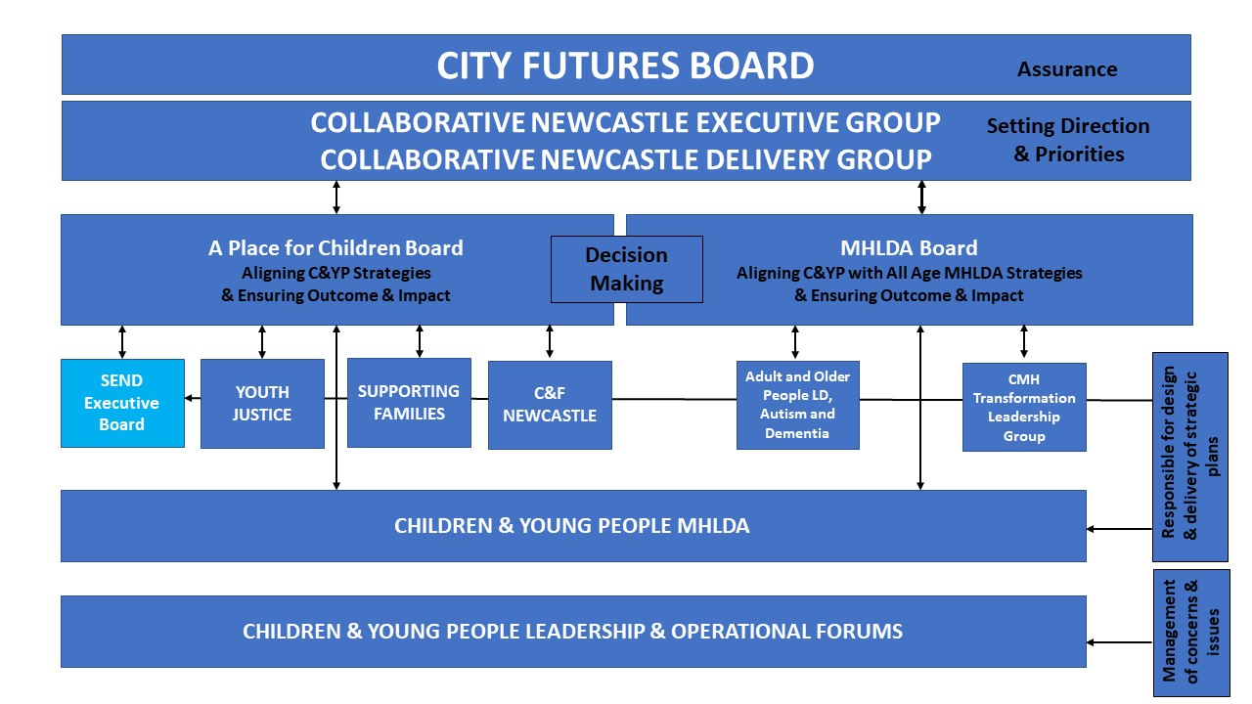
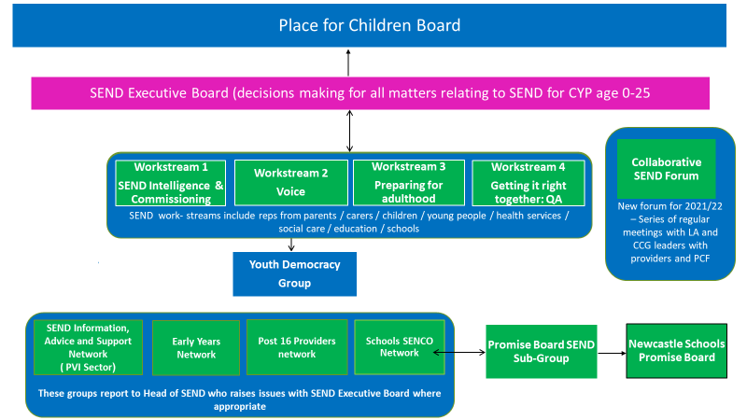

Decision making
The Board brings together senior decision makers from across the local area and with the seniority that enables them to speak with authority and commit ‘in principle’ on matters of commissioning, policy and practice. Formal decisions are subject to agreement by the Newcastle Local Area SEND Executive Board, and each organisation’s normal governance processes.
As a minimum, decisions will require representation from the CCG and Local Authority. If no agreement can be reached major issues of contention can be referred to the Place for Children’s Board.

If members are unable to attend, they should identify a deputy to represent them. The Board and Workstreams require at least 50% of attendees to be quorate. Wherever possible the workstreams will reach agreement by consensus. If the workstream is unable to reach a decision, they will defer the matter to the Head of SEND, who will decide whether to escalate to the Local Area SEND Executive Board.

Meetings
- The Director, Children, Education and Skills, NCC and the Director for Newcastle System, CCG, jointly Chair the SEND Executive Board.
- Support for the meeting will be provided by Newcastle City Council.
- Meetings will be held every two months for two hours at Newcastle Civic Centre or remotely via Microsoft Teams as appropriate.
- Board meetings will not be open to the public.
- All members of the Board are expected to attend meetings as a matter of priority. When attendance is not possible, an appropriate and informed deputy should attend instead.
- Other officers (such as Project Managers, workstream leads) and wider partnership and stakeholder members may be required to attend as determined by the Chair.
- All members of the Board, and other attendees to Board meetings, are expected to respect the privacy and confidentiality of the meetings and all associated papers.
- Papers for the meetings will be distributed one week in advance of each meeting.
- Following each meeting a SEND Executive Board briefing note will be distributed to stakeholders and published on the Local Offer and Services to Schools.
- The Chair will approve any and all documentation that may be required for reporting purposes to other groups, or entry into the public domain.
- The above may be amended as appropriate or necessary by decision of the Chair.

Meeting dates 2021/2022
- 13 October 2021
- 15 November 2021
- 17 January 2022
- 14 March 2022
- 16 May 2022
- 11 July 2022
Operational workstreams
Operational workstreams have been established to ensure the business of the Board can be effectively managed and its role and purpose achieved. There are four workstreams:
- SEND Intelligence and Commissioning
- Voice
- Getting it right together: SEND Quality Assurance
- Preparing for adulthood (to be re-established 2022)

Workstreams will:
- provide specialist advice, challenge and support to the Board
- provide regular reports to the Board
- act as the champion for community interests (providers, parents/carers, children and young people)
- be identified from existing groups (e.g. Parents/Carer Forum, Health Watch)
- vary according to the needs of the Board
- have terms of reference and membership in line with the Board’s priorities.

Additional groups may be established which will be task focused and have a short timescale, dependant on the work to be achieved.

We have also established a SEND Collaborative Forum, a space where senior commissioners and from the Local Authority and CCG meet with providers and parents and carers on a regular basis.

The terms of reference for these workstreams and the SEND Collaborative Forum are attached to this document.

Review
The Terms of Reference are effective from May 2022 and will be reviewed in May 2023 or until terminated by agreement between the parties.

Workstream 1: SEND Joint Intelligence and Commissioning

Purpose of workstream
The purpose of the Newcastle SEND Joint Intelligence and Commissioning workstream will be to:
- align joint planning, delivery and performance management of commissioning for SEND services in Newcastle, ensuring close cooperation between education, health services and social care
- ensure that commissioning decisions are joint decisions that meet the needs of children, young people and their families, both now and in the future, and that decisions are based on a joint understanding of need through integrated strategic needs assessments
- deliver and monitor progress of the SEND joint commissioning strategy for Newcastle
- develop market development strategies in relation to commissioning priorities, policy and practice
The workstream will provide a platform for health, education and social care partners to develop joined up strategic and organisational responses for children and young people with SEND and effectively share data to develop a better local understanding of the issues faced and inform joint commissioning decisions.
Meetings
- The workstream will meet on a quarterly basis.
- All members of the workstream are expected to attend meetings, and when attendance is not possible, an appropriate and informed deputy should attend instead.
- All members of the workstream and other attendees to meetings are expected to respect the privacy and confidentiality of the meetings and all associated papers.
- Papers for the meetings will be distributed one week in advance of each meeting.

Accountability
The workstream will be accountable to, and report to the Newcastle Local Area SEND Executive Board.
Decision Making
The workstream is a collaboration which brings together partners from education, health and care to identify and deliver joint commissioning of services for children and young people with SEND.
The workstream is not a decision making body and therefore whilst members will have seniority that enables them to speak with authority and commit ‘in principle’ on matters of commissioning, policy and practice, it is understood that formal decisions are subject to agreement by the Newcastle Local Area SEND Executive Board, and each organisation’s normal governance processes.
If unable to attend, Workstream members should identify a deputy to represent them. The Workstream requires at least 50% of attendees to be quorate. Wherever possible the workstreams will reach agreement by consensus. If the workstream is unable to reach a decision, they will defer the matter to the Head of SEND, as it may require escalation to the Local Area SEND Executive Board.
Wherever possible the workstream will reach decisions by consensus. If the workstream is unable to reach a decision, they will defer the matter to the Local Area SEND Executive Board.
Confidentiality
Papers considered to contain confidential information (which might include, for example, personal identifiable or commercially sensitive information) will be clearly marked as ‘confidential – for restricted circulation’ in accordance with Newcastle City Council’s Information Asset Clarification Policy.
Any breaches of confidentiality will be dealt with in accordance with the employing organisation’s policies and procedures.

Dealing with sensitive matters and conflicts of interest
The workstream may at times have to consider confidential information on matters related to commissioning, procurement or performance. Members are individually required to declare known conflict of interests prior to commencement of meetings. The workstream will determine whether or not any declaration necessitates exclusion from discussion on specific issues.

Information management and access to information
Each member of the workstream has responsibility for processing all requests for information (i.e. Freedom of Information Act 2000 and Data Protection Act 1998) directed at their organisation regarding their specific role and the information they hold. Information held on behalf of the workstream for the purpose of the conduct of workstream’s business will be by Newcastle City Council but requests for this information can be processed by any workstream member. If a member of the workstream is unable to process a request as they do not hold the information but know that a partner on the workstream does, then this request should be forwarded to Newcastle City Council to coordinate. Please note that information provided to the workstream by other partners will also be covered by the Freedom of Information Act, whether or not that partner is a public authority for the purposes of the Act.
For the purpose of the Data Protection Act 1998 the notification of Newcastle City Council, is sufficient to cover the activities and information held by the workstream. It is therefore imperative that all personal information is processed according to the principles of the Data Protection Act 1998.
RESTRICTED papers will only be made available to workstream members. However, these papers are subject to the Freedom of Information Act 2000 and may be disclosed in response to an information request, subject to the application of exemptions.

Review
The Terms of Reference are effective from May 2022 and will be reviewed in May 2023 or until terminated by agreement between the parties.

Membership
The workstream will be co-chaired by officers responsible for commissioning from Newcastle City Council and Newcastle Gateshead CCG/NECS. Opportunity to re-elect the chair(s) will be offered on an annual basis.
Members | Role / Organisation
Andrew Graham | Principal Adviser Children Education and Skills, Commissioning and Strategy (NCC)
Barbara Stanton (co-Chair) | Commissioning Service Delivery Manager, (NHS North of England Commissioning Support Unit)
Jenny Ellis | Designated Clinical Officer, CCG
Linzi McMeekin | SEND Commissioning Lead, (NCC)
Sarah Ledger | Performance Analyst (NCC)
Linda Steel | Placement Planning Officer (NCC)
Rachael Riley | Service Improvement /Lead, Children’s Social Care (NCC)
Rhonda Eagle/  Becky Polito | Commissioning and Procurement Lead Specialist, Collaborative (NCC)
Deanne Taylor | Head of SEND to attend when required
Neil McCarthy/Bob Gaffney | Information Analysis Manager (NHS North of England Commissioning Support Unit)
Jill Bauld | SEND Voice Lead, (NCC/CCG)
TBA | Representative from a School
TBA | Representative from Parent Carer Forum
TBA | Representative from Adult Social Care (NCC)
Jane Bayley | SEND SAR Team Manager
The Group may request other advisors to attend on an ad-hoc basis.
Meeting dates 2021/22
- 28/09/2021
- 16/12/2021
- 26/04/2022
- TBA

Workstream 2: Voice

Purpose of workstream
- To make sure that all SEND services build in a ‘getting it right together’ approach
- To make sure that there is clear and transparent communication back to children and young people (CYP) and Parent/Carers (P/Cs)
- To champion simple and inclusive ways of communicating
- To make sure that there are a lot of different ways for CYP and P/Cs to influence decisions made about the services they use
- To challenge for change and support services to work differently and share good practice
- To act as a connector to and from decision makers, C&YP and P/Cs
- To ensure the Local offer is fit for purpose and delivers what our families need

Key areas of work
The workstream will:
- provide specialist advice, challenge and support to the Board
- provide regular reports to the Board
- act as the champion for parents/carers, children and young people and wider communities of support
- support the voice of the Parent carer Forum
- support the voice of CYP by establishing a SEND CYP network
- raise the profile of the views of CYP and P/Cs- we will do this by delivering an annual calendar of events and other targeted work (designed and delivered together) (see next bullet points)
- Young People’s surveys
- Children’s Workshops
- 16- 25s Workshops and surveys
- Early years workshops
- Parent/ Carer surveys, events and workshops
- Development of the Local Offer
- EHC Plans
- Commissioned work i.e. Speech and Language Therapy (SALT), Occupational Therapy (OT), etc.
- Short Breaks service
- SEND Improvement Plan- working with parent/ carers and CYP to make services the best they can be
Accountability
The workstream will be accountable to, and report to the Newcastle Local Area SEND Executive Board.
Decision Making
The workstream is a collaboration which brings together partners from the education, health and care to identify and deliver joint commissioning of services for children and young people with SEND. The workstream is not a decision making body and therefore whilst members will have seniority that enables them to speak with authority and commit ‘in principle’ on matters of commissioning, policy and practice, it is understood that formal decisions are subject to agreement by the Newcastle Local Area SEND Executive Board, and each organisation’s normal governance processes.
If unable to attend, Workstream members should identify a deputy to represent them. The Workstream requires at least 50% of attendees to be quorate. Wherever possible the workstreams will reach agreement by consensus. If the workstream is unable to reach a decision, they will defer the matter to the Head of SEND, as it may require escalation to the Local Area SEND Executive Board.
Wherever possible the workstream will reach decisions by consensus. If the workstream is unable to reach a decision, they will defer the matter to the Local Area SEND Executive Board.
Membership
Members | Role / Organisation
Jill Bauld (chair / minutes) | SEND Voice Lead – (CCG and NCC)
TBA | SEND Youth Voice Trainee – YP Rep (NCC)
Philip Blackburn | SEND Youth Voice Trainee – YP Rep (NCC)
Rachel Rudd | VCS - Skills for People Rep
TBC | VCS – Children North East
Marie Leddy | Chair - Parent Carer Forum
Lyn Brown | Parent/Carer
Christianne Ormson | PPI and Community Development Lead (CCG)
Deanne Taylor | Head of SEND to attend when required (NCC)
Lara Lillico | Educational Psychology Service Manager (NCC)
Sarah Francis | Information and Advice Support Officer, SENDIASS (NCC)
Kay Harrison | PFA Lead (NCC)
Angela Gemmell | Service Manager SEND Outreach Service (NCC)
Sue Alexander/ Jill Tough | SEND School Effectiveness SEND Adviser (NCC)
Clare Stuart | Resource Worker, Fostering (NCC)
Rachel Slee | SEND Nurse Adviser (CCG)
Ben Dickenson | Child Friendly City Lead (NCC)
Ann Banks (as needed) | SEND Service Improvement Lead (NCC)
Meeting dates 2021/22
- 20/10/2021
- 19/01/2022
- 11/05/2022
- TBA September 2022

Workstream 3: Getting it right together:

SEND Quality Assurance

Purpose of workstream
The Getting it Right Together: SEND Quality Assurance workstream will work in partnership with families, young people and partner agencies across education, health and social care to:
- make sure children and young people benefit from consistent high-quality Education, Health and Care Plans (EHCPs) that are person centred and easily understood by everyone
- improve the experiences of children and young people with SEND and their parents and carers
- improve outcomes for children and young people with SEND
- draw together learning from all the areas described in the framework, and to be responsible for sharing good practice, making improvements where needed and reviewing the impact of these changes.

Key areas of work
The workstream will work with families, young people and partner agencies across education, health and social care to:
- ensure a strategic and coordinated approach
- coordinate single agency and multi-agency audits of EHCPs and annual reviews
- co-produce a Learning Log which details learning, actions, timescales, impact and next steps and share learning, actions and impact with families and partner agencies
- set task and finish groups in response to identified actions and receive feedback from these groups
- provide the following regular reports to the Board:
- Annual – Learning from EHCPs and annual reviews
- 6 monthly – Learning from children, young people, parents and carers
- 6 monthly – Learning from complaints and compliments
- Every SEND Executive Board – Local Area Outcomes Framework

Accountability
The workstream will be accountable to, and report to the Newcastle Local Area SEND Executive Board.

Decision Making
The workstream is a collaboration which brings together partners from the education, health and care to identify and deliver joint commissioning of services for children and young people with SEND. The workstream is not a decision making body and therefore whilst members will have seniority that enables them to speak with authority and commit ‘in principle’ on matters of commissioning, policy and practice, it is understood that formal decisions are subject to agreement by the Newcastle Local Area SEND Executive Board, and each organisation’s normal governance processes.
If unable to attend, Workstream members should identify a deputy to represent them. The Workstream requires at least 50% of attendees to be quorate. Wherever possible the workstreams will reach agreement by consensus. If the workstream is unable to reach a decision, they will defer the matter to the Head of SEND, as it may require escalation to the Local Area SEND Executive Board.
Wherever possible the workstream will reach decisions by consensus. If the workstream is unable to reach a decision, they will defer the matter to the Local Area SEND Executive Board.

Membership
Members | Role / Organisation
Chair, Deanne Taylor | Head of SEND, NCC
Jane Bayley | SEND Assessment, Provision and Review Service Manager, NCC
Jill Bauld | SEND Voice Lead, NCC/CCG
Jack Hussey | SEND Voice trainee, NCC/CCG
Philip Blackburn | SEND Voice trainee, NCC/CCG
Marie Leddy | Parent/Carer
Kirsty Stuart | Parent/Carer
Sarah Francis | Manager, Newcastle SEND Information, Advice and Support Service, NCC
Elise Houston | Principal Social Worker, Children’s Social Care
Jenny Ellis | SEND Specialist Nurse Advisor C&YP, CCG Designated Clinical Officer, (NewcastleGateshead CCG)
Becky Dunn | Workforce Development and Customer Relations Manager, NCC
Kay Harrison | PFA Lead, NCC
Sarah Ledger | Performance Analyst, NCC
Sue Alexander | SEND School Effectiveness SEND Adviser, NCC
Lianne Dixon | Early Years Advisory Teacher and Area SENCO, NCC
Hazel Newstead | Early Years SEND Lead, SEND Outreach Service, NCC
Steve Gittins | Chair SEND Sub-Group
Amy Anderson | Director of Additional Educational Needs, Benfield School Representing the secondary sector
Rachel Gibson | Post 16 representative, Newcastle College
June Ball | SENCO, Representing Specialist Providers
Heather Dryden | ​Nurse Specialist Children with Additional Needs, NUTH
Meeting dates 2021/22
The Getting it Right Together: SEND Quality Assurance Group meet termly, 2021/2022
dates as follows:

- 14/10/2021
- 17/02/2022
- 17/06/2022

Workstream 4: Preparing for Adulthood

Purpose of workstream
The PFA workstream will work in partnership with families and young people to embed preparing for adulthood from the earliest years to ensure that young people with SEND can live as independently as possible as adults.

Children and young people will be supported to develop life skills to enable them to:
- secure suitable employment, higher education and other work options
- live as independently as possible which includes having access to a range of housing options
- travel independently
- have good health and mental well being
- develop friendships, relationships and be part of the community
Key areas of work
The workstream will work with families and young people to:
- ensure a strategic and coordinated approach to the Preparing for Adulthood agenda across Newcastle
- co-produce an improvement plan
- set task and finish groups and receive feedback from these groups
- review and learn from case work
- provide specialist advice, challenge and support to the Board
- provide regular reports to the Board
- act as the champion for community interests (providers, parents/carers, children and young people)
Accountability
The workstream will be accountable to, and report to the Newcastle Local Area SEND Executive Board.
Decision Making
The workstream is a collaboration which brings together partners from the education, health and care to identify and deliver joint commissioning of services for children and young people with SEND. The workstream is not a decision making body and therefore whilst members will have seniority that enables them to speak with authority and commit ‘in principle’ on matters of commissioning, policy and practice, it is understood that formal decisions are subject to agreement by the Newcastle Local Area SEND Executive Board, and each organisation’s normal governance processes.
If unable to attend, Workstream members should identify a deputy to represent them. The Workstream requires at least 50% of attendees to be quorate. Wherever possible the workstreams will reach agreement by consensus. If the workstream is unable to reach a decision, they will defer the matter to the Head of SEND, as it may require escalation to the Local Area SEND Executive Board.
Wherever possible the workstream will reach decisions by consensus. If the workstream is unable to reach a decision, they will defer the matter to the Local Area SEND Executive Board.
Membership
Members | Role / Organisation
Chair, Kay Harrison | PFA Lead, NCC
Sarah Francis | Manager SENDIASS, NCC
Jackie Gates | SEND Manager, Newcastle College
Bill Pottinger | Team Leader Children with Disabilities Team, NCC
TBA | Service Manager LDA & Mental Health Services, NCC
Karen Hamilton | Headteacher, Sir Charles Parsons School
Samantha Riley | Adult Learning and Skills Manager, NCC
Mark Wakenshaw | Parent/Carer representative
Jill Bauld | SEND Voice Lead, NCC/CCG
Nicola Jones | SEND Transport Officer, NCC
Jane Bayley | SEN SAR Team, NCC
Rachel Slee | SEND Nurse Adviser, CCG
TBA | Representative from Community Sports and Parks
TBA | Representative from CCG
TBA | Representative from mental health services
Denise Bailey | SEN Caseworker
Deanne Taylor | Head of SEND to attend when required
Sue Alexander (as required) | SEND Advice, NCC
Children and young people | We will work with a wide range of young people across the city including young people from:  - City Learning and other study programmes  - Children North East’s FAB group  - School councils  - Voices for choices  Members of the PFA group are expected to discuss issues raised, with their groups of young people
Meeting dates 2021/22
The group will meet termly with other task and finish groups as required.

The post-16 providers group will meet as follows:

Collaborative Newcastle: SEND Forum

Getting it right together to improve SEND Services in Newcastle

January 2022

Contents
Newcastle Local Area SEND Executive Board Terms of reference 3
Workstream 1: SEND Joint Intelligence and Commissioning 8
Workstream 2: Voice 11
Workstream 3: Getting it right together: 13
SEND Quality Assurance 13
Workstream 4: Preparing for Adulthood 16
Background 20
Objectives of the Newcastle Collaborative SEND Forum 20
Meetings and membership 21
Core Group 21
Service Leads Group 22
Speech and Language Therapy 22
Occupational Therapy 22
Physiotherapy 22
ASD CYPS 22
Children’s Community Nursing Team 22
SEND Outreach Service 22
Newcastle Parent/Carer Forum 22
SEND Voice Trainees 23
Key officers 23
Accountability 23
Management of meetings 23
Meeting dates 24

Background
- During the COVID-19 pandemic Senior Officers from the Local Authority and the CCG started to meet every week so they could respond quickly to issues as they emerged and manage the impact on children and young people with SEND and their families. The meeting grew to include team managers from Speech Therapy, Physiotherapy, Occupational Therapy and CYPS from CNTW and NUTH.

- These meetings have been extremely useful in promoting genuine collaborative working between SEND providers and commissioners across education, health and social care.

- It is proposed that we continue with these meetings as we return to the ‘new normal’ and expand to include specialist teachers and the parent/carer forum.

- These terms of reference have been produced to formalise the arrangements.

Objectives of the Newcastle Collaborative SEND Forum
- A forum or all the partners in the SEND system in Newcastle which will:

- Oversee the SEND programme, including continuous improvement
- Identify what is working well, the areas that need to improve and work to eliminate any barriers to improvement
- Benefit children and young people with SEND by providing seamless provision by sharing and joining up work plans
- Ensure best use of the local area’s resources by eliminating any potential duplication of work and ensuring clarity of roles and responsibilities
- Share good practices and research new ways of working to benefit children and young people with SEND
- Work together to resolve complex cases and agree joint plans
- Consider roles/responsibilities and how to meet/set outcomes
- Ensure that the voice of the child/young person and the parent/carer is central to all work
- Consider feedback from parents/carers and children and young people and report back how feedback has influenced change

Meetings and membership
- A summary of the quarterly meeting cycle of the core group, service leads and parent carer forum are set out below:
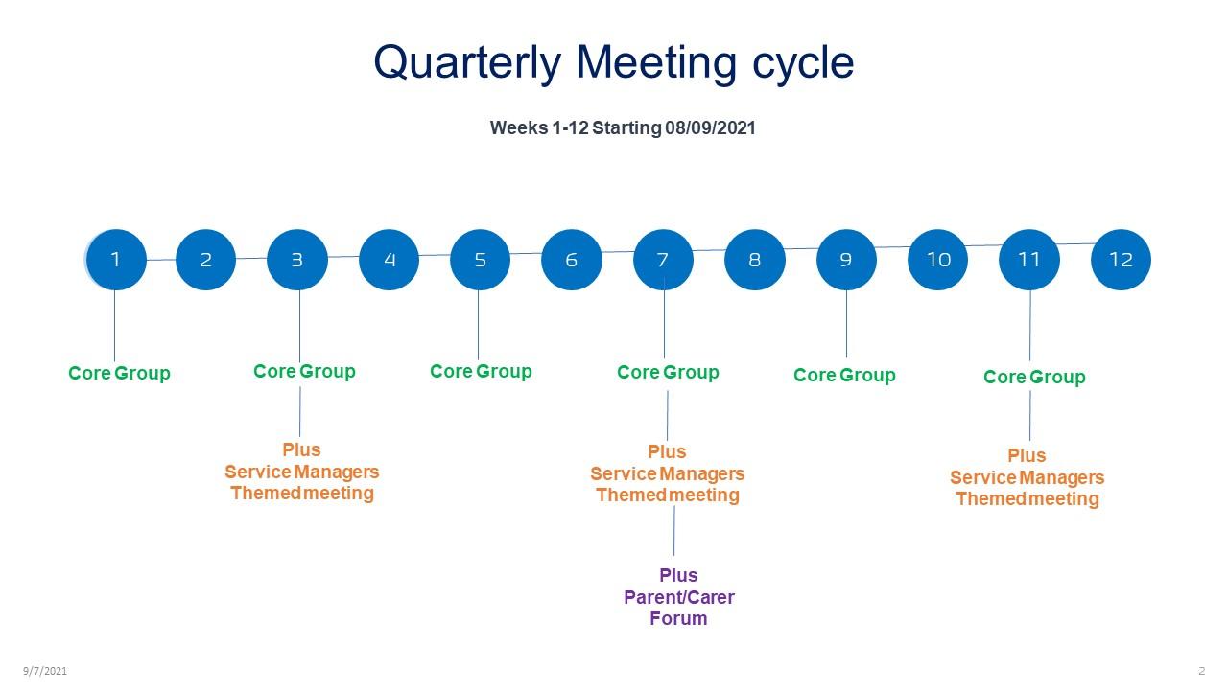

Core Group
- The Core Group will meet every two weeks on Wednesday at 4pm. The meetings are scheduled for one hour, but the time will depend on the number of agenda items to be discussed. The meetings will be via TEAMS until further notice.

- Core Group membership is:

- Jackie Cairns, Director for Newcastle System, NewcastleGateshead CCG
- Deanne Taylor, Head of SEND, Newcastle Council
- Mark Anderson, Designated Medical Officer, NewcastleGateshead CCG
- Jenny Ellis, Designated Clinical Officer, NewcastleGateshead CCG
- Barbara Stanton Commissioning Service Delivery Manager, (North of England Commissioning Support) representing NewcastleGateshead CCG
- Claire Knox/Linzi McMeekin. Commissioning Newcastle Council/ Jointly Funded Commissioning Officer (once in post)
- Rachel Riley, Team Leader Children’s Social Care, Newcastle Council
- Ann Banks, SEND Service Improvement Lead, Newcastle Council

Service Leads Group
- Service Leads or nominated deputies will be invited to attend a meeting with the Core Group once a month. The monthly meeting will include all service leads for the first half hour to discuss business items. The second half of the meeting will be a themed meeting which will only require the appropriate Service Leads. Meeting may be occur more frequently depending on the issues that emerge.

- The Service Leads of nominated deputies are:

Speech and Language Therapy
- Anna Williams, Associate Director, Central Locality Community Services, CNTW
- Steve Morgan Community Clinical Manager, CNTW, Fiona Johnstone, SALT Lead CNTW
- Jane Giles, Head of SALT, NUTH
- Ruth Symes, Clinical Lead Paediatric, CNTW

Occupational Therapy
- Rachel Guyll, Team Leader Occupational Therapy, NUTH
- Steven Morgan, Community Clinical Manager, CNTW

Physiotherapy
- Kim Jarvis, Operational Lead Community Physiotherapy Team, CNTW
- Steve Morgan, Community Clinical Manager, CNTW
- Gemma James, Principal Physiotherapist for Community Children’s Physiotherapy, NUTH

ASD CYPS
- Rebecca Beadle, Clinical Lead (ASD Pathway), CNTW, Newcastle and Gateshead Children and Young People’s Service
- Sarah Newton, ASD and ADHD, CNTW

Children’s Community Nursing Team
- Emma Whiley, CCNT
- Sarah McKeen, CCNT

SEND Outreach Service
- Angela Gemmell, Manger SEND Outreach Service,
- Hazel Newstead, SEND Early Years Lead
Education Psychology Service (EPS)
- Lara Lillico, EPS Service Manager
SEND Information Advice Support Services (SENDIASS)
- Sarah Francis, Manager SENDIASS

Newcastle Parent/Carer Forum
- The Parent/Carer forum will be invited to attend the full meeting (core group and service leads) on a quarterly basis for a question and answer session. They are also invited to raise agenda items with Head of SEND as appropriate.

SEND Voice Trainees
- Will be invited to attend as appropriate to bring the voice of the SEND CYP network.

Key officers
- Will be invited to attend as appropriate.

Accountability
- Members of the forum will ensure that their representatives on the SEND Executive Board are appraised of the work of the Forum.

- Members of the forum will collaborate as appropriate within workstreams of the SEND Executive Board as appropriate. The workstreams are:
- SEND Intelligence and Commissioning workstream where commissioning issues are identified
- SEND Voice workstream
- SEND QA workstream Getting it Right together
- SEND PFA workstream

Management of meetings
- The points below summarise the practical arrangements for the forum:

- All partners are invited to raise items for the agenda
- Agenda items to be sent to Susan Callaghan by close of play on Monday of each week for distribution every Tuesday.
- Log of agreed actions to be maintained and reviewed at each meeting.
- Issues that cannot be resolved to be escalated to the SEND Executive Board as appropriate.
- All papers will be stored in a Microsoft Team and all core group members will have access to this team.

