Autumn Term 2022: SEND News ‘You said we did’
Please see our biteable video: Autumn Term 2022 - SEND Service Update - YouTube
and if you want to find out more take a look at the webpages below:
Screen shot from SEND Local offer | Link to local offer page
SEND Descriptors of Need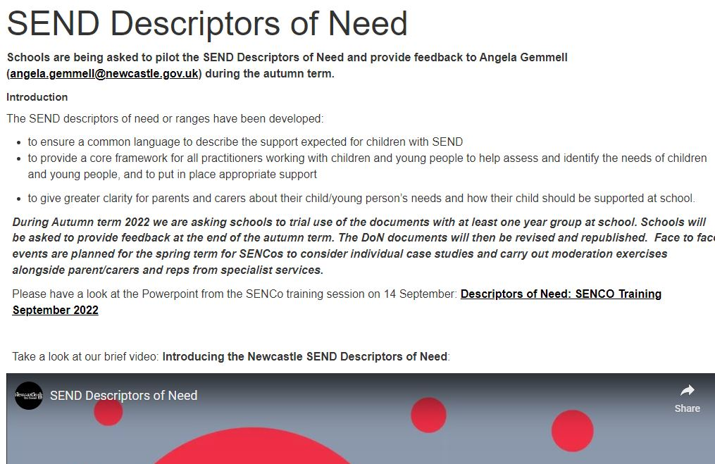 | SEND Descriptors of Need | Newcastle Support Directory
Outcomes framework  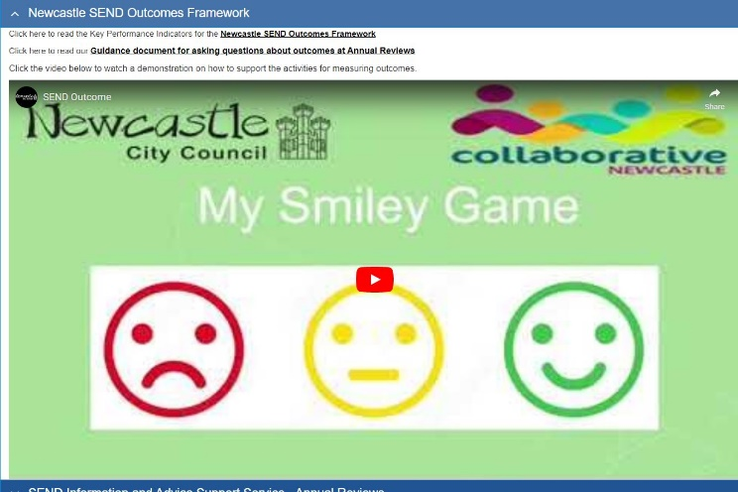 | SEND related policies and strategies (newcastlesupportdirectory.org.uk)
Accelerated Progress Plan  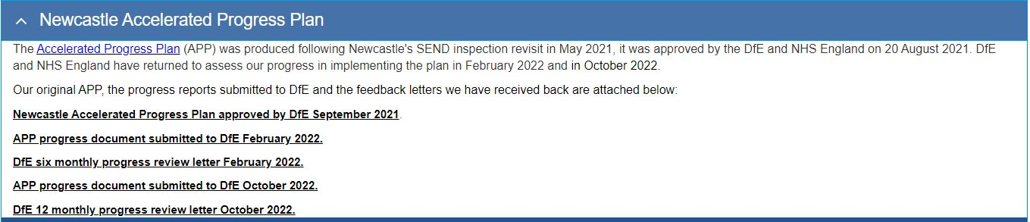 | SEND related policies and strategies (newcastlesupportdirectory.org.uk)
What’s new on the local offer?   | What's new on the local offer? | Newcastle Support Directory
SEND Portal  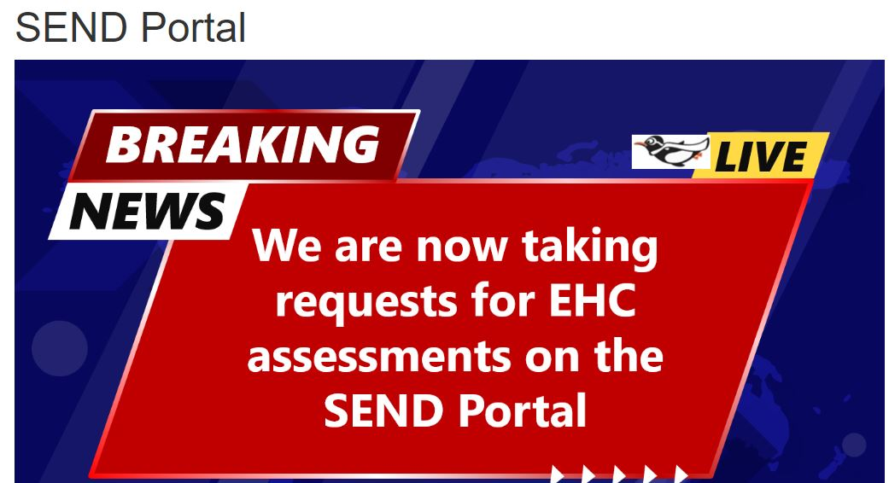 | SEND Portal | Newcastle Support Directory
Myth busters answers to parent carer questions  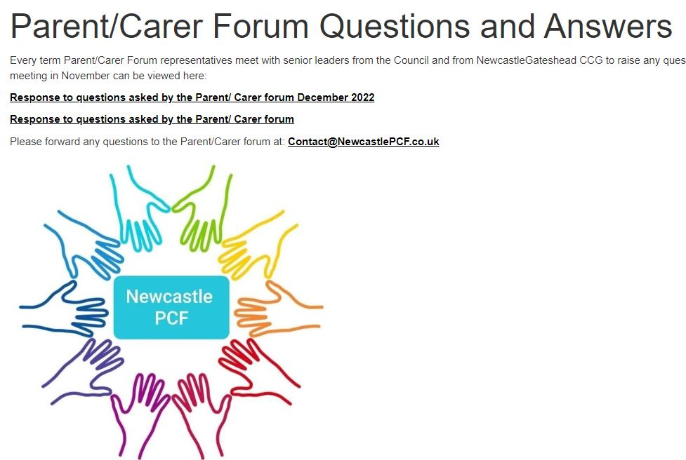 | Parent/Carer Forum Questions and Answers | Newcastle Support Directory

