**Newcastle Local Area**

**EHC decision making panels.**

**Terms of Reference.**

October 2023

# Contents

Introduction 4

Summary of panels 4

EHC request panel 5

EHC outcome and review panel 6

EHC placement panel 11

Supporting the panels 12

# Introduction

Newcastle City Council (the LA) is responsible for considering requests for a statutory assessment of a child/young person’s special educational needs and/or disabilities (SEND), and the monitoring and review of Education, Health and Care Plans (EHCPs) for children and young people aged 0-25. To do this it is good practice to establish multi-agency panels which ensure a joint collaborative approach to support the LA in making transparent and equitable well-informed decisions.

The main role of the panels is to consider a range of LA statutory duties, requirements and related matters including:

* EHC requests:
  + Based on the information and evidence provided decide whether an EHC needs assessment should proceed.
  + Provide advice if it is decided that an EHC needs assessment will not proceed.
* Decide the outcome of an EHC needs assessment:
* Based on all of the information and additional evidence gathered decide if an EHC Plan is required.
  + Provide advice and support if it is agreed that an EHC Plan is not required.
* Annual Reviews:
  + Requests for changes of types of provision i.e., from mainstream to specialist.
  + Recommend type of suitable provision for an upcoming Age phased transfers.
  + Consider a request for a Personal Budget.
* Children and young people transferring in to Newcastle:
  + Consider taking over responsibility of an EHCP.
  + Agree to continue with a statutory EHC Assessment.
  + Recommend type of educational provision.
  + Recommend a funding banding.

In advance of the panel meetings, it is expected that all members will have read the panel papers and noted their views, initial thoughts, and recommendations, highlighting any area for specific discussion.

In Newcastle we have established a number of panels to meet the requirements. They are summarised on the next page:

# Summary of panels

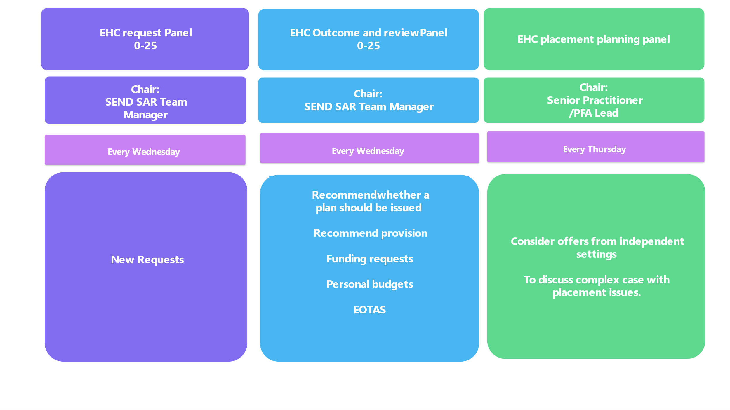

|  |  |  |
| --- | --- | --- |
| EHC request panel: Children and young people, age 0-25 | | |
| Purpose | | |
| To consider all requests for a statutory EHC assessment and make a decision whether the legal threshold is met to warrant a statutory assessment. | | |
| **Scope of the panel** | | |
| To consider whether the Assess, Plan, Do, Review process has been followed and there is evidence to support the request that demonstrates that despite relevant and purposeful action to identify, assess and meet the special educational needs of the child or young person, expected progress has not been made.  To consider whether the threshold has been met to initiate a statutory EHC needs assessment.  To identify cases that may require consideration at the Children’s Continuing Care Panel  **Exceptions.**   * There is a recognition that there will be times that decisions will need to be made outside of the EHC Panel’s scheduled meetings, to ensure that provision for a child or young person’s needs are considered urgently. * In such cases the SEND SAR Team Manager will liaise with colleagues and seek approval from the Head of SEND Service. * For information and transparency, any decisions made outside of the EHC panel framework will be reported to and recorded at the next available EHC panel. * When there is a high volume of new assessment requests for the panel, the SEND SAR Manager will consider the new requests for a statutory EHC assessment outside of panel or call an additional panel and decisions will be recorded retrospectively. | | |
| **Meetings** | | |
| Every Wednesday 2pm – 3pm (starting 7 September 2023), Civic Centre. | | |
| Service | Role |  |
| Chair | * Remind panel members of their duties and responsibilities to ensure that decisions made are in accordance with the requirement of the SEND Code of Practice. * Where there is a difference of opinion, have the final vote to determine a decision/action on behalf of panel. * Arrange for cases to be re-considered when necessary. * Approve the minutes and action sheets from the panel . | Jane Bayley, SEND Support Assessment and Review Manager |
| Senior Practitioners | * Provide their views and opinions | Beki Mellish/Tim McVicar,  Senior Practitioners |
| PFA Leads | Provide their views and opinions | Kay Harrison/Louise Melling,Preparing for Adulthood leads |
| Service Improvement Assistant | The panel will be supported by a Service Improvement Assistant who will maintain agenda and minutes of the meetings. | Julie Richardson, Service Improvement Assistant |
| Other |  |  |
| Observers | For personal development and knowledge building. |  |
| **Accountability** | | |
| The EHC request panel will be report performance ‘Joint Intelligence and Commissioning’ workstream and the ‘Getting it Right Together’ workstream who will in turn escalate issues where appropriate to the SEND Executive Board. | | |

|  |  |  |
| --- | --- | --- |
| EHC outcome and review panel: Children and young people, age 0-25 | | |
| Purpose | | |
| To ensure that Newcastle’s processes for undertaking EHC needs assessments, and reviewing and maintaining EHC Plans are transparent, consistent, and fully compliant with all legal requirements.[1] | | |
| **Scope of the panel** | | |
| On receipt of assessment advices:   * Recommend if an EHCP is required. * Recommend a type of educational provision i.e., mainstream or specialist. * Recommend level of High Needs Top-up funding to be allocated. * Provide advisory actions for education providers and other services. * If there is a decision not to proceed to issue a draft EHC Plan, provide advice and recommendations for a SEN Support Plan. * Refer children/young people in our care (CIC) who require a joint residential package of education, health and care to the Social Care Resource and Care Panel. * Identify cases that may require consideration at the Children’s Continuing Care Panel. * Consider funding requests.   Consider requests from an interim or annual EHC Review and:   * Recommend type of provision to meet need. * Recommend if an EHCP should be ceased, where outcomes have been met. * Consider Personal Budget requests. * Determine and agree funding in relation to a personal budget for EHC elements when requested. * Consider Education Other than at School (EOTAS) requests. * Consider children and young people who have moved into the Newcastle local area. * Determine whether an adoption of an EHC Plan is appropriate. * Agree responsibility to continue with a statutory assessment that has already started. * Make decision to reassess if appropriate. * Agree placements, needs and provision for pupils. * Agree funding allocation. * For children in the care of another LA ensure that financial responsibilities are clear   **Any other business**  At times, the EHC Panel will be asked to offer advice and recommendations to support a CYP with an EHCP. This may also include:   * Approval to seek a place within an Additional Resource Provision. * Approval for transitional support. * Approval for an assessment place. * Referrals from the SEND ASAP panel. * International new arrivals. * Any other requests.   **Exceptions**   * There is a recognition that there will be times that decisions will need to be made outside of the EHC Panel’s scheduled meetings, to ensure that provision for a child or young person’s needs is considered urgently. * In such cases the SEND SAR Team Manager will liaise with colleagues and seek approval from the Head of Service SEND. * For information and transparency, any decisions made outside of the EHC panel framework will be reported to and recorded at the next available EHC panel. * When there is a high volume of new assessment requests for the panel, the SEND SAR Manager will consider the new requests for a statutory EHC assessment outside of panel or call an additional panel and decisions will be recorded retrospectively. | | |
| **Meetings** | | |
| Every Wednesday 9.30 – 12 (starting 13 September 2023) via Teams | | |
| Service | Role |  |
| Chair | **Role**   * Remind panel members of their duties and responsibilities to ensure that decisions made are in accordance with the requirement of the SEND Code of Practice. * Where there is a difference of opinion, have the final vote to determine a decision/action on behalf of panel. * Arrange for cases to be re-considered when necessary. * Approve the minutes and action sheets from the panel . | Jane Bayley, Support, Assessment and Review Team Manager |
| Deputy | **Role**   * To deputise for the Chair. | * Lara Lillico, Service Manager EPS * Senior Practitioners/ * PFA Lead |
| Educational Psychology Service | * Provide professional advice and guidance. * Discuss the details of EP assessments undertaken. * Consider new requests for an Educational Psychologist (EP) assessment. * Consider requests for an EP re-assessment where appropriate. * Consider consultation responses. * Provide support and advice (regarding ongoing assessments). | Lara Lillico, Service Manager EPS/Deputy EPS Manager, Andrew Scott |
| Health  . | **Role**   * The Dedicated Medical Officer (DMO) sits on the EHC Panel and represents health and therapy services. * The Dedicated Clinical Officer (DCO) from the ICB can support schools with their duties under the ‘Supporting Pupils with Medical Conditions’ guidance. * The DMO and DCO have delegated responsibility on behalf of the ICB to make key decisions i.e., agreeing the health services in an EHC plan: * Consider the appropriateness of health requests/provision to be detailed in an Education, Health and Care Plan * Be part of the decision making on panel * Be a point of contact outside of panel if there are any concerns.   Consultant Paediatrician   * To provide professional advice and guidance.   Specialist Nurses   * To provide professional advice and guidance. | Kim Barret, Designated Medical Officer (DMO)  * Jenny Ellis, Designated Clinical Officer (DCO) * Rachel Slee/ Hazel MacEwan, SEND Specialist Nurses |
| Education | * Provide professional advice and guidance within area of expertise. * Provide support and advice (regarding ongoing assessments). * Provide educational advice, support, and recommendations to the EHC Panel. * Consider support available from the SEND Outreach Service and other educational support services. * Feedback to schools/SENCOs. * Liaise with schools/SENCOs when requests are declined.  Early years  * Early Years SEND Lead * Early Years Advisor (Inclusion)   **School**   * Kingston Park * Hadrian * Sir Charles Parsons * Trinity * Thomas Bewick   **Post 16**   * Sir Charles Parsons * Trinity * Thomas Bewick * College.   **SEND Advice Support Allocation Panel (ASAP)** | Hazel Newstead, Early years SEND Lead  * Lianne Dixon. Early Years advisor (Inclusion)  Suzanne Cowell, Kingston Park  * Alex Rayner, Hadrian * Karen Parker, Sir Charles Parsons * Michelle Higgins, Trinity * Thomas Bewick TBA * College TBA * Angela Gemmell, SENDOS Team Manager. |
| Social Care | * Consider the appropriateness of health requests/provision to be detailed in an Education, Health and Care Plan. * Be part of the decision making on panel. * Be a point of contact outside of panel if there are any concerns. * Should any concerns be discussed at the EHC Panel regarding a child that is active to social care/ Early Help, the Social Care representative who attends the EHC Panel meetings will raise this with the allocated social worker.   **Panel Members**   * Designated Social Care Officer (DSCO) * Team Manager: Adult Social Care and Integrated Services * CWD team * Early Help rep * Social care LDD teams | Kelly McGuiness, Designated Social Care Officer (DSCO)  * Susan Redmond/ Kirsty Turner, Social Care * Early Help rep TBA * CWD team TBA * Social care LDD teams |
| Placement Planning Officers | For awareness and to ensure robust placement planning and consultations. | Samantha Morris/Libby Stephenson, Placement Planning Officers |
| Observers | For personal development and knowledge building. |  |
| Service improvement assistant | The panel will be supported by a Service Improvement Assistant who will maintain agenda and minutes of the meetings. | Julie Richardson, Service Improvement Assistant |
| **Accountability** | | |
| The EHC request panel will be report performance ‘Joint Intelligence and Commissioning’ workstream and the ‘Getting it Right Together’ workstream who will in turn escalate issues where appropriate to the SEND Executive Board. | | |

|  |  |
| --- | --- |
| EHC placement panel: Children and young people, age 0-25 | |
| Purpose | |
| To consider offers from Independent Settings.  To discuss complex cases with placement issues. | |
| Chair | |
| SEND Support Assessment and Review Manager (LA). | |
| Deputies | |
| SEND Senior Practitioner/Preparing for Adulthood Lead. | |
| Service representatives | Identified Officer |
| Placement planning officers | Samantha Morris/Libby Stephenson |
| Finance representation | Stacey Denton |
| Commissioning |  |
| Any other |  |
| Service improvement assistant | Dawn Walker |
| **Scope of the panel** | |
| The panel will consider offers made from independent settings and in deciding whether these placement offers can be agreed taking into account the efficient use of resources. In order to make an informed decision, panel members will have access to:   * Previous Panel papers and recommendations. * Details of all recent consultations and responses, including evidence of communication to challenge a non-code compliant response (as per SEND Code of Practice). * Clarification of Children’s Continuing Care involvement. | |
| **Meetings** | |
| Every Thursday 3.30 – 4.30 (starting 9 November 2023) Civic Centre. | |
| **Supporting the panels** | |
| The panel will be supported by a Service Improvement Assistant who will maintain agenda and minutes of the meetings. | |
| **Accountability** | |
| The EHC request panel will be report performance ‘Joint Intelligence and Commissioning’ workstream and the ‘Getting it Right Together’ workstream who will in turn escalate issues where appropriate to the SEND Executive Board. | |

|  |
| --- |
| **Supporting the panels** |
| All panels will be supported by a Service Improvement Assistant who will maintain agenda and minutes of the meetings.   * All relevant information will be shared with resource panel members electronically via Teams Drive at least four days before every panel meeting. This will include all the necessary paperwork received to support the decision-making process. * Papers will be treated in utmost confidence and any printed papers will be destroyed securely following the meeting. * The meetings will be attended by a Service Improvement Assistant from the SEND team to record the decisions and actions agreed. * Funding Panel Action Sheet will be distributed within 2 days. * Funding Panel decisions will be distributed ithin 5 days. |

1. [SEND code of practice: 0 to 25 years - GOV.UK (www.gov.uk)](https://www.gov.uk/government/publications/send-code-of-practice-0-to-25)