
SEND Youth Voice Internship /Trainee
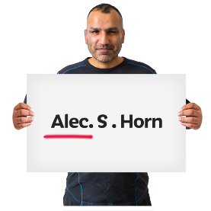 | What is your name?
 | What is your date of birth?
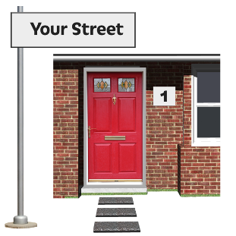 | What is your address?
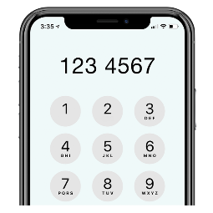 | What is your phone number?
 | What is your email address?
 | Tell us places you have worked or volunteered, including the start and end dates:
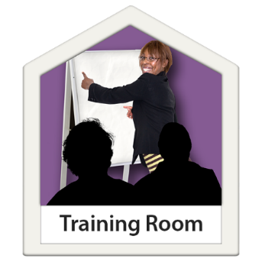 | What training have you had that might help you to do this job?
 | Tell us why you are the best person for the job.  Please look at the Job Description. It tells you what kind of person we are looking for.  Tell us as much as you can about what skills, experience and knowledge you have. Use examples from your own experience.  You need to show us that you have the passion skills and experience of as many things as possible, from the list in the Job Description.
Write your answer here. You can add one extra page if you need to.

 | Tell us what your needs are, please tick the boxes or add your own words:
Learning disability

Autistic person

Other

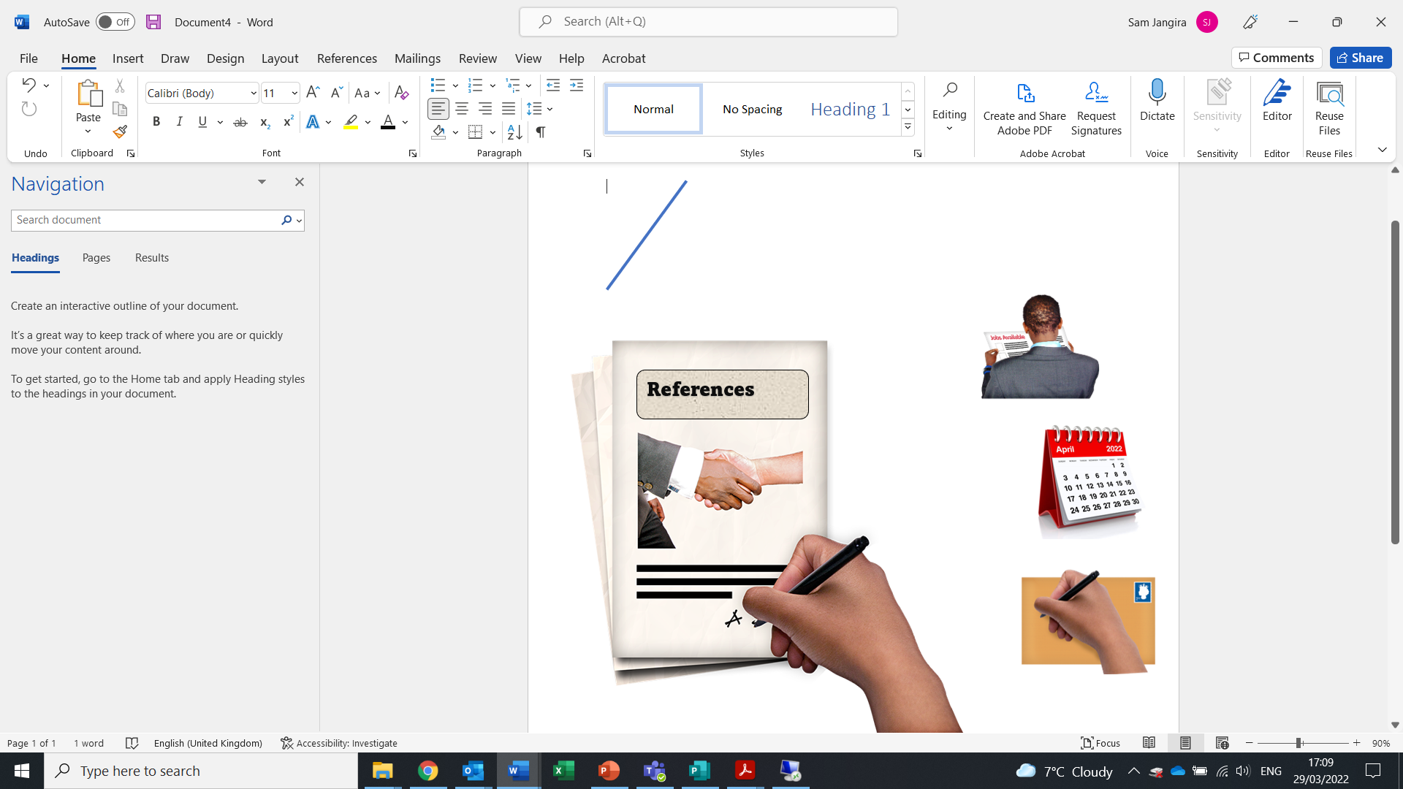 | Please tell us two people who can write a reference for you.  Name:  Address:  Email:  Phone  How do you know them?
Name:

Address:

Email:

Phone
How do you know them?

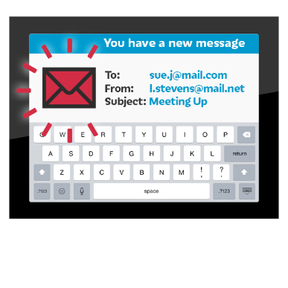 | If you have any questions about the job  Please contact  Jill Bauld jillian.bauld@newcastle.gov.uk  Text or call Jill on 07974215459

   | We must receive your application by:  9.00 am Monday 3rd October2022  Please send your completed form by email to  Jillian.bauld@newcastle.gov.uk

