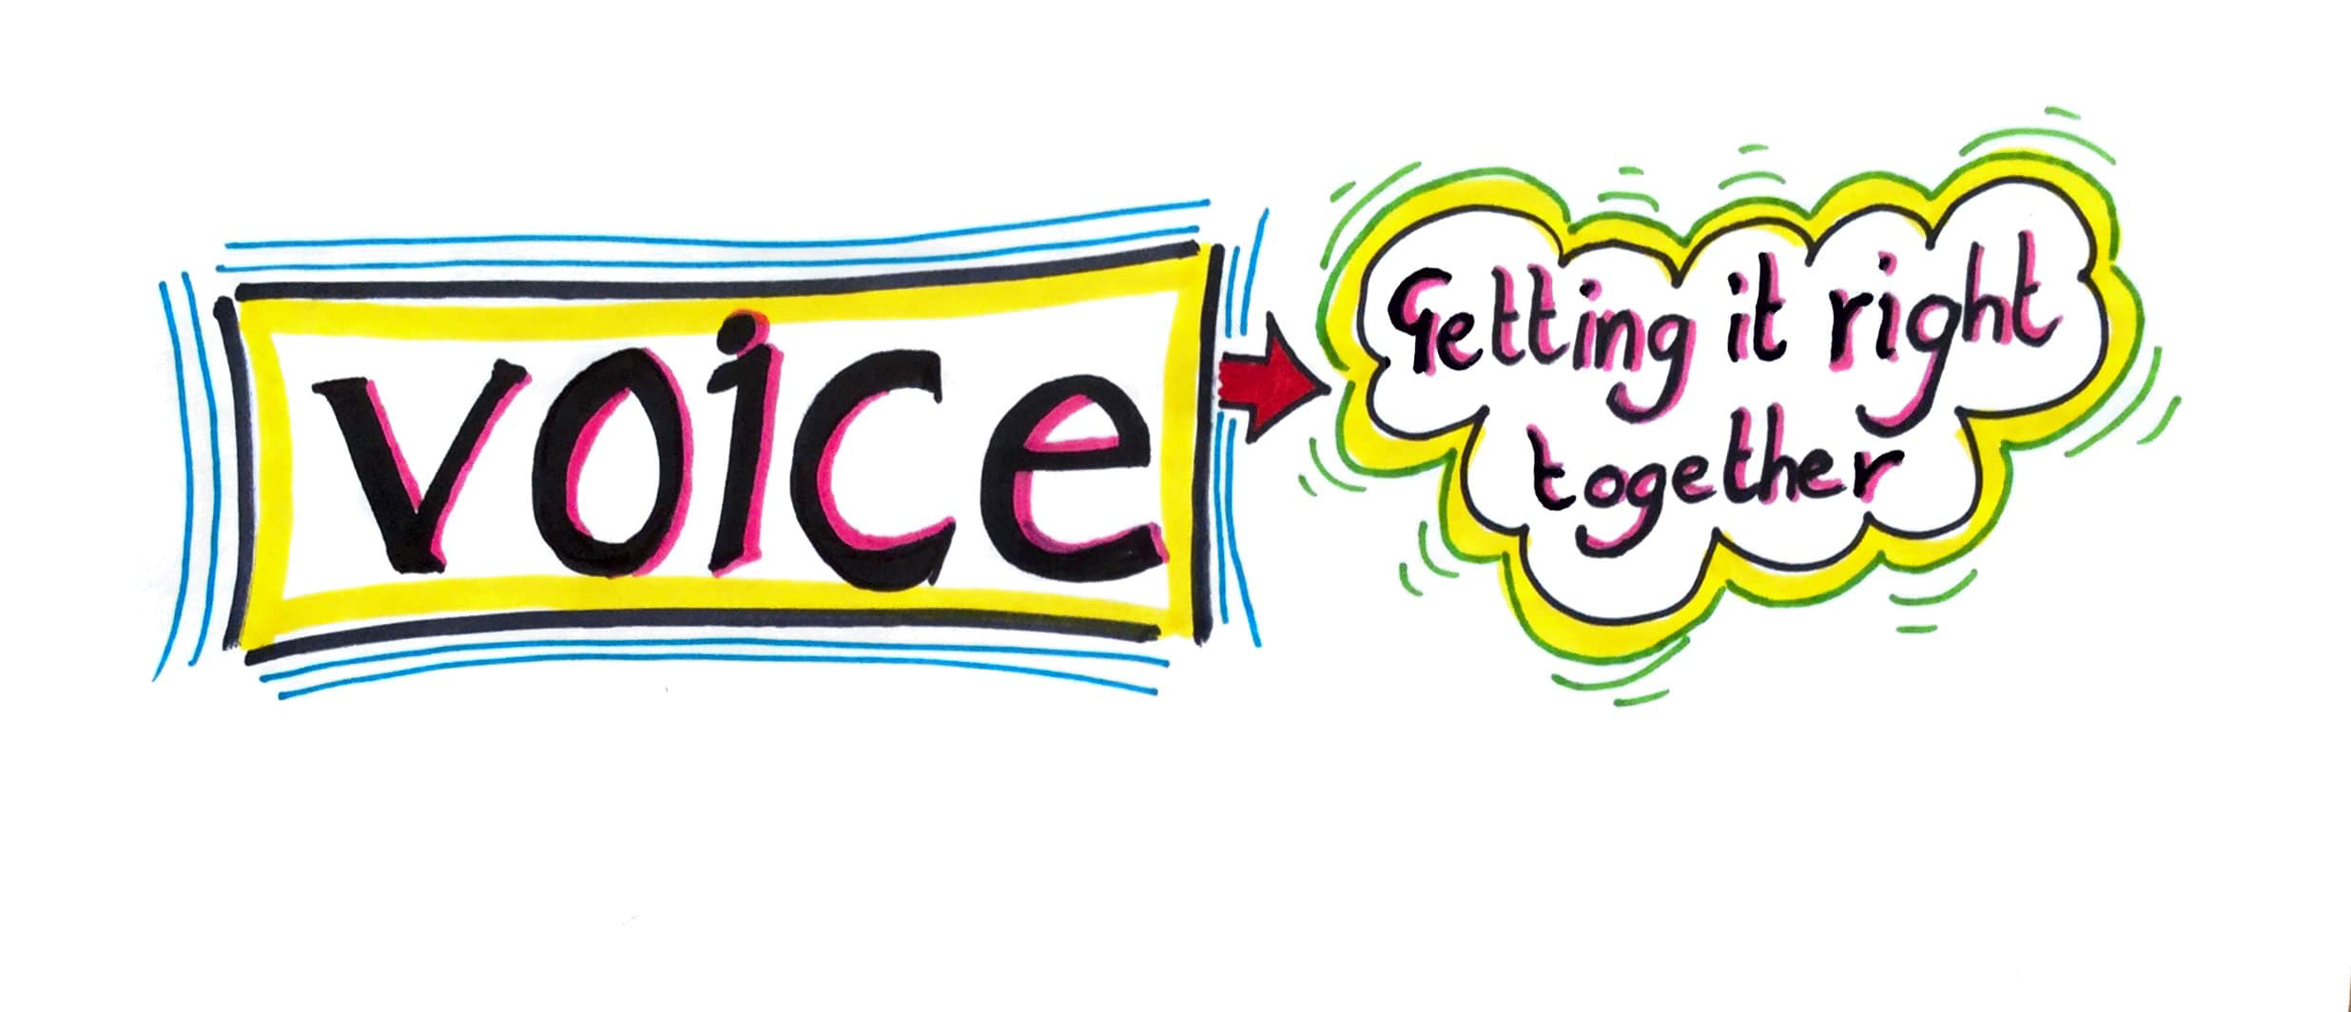

|  |
| --- |
| **Happiness Survey 21-22 Action Plan** |
| **Children and young people,Staff and Parent Carers completed workshops and surveys to help us understand what sorts of support was needed post pandemic in our settings.**  **The survey and workshops were co-produced with SEND children and young people and their main theme was mental health as this was an area they identified as being important to them.** |
| **The headings in bright yellow are the main emerging themes.** |
| **Friendships** |
| * **Help making friends and knowing what a good friendship looks like** * **Support for bullies** * **‘Friendly’ Schools** * **Activities and things to do that help us meet and make friends (all age ranges and especially post 16)** * **The importance of friends when changing schools/ provision** * **More value on time with friends** * **Combating loneliness in our schools** |
| **What will we do?** |
|  |
| **Who needs to be involved?** |
|  |
| **What has changed?** |
|  |
| **Support and Communication** |
| * **Clear information to children about what support is available (who is the person they can tell if they are having a bad day and need support?, do all pupils know this?)** * **Clear information to staff and parent carers about support, who to talk to, where to get information.** * **All provisions to look at establishing peer support groups** * **Simple way for CYP to let you know discreetly if they are anxious or sad** * **1-1 counselling/ support that is easily accessible for anyone that needs it** * **Information about school nurses, what are their roles? what do they do to help and support?** * **Positive support for bullies to help them change their ways** * **All provisions to establish really good communication with parent carers and pupils** |
| **What will we do?** |
|  |
| **Who needs to be involved?** |
|  |
| **What has changed?** |
|  |
|  |
| **Environment** |
| * **Establishing calm and kind environments** * **More opportunities to unwind and have chill out spaces that are easily accessible (staff, CYP)** * **Noise is a problem for all children, young people and staff** * **Policies that mean that it is OK to leave a lesson if you feel overwhelmed** * **More opportunities to learn outside/ different environments** |
| **What will we do?** |
|  |
| **Who needs to be involved?** |
|  |
| **What has changed?** |
|  |
|  |
| **Culture** |
| * **Kindness is a word that has been used by almost all respondents as an important culture change area for all provisions( to not be judged, to be understood, to be allowed to have a break when its needed)** * **More opportunities to be active and have breaks or learning interspersed with fun activity** * **Overwhelming response from staff and CYP about the pressure they all feel- too much to do, not enough time, everything is rushed- massive impact on MH and well being.** * **Establishing a calm, kind, friendly environment is the top ask of nearly all respondents of all ages.** * **Having help in the classroom is OK** * **Language used is simple and clear- check back that students understand, have revision cards at end of lessons so its clear what the expectation is** |
| **What will we do?** |
|  |
| **Who needs to be involved?** |
|  |
| **What has changed?** |
|  |
| **Shareing Good practice**  **This will link to Newcastle’s Accessibility Strategy, be ongoing and will enable us to learn from each other as we try things out** |
| **What will we do?** |
|  |
| **Who needs to be involved?** |
|  |
| **What has changed?** |
|  |