**Newcastle SENDIASS**



**Annual Review**

**2021-2022**

**Introduction**

This annual report aims to provide a formal service evaluation and an informative reflection that will give a sense of the achievement of the service.

We wanted to create a document which provides parents and professionals with information about the service enabling them to have a really clear understanding of what it does, how it helps and who can use it.

We have included feedback from parents, carers and young people as their views are important to us. We have also included feedback from professionals to show what they think of the service and working alongside it.

The world of Special Educational Needs and Disabilities (SEND) is complex; in this review we will try to present information in a way that doesn’t have any jargon or require any specialist knowledge to understand.

We are here to help so if there is anything in this review that you do not understand, please let us know.

**Service values and practice**

**Newcastle Special Educational Needs and Disabilities Information, Advice and Support Service (SENDIASS)** offers **impartial** and **confidential** information, advice and support to parents, carers, children and young people aboutmatters related to their or their child’s special educational needs and/or disabilities.

Staff are trained and have accurate and up to date knowledge of

· Education, social care and health law relating to SEND

· National and local policy and practice in meeting SEND

· SEND processes including Tribunal

Support is tailored to the individual service user, with the aim to build on that individual’s skills, knowledge and confidence to promote independence and self-advocacy.

**The service is free for young people, parents and carers to use.**

**You choose whether or not to use the service – you contact us not the other way around.**

**The service is confidential and impartial.**

The service can be accessed by children and young people independent of their parents. The service has adapted to include a text line and school drop-in clinics to make the service accessible for children and young people.**Who delivers SENDIASS?**

Newcastle SENDIASS is now jointly commissioned by education, health and social care in line with the national minimum standards. Following the joint commissioning agreement, the service has expanded and restructured. The diagram details the current structure

Service Manager

Senior Practitioner

SENDIASS Officer Children and Young Person Officer

The service also has one part time business administrator.

Newcastle SENDIASS does not work in isolation. Each local authority has its own service and they are all overseen by a national co-ordinator at the National Children’s Bureau. The national co-ordinator

* Liaises with government, in particular the Department of Education
* Hosts an e-forum for all SENDIASS staff
* Gathers and publishes benchmarking data for each service
* Provides training on the law, mediation skills and regular updates on SEN policy and practice.

**Service statistics**

This year the service has managed 876 cases. This is broken up into 799 parent and carers and 77 children and young people. On top of this the service has also provided a service to 52 people who were out of area and 268 professionals.

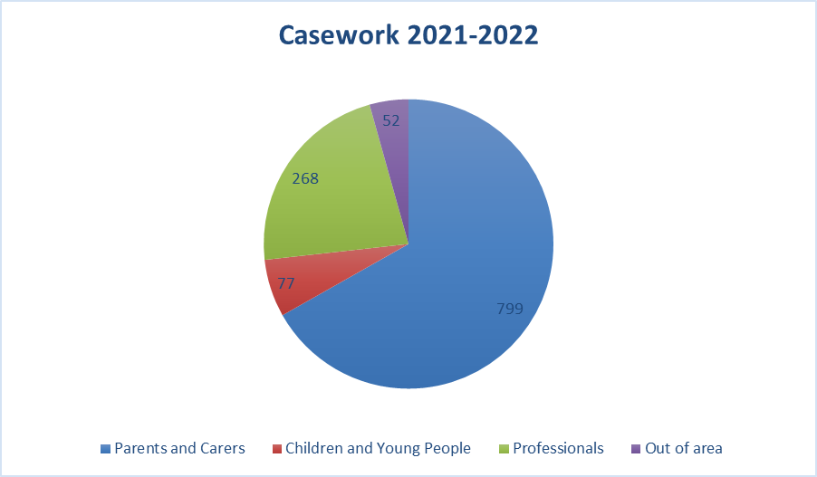

This service is seeing increasing demand with the number of cases going up significantly this year. The chart demonstrates real growth in the number of cases that the service is dealing with. The previous two years showed a slight dip due to the impact of the pandemic, and this year’s growth is potentially a result of that.

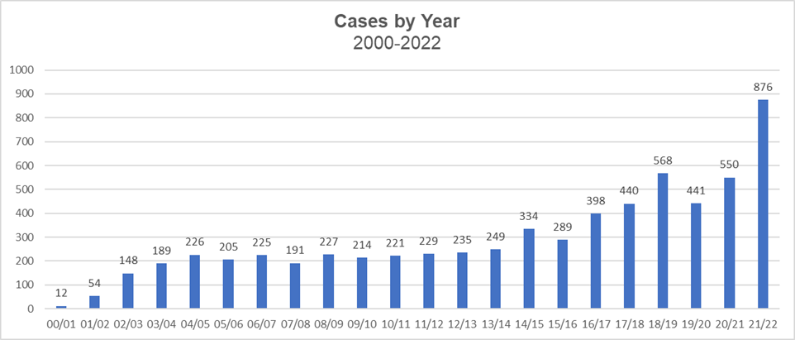

The service supports parents, carers, children and young people across a range of educational settings from early years to post-16. The chart below illustrates how many cases came from each sector during the academic year 2021-2022.

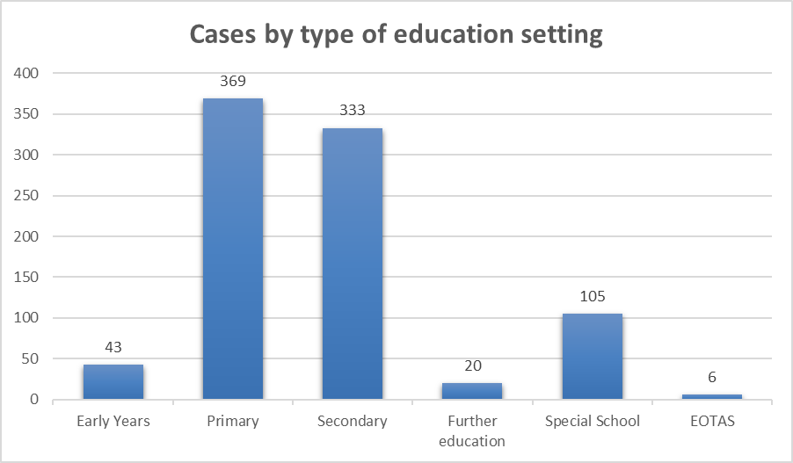

Out of 876 cases that we provided casework for, 204 had Education, Health and Care Plans.

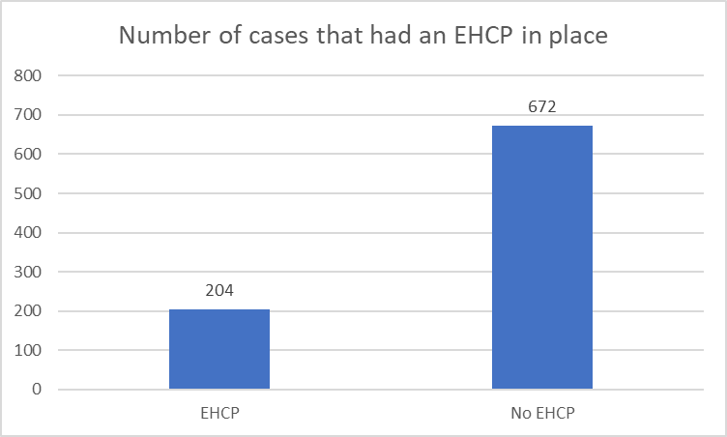

The service is for any child or young person, or the parents or carers of children and young people, who have special educational needs or disabilities. The child or young person does not need to have a diagnosis to access the service. The service has seen an increase in the number of children who have diagnosed neurodevelopmental needs and anxiety. The chart below illustrates the diagnosed needs for cases during the last year.

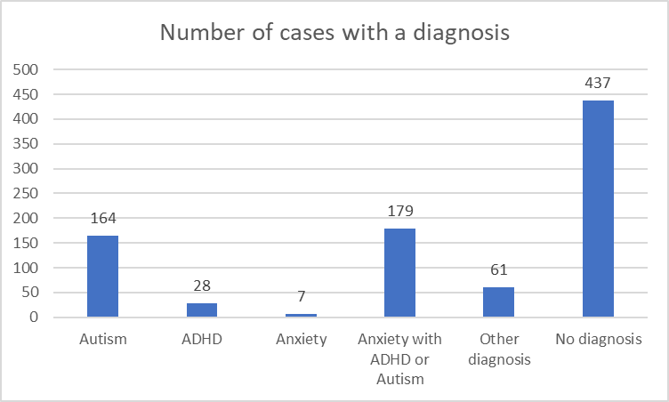

**Service developments over the last year**

**Children and Young People**

Changes in legislation (Children and Families Act 2014) gave significant new rights to young people once they reach the end of compulsory school age.

“Local Authorities must have regard to the importance of providing children and their parents and young people with the information and support necessary to participate in decisions.”

SEND Code of Practice Chapter 2 2.1

We employed a children and young people’s officer for the service to adapt and deliver the service directly to children and young people independent of their parents or carers. Since January 2022 the CYP officer has held 129 school clinics, supported at 12 coffee mornings and has attended 8 meetings to support children or young people.

Children and young people now account for 10% of the service case work. This just demonstrates that there is a need to have a dedicated worker who is able to adapt the service to make it accessible for children and young people.

We asked the children and young people who accessed the service for some feedback. **100%** of the children and young people who accessed the service gave the service a score of 10. **100%** of those who accessed the service said they would **always** recommend the service to a friend.

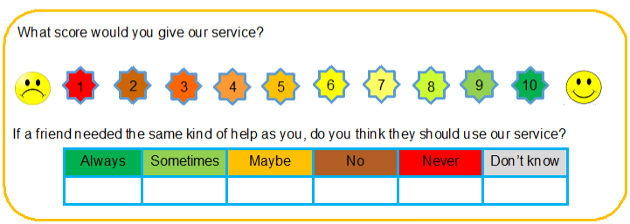

“School life has got better”

“Emma really helped me by listening and helping me to get support for school”

“I have enjoyed speaking with Emma”

“We have Emma from SENDIASS who is coming in every other week to gather student voice and that is a wonderful resource. Thank you SENDIASS for that fantastic service, that’s really useful to highlight general trends and points for us to develop and address.”

Secondary school Principal

“‘Thank you again for everything you did yesterday; we are so grateful that you are able to come into school to support the girls”

SENCO

“Many of the students have said their time with you has been really useful so far. Thank you.”

SENCO

|  |  |
| --- | --- |
| **SENDIASS** | **Children and Young Person Officer** |
| **Case study**  **1** | **Opportunity for all young people in secondary schools to meet with children and young person worker on a one-to-one basis in a confidential space. All conversations were led by the young person and appropriate support, advice and further meets were offered thereafter. All discussions logged digitally on an encrypted database to store relevant discussions and outcomes of each individual meet.** |

|  |
| --- |
| **Introduction**  This case involved a young person in a mainstream secondary school under a graduated phase to return to full time education. Due to covid, the young person was still not attending school on a full time basis and statistically, was below 40%. The SENCO discussed their concerns for the young person and lead up to exams in the next academic year. |
| **Background**  The young person discussed they had anxiety surrounding attending school, even with a graduated approach. The young person also discussed they had recently visited the doctors to be placed on the waiting list for an ADHD assessment as mum was concerned the young person may have additional needs which became more apparent as the young person got older.  The SENCO discussed with me that the young person struggled to sit still in lessons and mum was concerned the young person was not getting the support he needed during school time so aimed to support mum in the process of EHCP. The young person reported that he found it hard to focus on lessons but also did not want obvious strategies to support him in fear of looking different to his peers. |
| **Aims and objectives**  The aims were to create a safe environment for the young person to feel comfortable in without distraction from peers and staff.  To develop positive relationships and allow the young person to speak freely without judgement or correction of verbal language used.  To allow the young person to feel in control of the discussions and fully aware they were confidential unless they requested any information to be shared – logged on database.  To support the young person with anything he wanted to talk about and offer support and advice. This would be followed up on a fortnightly basis to discuss if the advice or support helped the young person or, if further support and advice was needed to provide positive impact on school/home life.  When information was shared with young person’s consent to SENCO, I would ensure the discussion was in the young person’s words. This would be at face value as well as an email to ensure the discussion was shared and positive impact could be supported in a young person-centred approach. |
| **Approach**  When I first met with the young person, he discussed when Geography lessons were on his timetable that he would avoid coming into school. He discussed he knew the relevant facts of the world and didn’t feel the need to know in depth knowledge. This led to the young person taking full days off when he knew Geography was on specific days.  The young person was given the space to discuss his likes and dislikes to the geography lessons and what could be done to improve them. The young person discussed he found it hard to sit still and taking time out of the lesson when needed had potential to make it more bearable. This was discussed with the SENCO immediately after the clinic with young person’s consent.  When I met with the young person two weeks later, the SENCO had implemented movement breaks for the young person to use anytime of the day as well as a card to show to other staff without having to explain why he needed to leave the classroom.  The young person had increased some lesson attendance but still not enough statistically. The young person disclosed that he stayed all day at school when he had trampolining which was at the end of the day. Through further discussions, the young person reported that he would attend everyday all day if he knew he had trampolining as an incentive. With consent, I passed this information onto the SENCO who then discussed trampoline movement breaks throughout the day as well as staffing to ensure the trampoline would be available at the end of every day for the young person.  The young person attended a further clinic and discussed the trampoline movement breaks made his day manageable and felt at ease retiring to school for longer days. |
| **Challenge**  Everyone surrounding the young person wanted him to attend school confidently every day. The young person discussed his mum would allow him to stay off school a lot without any given reason other than he felt tired. The young person discussed that he wanted his mum to be firmer with him as he knew he needed to be in school, but if his mum was allowing him to stay off, he was also taking that opportunity and not attending school. This resulted in the young person feeling more behind in his learning and overwhelmed with his initial return to certain subjects.  The SENCO was also aware off this dynamic and discussed it added an extra pressure to encourage the young person into school. This was an issue for the school to discuss with mum to encourage her son to return to school on the graduated timetable.  The young person wanted to attend full time everyday but initially felt the timetable would be too overwhelming. Therefore, a graduated return to school timetable was introduced. The young person would not attend school even on a graduated approach due to Geography lessons being on his timetable twice a week – creating a two-day absence each week. |
| **Successes**  Movement breaks and supportive time out of class strategies were put in place for the young person to take time out of lessons when necessary to prevent masking his behaviour of feeling overwhelmed and allowing more focus and concentration on his academic learning.  Trampoline movement breaks and evening incentives increased the young persons attendance greatly through discussions with myself which was passed onto SENCO who could ensure these strategies to be implemented to provide a greater attendance overall.  Geography lessons were completely taken off the young person’s timetable (SENCO’s decision) to allow maximum time in school and focus on core subjects to encourage the young person to further progress in his studies in preparation for exams the next year. |
| **Conclusion**  By offering the service of children and young person worker to attend the school, it allowed the young person to open to a new face and discuss any concerns or areas for improvement to improve his wellbeing.  Due to the discussions and consent of passing on critical information to the SENCO, the young person attended school more frequently and increased his attendance through the implementation of movement breaks and trampolining incentives for each day he attended.  Without the discussions with the children and young person worker, the young person may have potentially decreased his attendance at school further due to his anxieties of falling behind and the continued lack of attendance when geography was scheduled in.  The SENCO was verbally grateful for the feedback given on the young persons behalf as she could meet his needs to achieve greater academic learning through the consistent use of clinics aimed at supporting the young person. |
| **Child/Young person feedback**  The young person felt heard and understood when listened to. The young person felt safe knowing that anything discussed was confidential and if consent was given, that action was taken to greatly improve his wellbeing and academic achievement immediately.  The young person knew that the consistent meets allowed the discussion of strategies put in place to be amended through myself and the SENCO if they weren’t working or could be improved. |

|  |  |
| --- | --- |
| **SENDIASS** | **Children and Young Person Officer** |
| **Case study**  **2** | **Opportunity for all young people in secondary schools to meet with children and young person worker on a one-to-one basis in a confidential space. All conversations were led by the young person and appropriate support, advice and further meets were offered thereafter. All discussions logged digitally on an encrypted database to store relevant discussions and outcomes of each individual meet.** |

|  |
| --- |
| **Introduction**  This case involved a young person in a mainstream secondary academy who requested to speak with me after the academy displayed posters and flyers about the children and young person service. The young person wanted to discuss a teacher and their lack of support when time out was needed during a lesson. |
| **Background**  The young person had a diagnosis of ASD with strategies in place directed by the SENCO. Fidgets and time out pass were recommended by the SENCO to allow the young person to take time out of a lesson when he became overwhelmed with noise, lights or workload. The time out pass recommended five minutes maximum time which was agreed with young person.  The young person felt frustrated as the strategies were not being implemented in certain lessons which was making the young person dread attending the lesson and masking his frustration towards the teacher until he could no longer cope, then display his frustrations in a verbal reaction. |
| Aims and objectives  The aims were to create a safe environment for the young person to feel comfortable in without distraction from peers and staff.  To develop positive relationships and allow the young person to speak freely without judgement or correction of verbal language used.  To allow the young person to feel in control of the discussions and fully aware they were confidential unless they requested any information to be shared – logged on database.  To support the young person with anything he wanted to talk about and offer support and advice. This would be followed up on a fortnightly basis to discuss if the advice or support helped the young person or, if further support and advice was needed to provide positive impact on wellbeing, school or home life.  When information was shared with young person’s consent to the SENCO, I would ensure the discussion was in the young person’s words. This would be at face value as well as an email to ensure the discussion was shared and positive impact could be implemented through action in a young person-centred approach. |
| **Approach**  When I first met with the young person, he wanted to discuss a teacher within the academy that would not allow him to use his time out pass. He mentioned the teacher said the young person was using it as an excuse to leave the class as it was a lesson he didn’t like. The young person said he would mask his behaviour until he could no longer control it and have an outburst which the teacher would then sanction him for. The young person stated this was a constant occurrence despite communicating to the SENCO and learning support staff that the issue was affecting his  The young person reported that he had mentioned it to the SENCO as numerous of his peers that also had time out passes felt they could not use them when needed so collectively discussed their lack of enjoyment to attend the lessons.  The young person gave me permission to share the discussion with the SENCO to highlight the issues and continue to use strategies in place to support the young persons needs. |
| **Challenge**  Overall, the SENCO and myself aimed to support the young person’s wellbeing and academic achievement. The SENCO initially logged the discussions without any form of action which was discussed with the young person during frequent meets when he felt nothing had changed.  I highlighted to the SENCO that the strategies were not being implemented which was hindering the young persons ability to focus on the specific lessons and deliberately avoid the lesson by showing up late or walking out early due to frustration.  The young person reported he started to misuse his time out pass and not return to the lesson which resulted in a collaborative approach from his other peers. This disrupted the lesson for all attendees which hindered the academic learning and progress of the lesson structure.  The teacher was still unaware at this point that the young person and his peers were reaching out for support and advice to improve the lessons and feel confident that if he needed to use any strategies he would be allowed to do so. |
| **Successes**  After numerous conversations with the SENCO, action was taken for the SENCO to speak with the teacher. The SENCO discussed the teacher was unaware of the young person’s needs as he was a supply teacher. Although he was a consistent supply teacher for the same lessons, the SENCO acknowledged he was unaware of the specific needs of various young people. Therefore, to provide positive impact the teacher communicated to the SENCO that he would allow the time out passes to be used as well as the various fidgets need for the young person to cope with the school environment.  Due to the consistent clinics, I was able to bridge the lack of communication between the young person, SENCO and teacher and find a solution to allow the young person to feel listened to, action to be taken and positive impact upon his academic learning using additional strategies in place. |
| **Conclusion**  Through the display of the posters and flyers, the young person was able to communicate his need for support and advice which could be offered in a confidential space at the academy.  The young person continued to use the service to verbally discuss any frustrations he had regarding home and personal life understanding that I would listen, and he could return to his school day feeling less frustrated – supporting his wellbeing. |
| **Child/Young person feedback**  The young person developed a positive relationship and felt he could discuss anything with myself, and I would act appropriately to support him.  The young person would recommend the service to his peers who also started attending the clinics to receive appropriate advice and support. |

**Website**

The Department for Education alongside the Council for Disabled Children issued national minimum standards for SENDIAS services. One of these standards is that the service needs to have a website.

3.3 The IASS has a stand-alone service website that is accessible to all service users. The website includes;

* Contact details of the service
* Opening hours
* Response times
* Information on a range of SEND topics
* Signposting to other useful groups including parent groups and youth forums and national helplines
* Signposting to the Local Offer
* Key policies including a complaints procedure

There is a service website at [www.newcastlesendiass.co.uk](http://www.newcastlesendiass.co.uk). The service has two distinct sides, one for parents and carers and one for children and young people. We have sourced and created informative videos to make the website as accessible as possible.

**Social media**

The national minimum standards for SENDIAS services specify that the service needs to have a social media presence.

3.1 The IASS provides;

Impartial information, advice and support (IAS) on the full range of education, health and social care as defined in the SEND Code of Practice to the following service users –

a) children

b) young people

c) parents

This support is offered in a range of ways which includes face to face, a telephone helpline, email, website and social media.

We carried out a lot of market research for which online platforms SENDIAS services across the country were using, how they were using them and the level of engagement. We created a Facebook page for the service and launched it December 2021.

We use the Facebook page to share service updates, informative videos and to share information posts from other organisations. To date the page has 229 followers as detailed below.

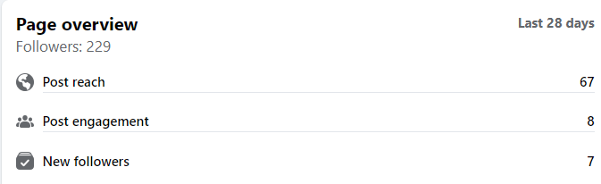

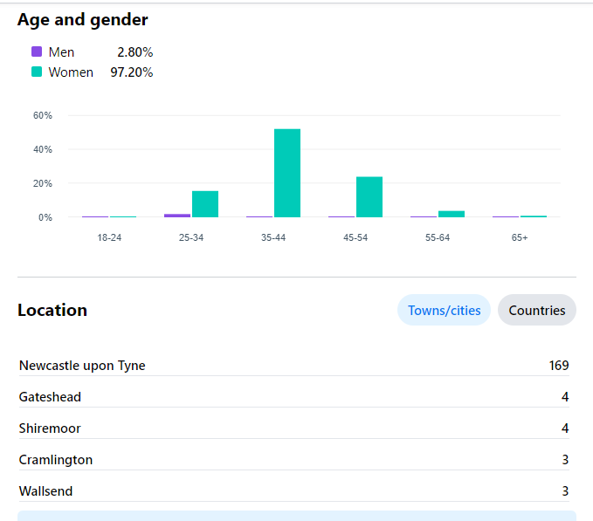

**Feedback from parents and carers**

SENDIASS report to the Council for disabled children (CDC) at set points throughout the year. These reports are based on service statistics and parent/carer feedback.

These are the set questions and responses given for the year 2021-2022

* Average score (1-10) of how worried parents felt before contacting the service

10

* Average score (1-10) of how worried parents felt after contacting the service

1

* 95% of parents/carers felt it was easy or very easy to get in touch with SENDIASS
* 100% of parents/carers felt the information, advice and support given by SENDIASS was helpful or very helpful
* 97% of parents/carers felt the SENDIAS service was neutral, fair and unbiased
* 100% of parents/carers were satisfied or very satisfied with the service SENDIASS provided
* 100% of parents/carers said it was likely or very likely that they would recommend the SENDIAS service.

"Just a quick thank you for supporting yesterday’s meeting. Very pleased you were there. "

“Thanks for coming today and apologies again about the late notice. All the meetings have really been a much more positive experience since sendias have been involved, which is ultimately making XXX more comfortable!”

“You are marvellous, thank you very much”.

I just wanted to say thank you very much for your help in the meeting with school. I felt you really heard what we are worried about and helped us explain that to school. We got much further in that meeting that we did in the last one as a result.

“Thanks for everything, you’ve been an absolute god send”

“Thank you for your intervention and support at yesterday’s meeting, It was agreed that he will be part of his own year group again.”

“Thank you so much for getting me an answer yesterday and the right answer I have been waiting for! Was lovely speaking to you yesterday. Thank you for all your help and support!”

“I just wanted to say thanks for your help and support today. It really helps the situation having you on the call.”

**Case study**

We have included a couple of case studies so that you can read about real things happening to real people. We have changed any names to protect the confidentiality of the service users. The case studies give examples of the way in which we provide advice and support.

|  |  |
| --- | --- |
|  | **Early intervention** |
| **Case study**  **1** | **During an initial appointment Children and Young People’s Service (CYPS) signposted a parent to the service. We were able to become involved at the earliest stage and support the parent through age phase transfer.** |

|  |
| --- |
| **Introduction**  This case involved a child going through age phase transfer to Secondary School. Children and Young People’s Service (CYPS) signposted the parent to the service. We supported the parent through the transition and helped to ensure that the Secondary school was able to provide the correct support from the start. |
| **Background**  The parent attended an initial appointment at the Children and Young People’s Service (CYPS) in April 2020. During that appointment they mentioned Newcastle SENDIASS and the benefits that the service might bring to families.  The parent contacted the service to check what SEND IASS could do for her. The child has a range of needs and although she was being well supported in the Primary school, the parent was really concerned about the transition to Secondary School. |
| **Aims and objectives**  Our objective was to ensure that there was a good supported transition process.  We wanted the Secondary School to gain a good understanding of the child’s needs, and how the Primary School were meeting those needs. They would then be able to form a plan for how they were going to implement strategies and meet her needs from the first day of her attending.  At the end of the process we wanted the Secondary school to be able to provide the correct level of support and successfully meet all her needs. Both schools and all the professionals involved would understand the impact a well-supported transition can have and their role in the process. |
| **Approach**  When the parent contacted the service, we spoke at length about how things were going for her child at school and what her concerns were for moving forwards. The parent was very clear that although her child has a range of needs, the Primary School have been able to meet them.  Through the discussion the parent informed us of the various professionals that are currently involved with her child. We were able to establish two key pieces of information that we look for:   * The right people are involved * They are doing the right things   We explained to the parent how a well-supported transition can work and what would need to happen to facilitate this. We attended a transition meeting with her Mum soon after the May half term holiday. The Secondary School SENCO made a note of what support is needed and all the professionals involved were able to feed in to the process.  However, at the start of the September term the parent contacted us to say that things were starting to go wrong, and she felt her child’s needs were not being met. We supported the parent at a meeting with school to discuss what was successful and what was not working. We were able to draw on the expertise of professionals involved who advised school with alternative strategies and adapting existing successful strategies to suit the Secondary setting.  The meeting was productive and enabled the school to form a clear plan moving forward. The parent felt reassured that school understood her child’s needs and would be able to make a few tweaks to the provision which would make it a success. |
| **Challenge**  The two schools involved in the process did not have a clear plan for the transition. Our involvement helped get things right for this individual child and helped the schools to gain a better understanding of how a supported transition can work.  There were a number of professionals involved with this child, who were doing the right things within their area of expertise; however, none of them were experts on SEN processes. Our involvement helped to draw on their expertise and apply it to the process to ensure a smooth transition happened. It also enabled the professionals to stay within their remit and prevent any bad advice or misinformation being given as part of the process.  Things started to go wrong once the child had transitioned to the secondary school. Our involvement enabled us to work with the parent and the school to resolve these quickly, to get things back on track and ensure the child’s needs were being met. |
| **Successes**  Having worked closely with the team at the Children and Young People’s Service (CYPS) the worker had a good understanding of our role and signposted the parent to us at the earliest opportunity. This enabled us to have a positive impact and get things on track without the parent waiting until things had reached crisis point before being signposted to us.  Supporting the parent through this process gave both schools a greater understanding of how to implement a supported transition. The Primary school gained insight into what is possible in the secondary setting.  The meeting at the Secondary school enabled the SENCO to take advice from a range of professionals and understand their responsibilities in their duty to meet the child’s needs. |
| **Conclusion**  The support we offered the parent with this case helped her to feel reassured that the right things were being agreed. She felt supported at a time of high anxiety and was able to reach out as soon as she felt that things were no longer working.  This case highlighted the importance to us of publicising our service to the teams within health and social care, as well as local voluntary services. The knowledge and understanding of our service enabled the worker from the Children and Young People’s Service (CYPS) to signpost the parent to us at the earliest opportunity. This meant that we were able to be more effective and help to put things right, avoiding the situation reaching crisis point.  All professionals who were involved in the case have a greater understanding of our role and the difference that we can make. This will help them realise when to signpost to us when they come across future situations.  The Secondary school now has a better understanding of how a supported transition should be implemented, how flexible they can be with their provision, their duty to meet need and who they can contact if they need further advice. |

|  |  |
| --- | --- |
|  | **Disagreeing with the Local Authority over placement** |
| **Case study**  **2** | **The school SENCO recommended parents contact us after they had requested a change of placement at Annual Review. The child was currently at a mainstream Primary school and they were requesting an independent special school, the Local Authority were not in agreement.** |

|  |
| --- |
| **Introduction**  This case involved a child going through age phase transfer to Secondary School. The child was currently placed in a mainstream Primary School where they received over 15 hours 1:1 support, the parents were requesting an Independent Special School to be named on the EHCP for Secondary school. They had held an Annual review in the Autumn term and submitted their request which had been turned down. They had worked with the school and were holding another review with additional evidence; it was at this point they contacted us for support. |
| **Background**  Their child has a diagnosis of Autism Spectrum Disorder, he was in Year 6 and was working at around year 1 academically. School had requested an EHCP when the child was in Year 5 and had since been providing 15 hours 1:1 support to teach him numeracy, literacy and phonics in a separate room to his class.  When preparing for the Year 6 Annual Review they were considering Secondary options and given his academic abilities they felt very strongly that a mainstream Secondary School could not meet his needs. The Local Authority presented the evidence from the review to the panel and then made the decision that mainstream could continue to meet his needs.  School contacted numerous professionals that had been involved to pull additional evidence together. They then co-ordinated a second annual review and recommended parents contacted our service and invited us to attend. |
| **Aims and objectives**  Our objective was to support the parents to express their views to the Local Authority.  We wanted school to understand what criteria the decision will be based on and the evidence they needed to present to the Local Authority. They would then be able to present the correct information which would enable the Local Authority to understand the child’s needs.  We wanted the parents to be clear on the criteria that the Local Authority would be using to make their decision so that they could present their strongest argument. The parents were very concerned about bullying and transport, and although they needed to express their concerns, we wanted them to understand that his cognition and ability to access learning was the strongest evidence for his need for a specialist setting.  Our aim was for all professionals to be on the same page and ensure that all concerns were recorded and presented to the panel so the decision would be based on all of the information.  At the end of the process we wanted the Primary school to have a better understanding of the process and the evidence they need to present. |
| **Approach**  When the parent contacted the service, we spoke at length about how things were going for his child at school and what his concerns were for moving forwards. The parent was very clear that although the Primary School have been able to meet his needs it has taken an extensive amount of 1:1 support and he felt there was no way a mainstream secondary provision would be able to.  We talked about the upcoming review meeting and supported the parent to write down key points that were pivotal to his request. The parent had a lot of concerns and needed support to prioritise which points were the basis for his argument, which points provided additional evidence and then his other concerns that needed to be expressed to give the whole picture.  The parent was really concerned that school have been really supportive and have provided loads of evidence, but the local authority had said that there was a lack of evidence for the need to change placement. I explained to the parent that sometimes there is confusion over what to provide as evidence and agreed to speak to the school SENCO to ensure that she had everything she needed in preparation for the review.  We called the SENCO and were able to provide her with structure to present the evidence to the local authority. For a lot of the evidence she had there was no context which made it difficult for the local authority to gain a real insight into the support required for this child to access education.  We attended the annual review to support the parents, but due to the pandemic this was a virtual meeting. During the course of the meeting we were able to keep the conversation focused. The conversations we had had prior to the meeting were evident as both parents and school were able to express their views and evidence very clearly and concisely. The SEN caseworker from the local authority gained a real insight into the concerns and understood why a special school placement was being pursued.  After the meeting we spoke to the parents to debrief and answer any questions they had. They felt that meeting had gone much better than they were expecting because of the preparation they had been able to do for it.  The parents contacted us a few days after the panel date to say that they had still not heard the outcome. We got their permission to call the Local Authority and do some fact finding. We called the SEN Caseworker and were told that a decision had not been made but the panel were recommending mainstream placement based on a lack of evidence. We commented on the evidence that had been raised at the meeting at which point it became evident that there had been no notes taken at the meeting.  We called the SEND assessment, provision and review manager and explained to him that we were really concerned that panel were still recommending mainstream provision. We explained that it had been clear in the meeting that this child is not able to have his needs met within mainstream settings and it seems that has not translated onto the information that the panel reviewed. He assured us that he had not made a decision yet and he would like an Education Psychologist to provide advice before finalising a decision.  We called the parents to inform them of the next steps. We helped them to prepare for their discussion with the education psychologist by structuring their points, and we helped them to understand what information the psychologist would need to understand why mainstream is unsuitable. |
| **Challenge**  Everyone involved with this child had a really good understanding of his needs and how to support them and were really clear that it was not possible within a mainstream setting; however, they were not clear on how to present that information to the Local Authority. Our involvement helped to draw on their expertise and apply it to the process to ensure the Local Authority were presented with all of the relevant information to make an informed.  There was a breakdown of communication which was resulting in the panel making a recommendation which would not meet the child’s needs. Our direct communication with the SEND manager meant we were able to relay the information from the review meeting that was not presented clearly to the panel.  We had to manage parents’ expectations throughout the process. We were very clear that we would help them to express their concerns and help all parties to understand the evidence that was needed, but we could not guarantee the outcome. This came to us at the end of the summer term when the child was in Year 6 so we also had to prepare the parents for the child transitioning to the mainstream secondary school, as the timing meant if the local authority named mainstream the next academic year would start before there would be time to appeal the decision. We had regular contact with the SENCO at the mainstream secondary school and he was preparing to do some transition work in the summer if the Local Authority named mainstream. |
| **Successes**  Unfortunately, things were already at crisis when the parents contacted us, however our involvement helped the professionals to gain a better understanding of the process and the need to signpost parents to us at the earliest point.  Supporting parents through this process gave school a greater understanding of the evidence that is needed for the Local Authority and the importance of the timing for going through such processes.  This case highlighted the need to record the information that is given during the discussion at review meetings and to ensure that the information is passed to the panel. Our communication with the Local Authority officers also drew attention to this point as something that should be considered moving forwards. |
| **Conclusion**  The support we offered the parents with this case helped them to feel empowered, they were able to express their views in meetings and understand the process. They felt supported at a time of high anxiety and we were able to provide clarity and structure at every stage of the process.  This case highlighted the importance to us of publicising our service to the teams within education, health and social care, as well as local voluntary services. The parents were signposted to us when the situation was already at crisis point, rather than at the earliest opportunity. All professionals who were involved in the case have a greater understanding of our role and the difference that we can make. This will help them realise when to signpost to us when they come across future situations.  The Primary school now has a better understanding of how to present evidence and the evidence that is needed to help the panel make an informed decision. They also have a better understanding of the process and how important the timing of going through the EHC process is.  The key issue in this case was communication, we enabled the parents to communicate their views clearly and prioritise the key points. We communicated with all parties to ensure the vital pieces of information were not missed and, we highlighted the need for verbal information to be recorded at key meetings.  The Local Authority named the independent special school in the final plan. When we spoke to the Primary school we were able to make it clear that we do not have any power over the decisions that are made, but rather we had ensured that all of the information had been presented so the Local Authority were making an informed decision. The Local Authority made their decision based on the evidence which clearly demonstrated his needs could not be met within mainstream. |
| **Parent feedback**  “We wouldn’t have got the outcome if it wasn’t for you. You made it really clear what information was needed from all of the professionals and helped the Local Authority to understand. You were brilliant, thank you.” |

**Feedback from Professionals**

“I just wanted to say thank you so much for your help in the review yesterday. Your advice was greatly appreciated and always will be!”

SENCO

“I don’t know how families do this without the support of the likes of yourself and SENDIASS”

Specialist teacher

“Thank you for your help, I’ve just finished writing up his profile. And I wouldn’t have been able to without your support and help.”

SENCO

“I think your service is just wonderful. I think what you do is so good and I recommend you to everyone. You’re just fantastic and always there in an emergency.”

Community practitioner CYPS

“I really appreciate what SENDIASS do, you are so helpful in meetings. When Helen came out a meeting that you attended last week, she was so complimentary about how helpful you were”

Secondary Principal

“Thank you for your support at the meetings”

Family support worker

**Learning, Development and Growth**

**Continuing to develop**

* Collaborative working. We recognise the need for SEND information providers to be working together. The service has been instrumental in the development of the SEND information, advice and support network. This network consists of local organisations that are working strategically to improve the service within Newcastle. They are committed to ensuring the right information, advice and support is being provided at the right time by the most appropriate provider. The network has not meant since the pandemic, however there is a real need to get this going again and to work together.
* We have adapted the service to young people yet, we need to continue to grow this service and increase the reach across young people with SEN in the city. Our children and young person’s officer has established clinics in the secondary schools across the city, we would like to increase this to post-16 and specialist settings this year.
* Training and awareness. The minimum standards detail that the service should provide training to parents, carers and professionals. This is not something we have implemented during the pandemic however we previously had real success with our training sessions. These sessions help to promote the service, increase understanding around SEND processes, and help to ensure that organisations are signposting to the service at the earliest opportunities.

**Questions for the future**

These are the questions we are asking ourselves as we develop the service and plan for the next year.

* How can we ensure that the service can accommodate the ever-increasing demand?
* How can we ensure that parents, carers and young people know about the service and access it when they need it?
* How can we encourage more joined up working between Education, Health and Social Care services?
* How can we ensure that the voices of parents, carers and young people are listened to and responded to by schools, the local authority and the government so that we respond to the needs of all?



**You can contact the Special Educational Needs and Disabilities Information, Advice and Support Service (SEND IASS) at**

**Woodlands Children’s Centre**

**Newton Place**

**High Heaton**

**Newcastle Upon Tyne**

**NE7 7HD**

**Phone: 0191 211 6244**

**Email:** [**sendiassadmin@newcastle.gov.uk**](mailto:sendiassadmin@newcastle.gov.uk)

**www.newcastlesendiass.co.uk**