


SEN and Disabilities
Review Framework
Special Schools

Updated by
School Effectiveness SEND Team
September 2022

School:

SEND GUIDANCE

The SEN and Disabilities Framework is a tool to support the leadership and management in improving provision and outcomes for pupils in their school.

The self-assessment is divided into 5 sections. Within each of the sections there is a set of statements against which the school can evaluate current practice. The statements cover the range of activities which together help the school to improve its provision. The self-assessment may be completed at a single session or at several over a period of time.

The completed self-assessment allows the school to:

- identify strengths and areas for development
- prioritise actions according to its own judgements
- identify lines of enquiry for peer reviews

This review framework reflects:
- The SEND Code of Practice 2014:
Improving outcomes: high aspirations and expectations for children and young people with SEND
6.1 All children and young people are entitled to an education that enables them to make progress so that they:
- achieve their best
- become confident individuals living fulfilling lives, and
- make a successful transition into adulthood, whether into employment, further or higher education or training.
- Whole School SEND Review Guide – annex 2 for special schools

- Ofsted education inspection framework, July 2021

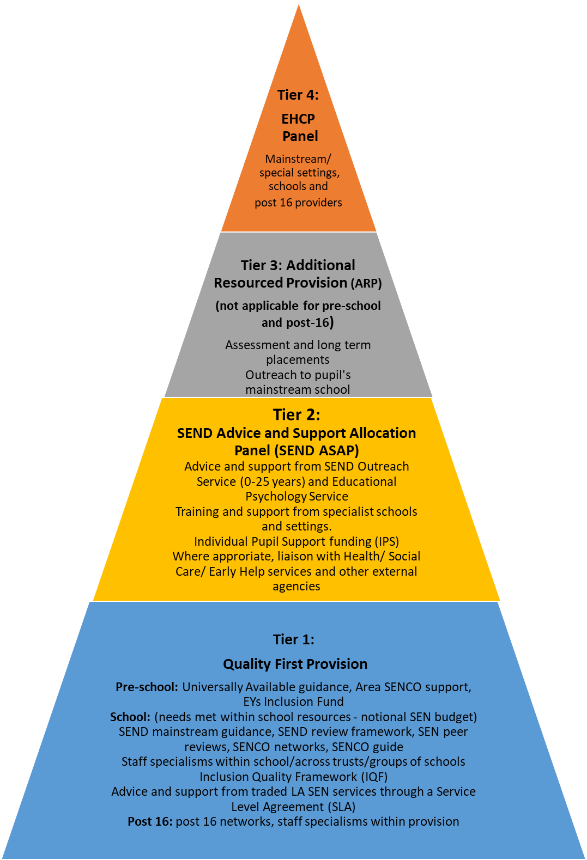




How we meet SEND needs in Newcastle for Children and Young People (CYP) age 0-25 in early years settings, schools, and post 16 providers
(The Graduated Response)

April 2022

This is not intended to show a SEND pathway for individual support. It outlines the support available at various levels of the graduated response. For example, a child or young person may have an EHCP without accessing SEND ASAP or an ARP placement. It is also possible for a child or young person with an EHCP to access support via SEND ASAP

Section 1: Achievement and Outcomes

 |  | Yes | To some extent | No | Evidence / Actions / comments
a. | The school uses a range of diagnostic tools and the expertise of outside agencies to identify and review the specific needs of pupils.
b. | Pupils have their progress reviewed in line with whole school assessment procedures.
c. | Pupils have personalised plans that are reviewed at least 3 times a year with parents and carers and changes to provision made as required.
d. | Pupil outcomes are aspirational and prepare them for their next steps in learning and development.
e. | Regular moderation of teacher assessment takes place, both internally and with local partners.
f. | From their different starting points and considering their individual academic and non-academic needs pupils make expected progress. Internal as well as local authority and national data sets are used to evidence this.
g. | The school effectively evaluates the impact of interventions with cohorts of pupils.
h. | Attendance rates, behaviour and exclusions of pupils is closely monitored and scrutinised to ensure all needs are addressed effectively.
i. | Provision is focused on pupils needs. Senior and middle leaders work closely with teachers to ensure the curriculum is accessible.
j. | Documentation shows a logical sequence of assess, plan, do and review.
k. | Annual reviews are carried out in line with national and local guidance.
l. | Pupils are encouraged to be actively involved in all aspects of their support plans and reviews and their contributions are valued and recorded.
m. | Pupils making transitions into post-16 or post-19 EET are supported and their outcomes are tracked (in liaison with The Careers and Guidance Team).

Section 2: Provision, Access and Support

 |  | Yes | To some extent | No | Actions / comments
a. | The school has developed a broad range of balanced provision and pupils can access a wide range of support.
b. | The curriculum and care practices meet the needs of all pupils.
c. | Provision is planned on an annual audit of pupils needs.
d. | Provision addresses expected outcomes of the EHCP.
e. | Provision enables pupils to have a positive attitude to learning and experiences.
f. | The school uses a range of appropriate evidence-based interventions which are coordinated effectively to ensure they have a positive impact on outcomes. Outcomes from interventions are integrated into classroom teaching.
g. | There are identified areas within the school for use as a quiet / time out / low arousal space.
h. | There are effective systems in place for the transfer and induction of pupils. Pupils and their parents/ carers are central to this process.
i. | Pupils are actively involved and prepared for the next stage of their education, training, employment and independent living.
j. | There is effective liaison with external agencies.
k. | Pupils can access appropriate personal support.
l. | Induction programmes / procedures are in place, to inform new and supply staff about the needs of pupils.
m. | Pupils have confidence in the procedures to address issues of bullying.
n. | The school can show evidence of effective intervention and consistent practice for bullying or racist behaviour
o. | Systems are in place to give pupils a voice e.g. school council, peer supporters and Mentor/ Buddy schemes. Pupils are provided with opportunities to express their views through appropriate communication methods.
p. | Pupils have access to an equitable offer of meaningful enrichment activities, lunchtime clubs and wrap around activities.
q. | Clear and effective risk assessment procedures, including positive handling, are in place for identified pupils who may be at risk or present a risk to others.
r. | There are procedures in place to help identify and support issues of mental health within the school.
s. | The school seeks to minimise exclusions and can demonstrate that all reasonable steps have been taken before exclusion is used.
t. | Pupils with SEND should not be offered a partial timetable unless there are exceptional circumstances. Any partial timetable should be short term and reviewed regularly with the parent/ carer and pupil.

Section 3: Teaching and Learning

 |  | Yes | To some extent | No | Actions / comments
a. | Teachers and leaders have a good understanding of how pupils with SEND achieve irrespective of complexity of need.
b. | Staff have a clear understanding of pupil need and personalised strategies are informed by parent/ carer partnership.
c. | Teachers’ planning (and other evidence such as direct observation) takes account of pupils’ identified needs and shows that a range of strategies is in use.
d. | Systems are in place to ensure the awareness among staff of the particular needs of pupils and an understanding of practical ways of meeting those needs in the classroom.
e. | The curriculum enables pupils to know, remember and do more so that they achieve the best possible outcomes.
f. | The school has a high degree of expertise across staff in all age phases and is aware of areas for further improvement.
g. | All staff receive regular, high quality CPD to support improved progress and outcomes.
h. | Systems are in place to monitor the quality of teaching and classroom practice is rigorously evaluated. Evidence shows that teaching of all pupils is considered to be consistently good or better.
i. | All staff set high expectations for all learners across the curriculum and support pupils to meet these expectations.
j. | Support staff are well briefed for all activities and work confidently in classrooms and / or intervention programmes.
k. | The deployment of support staff is regularly reviewed and evaluated for impact. Any specialisms and expertise are utilised and matched to the specific needs of pupils.
l. | All staff have easy access to current targets / outcomes for pupils they teach or support.
m. | Pupils show positive attitudes towards the provision made for them and can talk / communicate about their learning.

Section 4: Leadership and Management

 |  | Yes | To some extent | No | Actions / comments
a. | The school has a clear vision for the education of all pupils on its roll.
b. | There is a clear strategic plan for the relationship between education and therapeutic provision.
c. | The school has a culture of high aspirations for all pupils irrespective of complexity of need.
d. | The school pays due regard to the SEND Code of Practice (2014). The school has published its SEND information report online which provides a comprehensive summary of provision and includes links to the Local Offer.
e. | The school is appropriately staffed and resourced in order to ensure high quality provision and that the pupils have their statutory needs met.
f. | The leadership team have a good understanding of the Local Offer and specialist agencies, including health and social care services, available to support pupils with SEND.
g. | Governors hold the school to account in order to have a positive impact on the outcomes for all pupils.
h. | There is a strategic approach to continuing professional development (CPD) which ensures that all staff are effective in meeting the needs of pupils with SEND.
i. | Multiagency support is engaged appropriately and utilised effectively.
j. | The school has systems to monitor the effectiveness of quality first teaching and interventions.
k. | There is positive feedback from parents / carers and any issues are dealt with effectively.
l. | Support staff are well deployed to make teaching work more effectively.
m. | The school has an up to date behaviour policy and guidance which meets the needs of all pupils.
n. | The school is outward facing and actively engages with other settings and the LA to develop practice.

Section 5: Parent / Carer Partnerships

 |  | Yes | To some extent | No | Actions / comments
a. | Parents/carers are provided with appropriate information including SENDIASS and how to find and use the Local Offer.
b. | The SEND information report provides a comprehensive summary of provision at the school.
c. | The school recognises the role parents/carers have in their child’s education and fully involves them in co-production and can demonstrate this.
d. | The school maintains regular contact with parents/carers in sharing successes and concerns.
e. | Parents/carers are fully involved in transition arrangements from one phase or school to another.
f. | The school recognises the differing needs of parents/carers themselves, (i.e. a disability or communication or linguistic barriers) and takes steps to address these to enable the parents/carers to participate fully in their child’s education.
g. | The school asks for feedback from parents / carers to meaningfully contribute to shaping the quality of support and provision.
h. | Parental surveys/questionnaires reflect positive experiences for parents/carers. Any identified concerns are addressed.
i. | Systems are in place to allow parents and carers to meaningfully contribute to shaping the quality of  support and provision,  The school and parents work in partnership to achieve genuine co-production, for example parent/  carer forums and workshops.

