


SEN and Disabilities
Review Framework

Updated by
School Effectiveness SEND Team
September 2022

School:

Date completed:

SEND GUIDANCE

The SEN and Disabilities Framework is to support the leadership and management of SEND leading to improved outcomes for pupils with SEND.

The self-assessment is divided into 6 sections. Section 1 is the financial management of resources. Within each of the other 5 sections there is a set of statements against which the school can evaluate current practice. The statements cover the range of activities which together help the school to improve its SEND provision. The self-assessment may be completed at a single session or at several over a period of time.

The completed self-assessment allows the school to:

- identify strengths and areas for development
- prioritise actions according to its own judgements
- identify lines of enquiry for SEND peer reviews

This review framework reflects:
- The SEND Code of Practice 2014:
Improving outcomes: high aspirations and expectations for children and young people with SEN
6.1 All children and young people are entitled to an education that enables them to make progress so that they:
- achieve their best
- become confident individuals living fulfilling lives, and
- make a successful transition into adulthood, whether into employment, further or higher education or training.
- SEND mainstream guidance for supporting children and young people who have special educational needs and disabilities (SEND) at SEN support in mainstream schools and settings, July 2021

- Ofsted education inspection framework, July 2021

- The graduated response to meeting special educational needs in Newcastle, April 2022

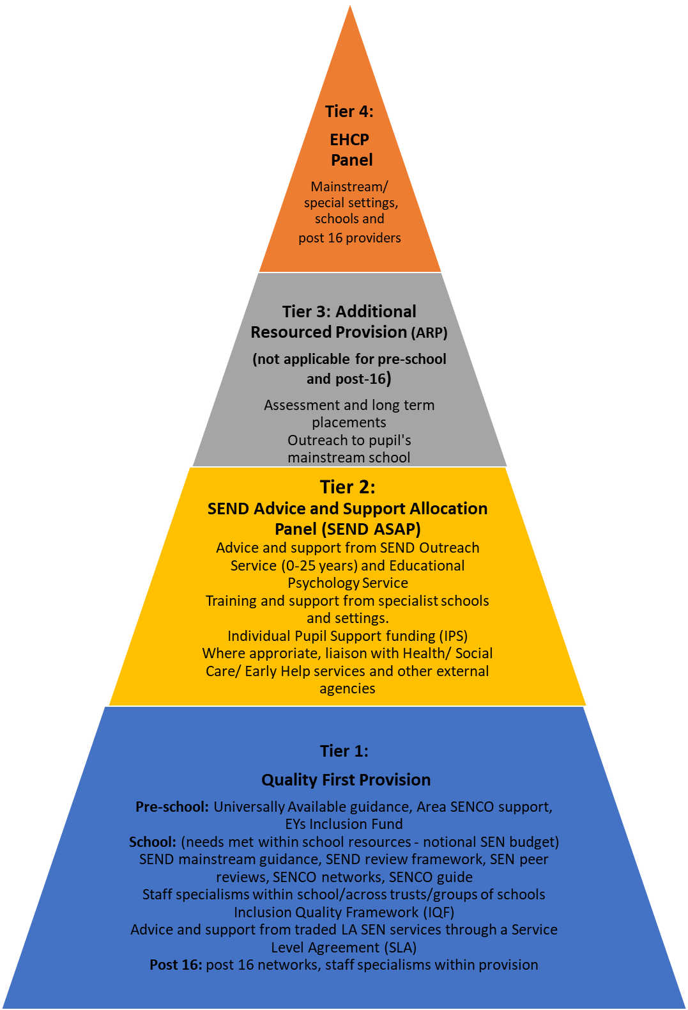


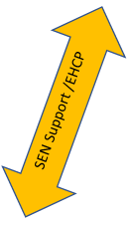

This is not intended to show a SEND pathway for individual support. It outlines the support available at various levels of the graduated response. For example, a child or young person may have an EHCP without accessing SEND ASAP or an ARP placement. It is also possible for a child or young person with an EHCP to access support via SEND ASAP

How we meet SEND needs in Newcastle for Children and Young People (CYP) age 0-25 in early years settings, schools, and post 16 providers
(The Graduated Response)

April 2022

Section 1: Management of Resources

Local authorities have a legal responsibility to ensure that the special educational needs of pupils are met. There are three elements of funding to support pupils with SEND.

Element 1 – A generic amount for each pupil on roll i.e., the whole school budget share divided by the number of pupils.
Element 2 – Any amount from a school’s notional budget for SEND across the school, up to a maximum of £6,000 for any one pupil.
Element 3 – High Needs top-up funding for named pupils from the Local Authority central fund.

Other funding sources can also be used to secure the best outcomes for pupils with SEND. For example:
- If a pupil has SEND and is also in receipt of Pupil Premium the available funding can be pooled to meet identified needs.
- Some pupils with complex needs and an EHC Plan may be in receipt of Social Care or Health funding to help them achieve educational outcomes.
- In early years, Disability Access Fund and inclusion fund allocations.

A school should have a clear rationale for the financial decisions it makes, including for the notional SEND budget. Completion of Section 1 will ensure that spending decisions are transparent and can help inform financial decisions.

Section 1: Management of Resources

Total number of pupils on roll
Number of pupils at SEN Support
Number of pupils with individual pupil support funding (IPS)
Number of pupils with an EHCP

The next table is designed to help you to describe all of the SEND funding your school receives for mainstream pupils from Newcastle or any other LA.

*Education financial resources delegated by the LA for SEND within the school budget: | Total amount
Element 2, notional SEND budget  (Elements of AWPU, deprivation and low prior attainment) | £
Element 3, also known as High Needs top-up funding for specific pupils  (IPS and EHCPs) | £
Early years, where applicable
Disability Access Fund
Inclusion Fund allocations
TOTAL SEND FUNDING | £

Guidance notes

*The allocation of SEND education funding can be complex:
- Element 2 funding is allocated per financial year, from April to March for LA schools and Sept to August for academies. It does not change during the year because SEND pupils leave or start at the school.
- Element 3 funding is a per-year amount for named pupils which can start / end at any time during the financial or academic year. The LA agrees the funding per-financial year and adjust it on a termly basis if anything changes for that pupil.

Does your school receive any other resources specifically for SEND pupils which are not paid for from the finances listed above? Describe those resources here:

The school’s spending on SEND provision from Element 2 notional SEND budget and Element 3 for specific pupils with high needs is identified against the following:
£
Please specify in detail below how the notional SEND is spent:
SEN support
EHCP

Please specify in detail below how the High Needs Top Up is spent:
SEN support with IPS
EHCP

Other funding (can include delegated budget / grants/ Trust funding)
Making any provision, in addition to the above, to meet the requirements of pupils with SEND at SEN support, High Needs top up and EHC Plans.
Expenditure total:

The school provides the following from its delegated budget:

Providing a SENCO/Inclusion Manager in line with the expectations of the SEND Code of Practice (2014)
Providing pastoral and management time in addition to that of the SENCO
Providing additional staffing aimed at reducing class sizes in such a way as to benefit identified groups of pupils with SEND
Providing training in SEND/Inclusion for Governors
Capital and recurrent expenditure on specific areas for additional educational needs including reasonable minor adaptations.
Publications for staff, governors, parents/carers, pupils.
Provision for every pupil to be included in all activities including school trips and out of school clubs.

Section 2: Achievement and Outcomes

 |  | Yes | To some extent | No | Evidence / Actions / comments
a. | Whole-school assessment procedures are used as a tool for the early identification of pupils with SEND.
b. | The school uses a range of diagnostic tools and the expertise of outside agencies to identify and review the specific needs of pupils.
c. | Pupils with SEND have their progress reviewed in line with whole school assessment procedures.
d. | Pupils’ outcomes and progress are reviewed at least 3 times a year and changes to provision made as required.
e. | Pupil outcomes should prepare them for their next steps in learning and development.
f. | Regular moderation of teacher assessment takes place, both internally and with local partners.
g. | From their different starting points pupils make expected progress. Internal as well as local authority and national data sets are used to evidence this.
h. | Significant variation in the progress measures of pupils with SEND when compared with non-SEND pupils is identified and addressed.
i. | For pupils with SEND, outcomes are improving as a result of the different or additional provision being made for them.
j | Evidence informed and targeted interventions are used. Such interventions are planned so that they do not interrupt learning sequences within the curriculum.
k. | The school evaluates effectively the impact of interventions with cohorts of pupils.
l. | Significant variation in the attendance rates of pupils with SEND compared to the rates for other groups of pupils is identified and addressed.
m. | The list of pupils with SEND is regularly updated and distributed.
n. | Provision is focused on pupils needs and reflects that which is additional and different beyond quality first teaching and an accessible curriculum expected of class teachers.
o. | Documentation shows a logical sequence of assess, plan, do and review.
p. | EHCP Annual Reviews are carried out in line with national and local guidance.
q. | Pupils and parents / carers are informed of the purpose of the additional provision that is being made to meet identified needs.
r. | Pupils are encouraged to be actively involved in all aspects of their support plans and their contributions are valued and recorded.
s. | Pupils making transitions into post-16 or post-19 EET are supported and their outcomes are tracked (in liaison with The Careers and Guidance Team).

Section 3: Provision, Access and Support

 |  | Yes | To some extent | No | Actions / comments
a. | There are clear entry and exit criteria for additional and different support, either in class or on a withdrawal basis, and these are consistently applied.
b. | Baseline measures of pupil performance are recorded prior to the start of any new intervention and are included in regular reviews of pupil progress.
c. | All pupils receive their full entitlement to a broad, balanced and accessible curriculum.
d. | The curriculum and care practices meet the needs of pupils with SEND.
e. | Pupils with EHCPs: provision addresses expected outcomes of the EHCP.
f. | Pupils receiving IPS top up funding: provision addresses identified needs.
g. | Pupils at SEN support: provision addresses identified needs.
h. | Provision enables pupils to have a positive attitude to learning and experiences.
i. | The school uses a range of appropriate evidence-based interventions.
j. | All staff are aware of the nature and location of resources including ICT and these are accessible.
k. | There is an identified area within the school for use as a quiet / time out / low arousal space.
l. | There are effective systems in place for the transfer and induction of pupils. Pupils are central to this process.
m. | Pupils are actively involved and prepared for the next stage of their education, training, employment and independent living.
n. | There is effective liaison with external agencies.
o. | Pupils can access appropriate personal support.
p. | Appropriate documentation is in place and reviewed annually  - SEND policy  - SEND information  - Annual SEND report  - Accessibility Plan (3 years).
q. | Induction programmes / procedures are in place, to inform new and supply staff about the needs of identified pupils.
r. | Pupils with SEND have confidence in the procedures to address issues of bullying.
s. | The school can show evidence of intervention and consistent practice for bullying or racist behaviour
t. | Medical policy updated in line with the statutory guidance ‘Supporting pupils at school with medical conditions’ (updated 2017)
u. | Procedures re medical interventions are clear, effective and reviewed regularly with medical representatives.
v. | Health care plans are in place for pupils with physical and/or medical needs. Staff are aware of these and confident in implementing them.
w. | Systems are in place to give pupils a voice e.g. school council, peer supporters and mentor/ buddy schemes. Pupils with SEND are proportionately represented.
x. | Clear and effective risk assessment procedures, including positive handling, are in place for identified pupils who may be at risk or present a risk to others.
y. | There are procedures in place to help identify and support issues of mental health within the school.
z. | The school seeks to minimise exclusions and can demonstrate that all reasonable steps have been taken before exclusion is used.
aa. | Significant variation in the number of managed moves and in year transfers for pupils with SEND compared with non-SEND is identified and addressed.
bb. | Alternative provision is suitable and safe and meets academic/ vocational/ technical and pastoral needs.
cc. | Pupils with SEND should not be offered a partial timetable unless there are exceptional circumstances. Any partial timetable should be short term and reviewed regularly with the parent/ carer and pupil.

Section 4: Teaching and Learning

 |  | Yes | To some extent | No | Actions / comments
a. | Teachers follow the cycle of assess, plan, do and review as outlined in the graduated response and deliver high quality teaching to all pupils.
b. | Teachers’ planning (and other evidence such as direct observation) takes account of pupils’ identified needs and shows that a range of strategies for an accessible curriculum are in use.
c. | Systems are in place to ensure the awareness among staff of the particular needs of pupils and an understanding of practical ways of meeting those needs in the classroom.
d. | The curriculum enables pupils with SEND to know, remember and do more so that they achieve the best possible outcomes.
e. | Teachers and teaching assistants (TAs) are involved in curriculum planning and review.
f. | All staff receive regular, high-quality CPD.
g. | Systems are in place to monitor the quality of teaching including interventions.
h. | All staff set high expectations for all learners across the curriculum and support pupils to meet these expectations.
i. | TAs are well briefed for all activities and work confidently in mainstream classrooms and / or intervention programmes.
j. | The deployment of TAs is regularly reviewed and evaluated for impact. Any specialisms and expertise are utilised and matched to the specific needs of pupils.
k. | Outcomes from interventions are integrated into classroom teaching. The class teacher retains the responsibility for the progress and outcomes of all pupils.
l. | All staff have easy access to current targets / outcomes for pupils they teach or support.
m. | Staff CPD regularly focus on SEND and inclusion.  Local and national guidance is effectively disseminated, including the SEND Mainstream Guidance.
n. | Pupils show positive attitudes towards the provision made for them and can talk about their learning.

Section 5: Leadership and Management

 |  | Yes | To some extent | No | Actions / comments
a. | The school pays due regard to the SEND Code of Practice (2014). The school has published its SEND information report online and includes links to the Local Offer, to meet statutory requirements.
b. | The SEND information report is on the school website and is reviewed annually in the light of feedback from parents / carers and pupils.
c. | The SENCO has a good understanding of the Local Offer and specialist agencies, including health and social care services available to support pupils with SEND.
d. | Securing better outcomes for pupils with SEND is included in the School Development Plan.
e. | There is an action plan for SEND and this is regularly reviewed as part of an internal evaluation cycle.
f. | There is a strategic approach to continuing professional development (CPD) which ensures that all staff are effective in meeting the needs of pupils with SEND.
g. | The effectiveness of quality first teaching is considered before assuming a pupil has SEND.
h. | A new SENCO (from Sept 2009) has achieved or is studying for the NASC award.
i. | The SLT ensures the SENCO has sufficient protected time to carry out the role effectively.
j. | The SENCO liaises with the leadership team and contributes to the decision-making process, including financial, relating to SEND.
k. | There is a systematic record and evaluation of the use of all SEND funding.
l. | There are regular meetings between the SEND governor and the SENCO.
m. | The governors hold the school to account on the effectiveness of resources in relation to SEND.
n. | The SEND link governor has attended appropriate training.
o. | The SENCO liaises with the Designated Teacher where a child in care also has SEND.
p. | The school has systems to monitor the effectiveness of quality first teaching and interventions.
q. | There is positive feedback from parents / carers and any issues are dealt with effectively.
r. | TAs are well deployed to make teaching work more effectively.
s. | Pupils with SEND are able to and actively encouraged to participate fully in the life of the school.
t. | The school has an up-to-date behaviour policy and guidance which meets the needs of all pupils, including early identification where challenging behaviour may be reflective of an underlying SEND.
u. | The SENCO actively engages with other settings and the LA.
v. | The number of pupils with SEND moving on and off roll is monitored.
w. | There is evidence that any managed moves are carried out within the statutory guidance and used in the pupil’s best interests.
x. | The school, in conjunction with the Local Authority, identify pupils missing education and ensure that pupils remain on the roll of the school until admission to another setting is confirmed.

Section 6: Parent / Carer Partnerships

 |  | Yes | To some extent | No | Actions / comments
a. | Parents/carers are provided with appropriate SEND information including SENDIASS and how to find and use the Local Offer.
b. | The school recognises the role parents/carers have in their child’s education and fully involves them from when there are initial concerns about possible SEND.
c. | The school has a system for informing parents/carers when special educational provision is going to be made for their child and seeks their permission before referring to other agencies.
d. | The school maintains regular contact with parents/carers in sharing successes and concerns.
e. | Parents/carers are fully involved in transition arrangements from one school to another.
f. | The school recognises the differing needs of parents/carers themselves, (i.e. a disability or communication or linguistic barriers) and takes steps to address these to enable the parents/carers to participate fully in their child’s education.
g. | Parental surveys/questionnaires reflect positive experiences for parents/carers. Any identified concerns are addressed.
h. | The school actively seeks to reduce any barriers to admission that may arise from a pupil’s disability, individual needs or history.
i. | Systems are in place to allow parents and carers to meaningfully contribute to shaping the quality of  support and provision,  The school and parents work in partnership to achieve genuine co-production, for example parent/  carer forums and workshops, and structured conversations for pupils with SEND with EHC plans.

