Membership of toy library
We offer a free service for families, NAPI’S charging policy for childminders and groups settings will apply. Full details will be made available.

Contact details
Kelly Proudlock
Heaton Community Centre
Trewhitt Road
Heaton
Newcastle upon Tyne
NE65DY

Telephone: 0191 2656158
Email: admin@napi.org.uk
toystore@napi.org.uk

Newcastle Action for Parent and Toddlers Group Initiative

ADDITIONAL NEEDS TOY LIBRARY
Newcastle Action for Parents and Toddlers Group Initiative (NAPI) has been in existence since 1995 and has a long history of delivering appropriate high quality service for children under 5 and their parents in Newcastle upon Tyne.

We are pleased to announce a new and exciting improvements to our current toy library service. We are now able to of provide a service for children with complex and additional needs.
NAPI currently holds a stock of over 700 toys which are aimed at children with complex additional needs. With a further 3400 toys which can be targeted to the needs of individual children depending on their ability or stage of development.

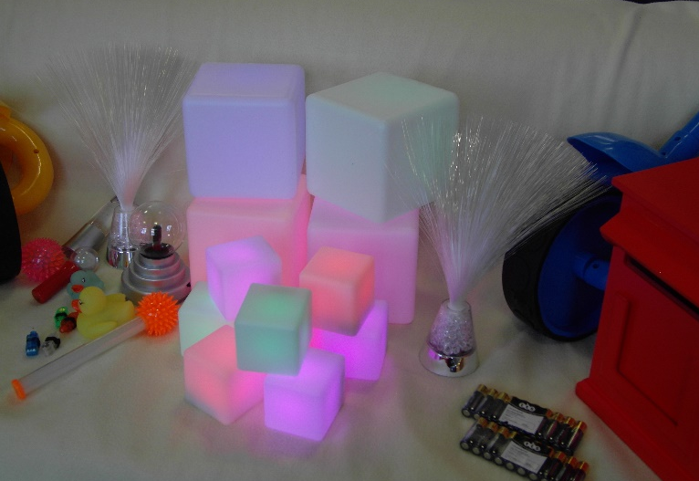

What will this service offer! -
- A dedicated service for parents/ cares, childminders and other settings who care for children with special and additional needs.

- A toy library that is set up to give children and young people with special and additional needs an opportunity to loan suitable, quality toys and specialist equipment.

- A service which removes the barriers of cost and access to specialist equipment.

- A dedicated person to promote the development of play for all children.

- Support for the development of individual resilience by developing confidence, supporting problem solving and developing a sense of belonging which reduces the feeling of loneliness and isolation.

