Rainbow Borrowers
Rainbow Borrowers is a toy loan service which runs alongside a play session for children under 5yrs
These sessions are dedicated for children with additional needs and their families.
No need to book, just turn up.
Pass it on parents (Family Advice & Support Team) will be joining us with advice and support.
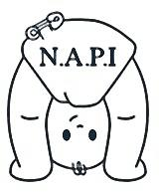

Location: - Galafields Centre
Newbiggin Lane NE5 1LZ
Session days: – Tuesday 17th May, 21st June,19th July
Sessions times: - 1pm – 2.30pm
Term time only
free
We are ran by Newcastle Action for Parent and Toddler Groups Initiative (NAPI) who support and give advice to toddler groups across the city. If you would like to contact us for any reason please ring 0191 2656158.
We work closely with Newcastle Community Family Hub and we share information of parents attending as part of the offer of services for children under 5.

