Rainbow Borrowers
Rainbow Borrowers is a toy loan service which runs alongside a play session for children under 5yrs
These sessions are dedicated for children with additional needs and their families.
No need to book, just turn up.
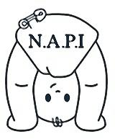

Location: - West Walker Centre
Greenford Road NE6 3BU
Session days: – Tuesday 26th April, 24th May, 28th June, 12th July
Sessions times: - 1pm – 2.30pm
Term time only
Free
We are ran by Newcastle Action for Parent and Toddler Groups Initiative (NAPI) who support and give advice to toddler groups across the city. If you would like to contact us for any reason please ring 0191 2656158.
We work closely with Newcastle Community Family Hub and we share information of parents attending as part of the offer of services for children under 5.

