Newcastle Local Area Joint Commissioning Strategy for Children and Young People with Special Educational Needs and Disabilities (SEND), 2020 – 2023



Approved by SEND Executive Board September 2020

**Contents**

Part 1: Introduction 3

1.1 Our Vision 3

1.2 Purpose of our Joint Commissioning Strategy 3

1.3 Definition of Special Educational Needs and Disabilities (SEND) 4

1.4 Legislative Context 4

1.5 Local Context 5

Part 2: How we will work together to develop a better shared understanding of needs and develop joined up responses 7

2.1 What is Commissioning 7

2.2 What is Joint Commissioning 7

2.3 Our Joint Commissioning Cycle 8

2.3.1 Establishing partnerships 10

2.3.2 Developing a joint understanding of needs 12

2.3.3 Jointly planning service provision 12

2.3.4 Jointly delivering services 13

2.3.5 Joint review and monitoring outcomes 13

2.3.6 Ways in which we will strengthen how we work together throughout the joint commissioning cycle 14

Part 3: Our joint commissioning objectives and priorities 16

3.1 Our joint strategic objectives: 16

3.2 Our joint commissioning priorities for 2020-22 17

# **Part 1: Introduction**

## **1.1 Our Vision**

Our [Newcastle Local Area Send Strategy 2019-2022](https://search3.openobjects.com/mediamanager/newcastle/repository/files/2_local_area_send_strategy_2019_2022.pdf) describes our vision for children and young people with SEND in Newcastle.

Our vision for children and young people with special educational needs and disabilities (SEND) in Newcastle Upon Tyne, is to have a high quality, well-planned, co-ordinated provision, that meets their needs from birth to the age of 25 and supports families.

Newcastle is a great place to live grow up and fulfil your potential. We want our children and young people to:

* Be safe and feel safe
* Be happy and feel included
* Be healthy and well cared for
* Do well in all levels of learning and have the skills for their life
* Feel valued and have a voice in decisions about their lives and the city

For those with SEND this means that, as a local area, we are committed to:

* creating a fully inclusive, partnership-driven system, where children and young people with SEND will have all of their needs identified and met in a timely manner
* true co-production with children, young people and their parent/carers
* maintaining high expectations for all children and young people and, through providing the right support at the right time, enabling them to have a successful future and contribute to their communities

## **1.2 Purpose of our Joint Commissioning Strategy**

The strategy sets out a three-year direction of travel and describes:

* our vision and context (Part 1)
* how partners will work together to achieve integrated services that responds to local need (Part 2),
* and
* our joint commissioning priorities over the next three years (Part 3).

The joint commissioning arrangements within the strategy covers the services for 0-25-year-old children and young people with SEN or disabilities, both with and without Education Health Care Plans (EHCP).

This is a partnership strategy for the local area that will be delivered across the city inclusive of statutory and voluntary partners across the education, health and social care economy.

Children, young people and their families are at the core of our joint commissioning. The strategy is also underpinned and influenced by legislation and national guidance, as well as local strategies and arrangements. It reflects the requirements placed on local authorities, schools and CCGs, and sets out how the Council and CCG will work within the strategic context to improve outcomes and make best use of resources by taking a whole system approach across education, health and care.

## **1.3 Definition of Special Educational Needs and Disabilities (SEND)**

Special Educational Needs and Disabilities - often called ‘SEN’ or ‘SEND’ - is a legal term for children and young people who need extra support during their education.

The SEND Code of Practice provides the following definitions:

*‘A child or young person has* ***SEN*** *if they have a learning difficulty or disability which calls for special educational provision to be made for him or her.’*

and that a **Disability** is when someone has

*‘a physical or mental impairment which has a long-term and substantial adverse effect on their ability to carry out normal day-to-day activities’*

## **1.4 Legislative Context**

The strategy is being implemented against a background of significant government reforms to education, health and social care for children and young people with SEND and their families and/or carers:

* Children and Families Act, 2014
* Care Act, 2014
* SEND Code of Practice 0-25, 2014
* Equality Act, 2010

The overall purpose of these reforms is to join up support across health, education and social care from birth to 25, with the aims of ensuring early intervention, that children and parents are at the centre of decision-making, and ultimately facilitate better outcomes for children and young people.

Children and Families Act 2014: Section 25 of the Children and Families Act 2014 places a duty on local authorities to ensure integration between educational and training provision, health and social care provision, where this would promote wellbeing and improve the quality of provision for disabled young people and those with Special Educational Needs (SEN).

Care Act 2014: The Care Act 2014 requires local authorities to ensure co-operation between children’s and adult services to promote the integration of care and support with health services, so that young adults are not left without care and support as they make the transition from children’s to adult social care. Local authorities must ensure the availability of preventative services for adults, a diverse range of high-quality local care and support services, including information and advice on how adults can access this universal support.

Section 26 of the Act also states that local authorities and CCGs must make joint commissioning arrangements for education, health and care provision for children and young people with SEN or disabilities.

SEND Code of Practice 0-25, 2014: The Department of Education and Department of Health published the Special Educational Needs and Disability (SEND) Code of Practice in 2014 and updated the document in 2015. The Code reflects the changes introduced by the Children and Families Act 2014 and explains the duties of local authorities, health bodies, schools and colleges to provide for those with special educational needs under the Act.

The SEND Code of Practice gives statutory guidance to local authorities and CCGs on the joint planning and commissioning of services to ensure close co-operation between education, health services and social care.

Equality Act, 2010: A disability under the Equality Act is defined as ‘a physical or mental impairment which has a long-term and substantial adverse effect on their ability to carry out normal day-to-day activities’.

## **1.5 Local Context**

* **Key information**

There are around 44,893 children and young people in Newcastle schools[1] and of these:

* There are 7,180 children and young people with SEND (EHCP and SEND Support (16.0% of all pupils); compared with 14.9% nationally.
* There are 5,934 children and young people with SEN Support (13.2% of all pupils); compared to 11.9% nationally, and
* There are 1,246 children and young people with EHCPs (2.8% of all pupils); compared with 3.1% nationally.

*Based on census data, January 2019*

Of all children and young people with SEND, 86% have one of five primary needs. These are: moderate learning difficulty; speech, language and communication needs; social, emotional and mental health; specific learning difficulty; and autism.

**This pie chart shows the proportion of children and young people in Newcastle schools by primary type of need.  

Of all children and young people with SEND, 86% have one of five primary needs. These are: moderate learning difficulty; speech, language and communication needs; social, emotional and mental health; specific learning difficulty; and autism**

* **Related SEND strategies and plans**

This joint commissioning strategy demonstrates the commitment of partners to working together to secure high-quality outcomes for children and young people with SEND. It is fundamental to achieving the aims and priorities agreed by partners in the following documents by setting out the joint commitments of all key partners.

* [*Newcastle Local Area SEND Strategy 2019-2022*](https://search3.openobjects.com/mediamanager/newcastle/repository/files/2_local_area_send_strategy_2019_2022.pdf): setting out our high-level direction of travel and ambitions for an inclusive SEND system, where children and young people with SEND have all their identified needs met.
* Newcastle Local Area SEND Overview Plan 2019-2022: detailed priority actions that will take place over the next three years, and timescales for these [soon to be published on the Local Offer].
* [Newcastle Local Area 3 year SEND Capital Fund Plan](https://search3.openobjects.com/mediamanager/newcastle/repository/files/191219_newcastle_send_capital_plan_-_revised_publication_dec_2019_1.pdf): Our capital investment plans for next three years.

# **Part 2: How we will work together to develop a better shared understanding of needs and develop joined up responses**

## **2.1 What is Commissioning**

Commissioning is a continual process that involves assessing needs and resources, identifying where needs are not met by current services, planning, purchasing and monitoring services to achieve the best outcomes, by taking decisions about priorities and ensuring that resources are used in the best possible way.

## **2.2 What is Joint Commissioning**

Joint commissioning is a strategic approach and involves planning and delivering services in a holistic, joined up way. It offers health, education and social care partners a way of working together to redesign services and operate more effectively.

It is recognised that joint planning and commissioning are a key part of the SEND reforms that will help lead to better integrated processes. It requires cultural change across organisations, that in turn requires clear leadership and understanding between partners. The purpose of joint commissioning for SEND is to ensure the best possible response to a child’s or young person’s needs, aligning and integrating strategic needs assessment, planning and delivery of services to achieve more.

This includes jointly identifying current and future needs, any gaps in provision and maximising resources and sharing intelligence across all services, to both improve outcomes for children, as well as help inform commissioning and planning decisions across all aspects of SEND support.

Commissioning responsibilities for SEND is complex. The Children and Families Act 2014 provides a legislative framework for joint commissioning across the NHS and local authorities and provides a number of opportunities and benefits for commissioning across the whole system.

Our aim is that all partners have a shared understanding of joint commissioning, which includes a range of different joint working opportunities. Joint commissioning does not necessarily equate to joint procurement; aligning procurement is only one of the many ways that Newcastle City Council, Newcastle Gateshead Clinical Commissioning Group, and other partners, can jointly commission. For instance, in Newcastle, we may jointly commission by:

* developing arrangements for packages of service to individual people which are jointly designed, drawing from a range of macro commissioning arrangements;
* aligning commissioning plans for the same or complementary requirements
* pooling funding for a particular requirement or service user group, from which either joint procurements or single organisation procurements may draw;
* agreeing a shared specification and running a single procurement process which one partner organisation oversees.

## **2.3 Our Joint Commissioning Cycle**

We have adopted the Joint Commissioning Cycle from the SEND 0-25 Code of Practice as a framework for ensuring continual joint review and improvement.

The framework will help us achieve the ambitions for joint commissioning as set out in our [Newcastle Local Area SEND Strategy 2019-2022](https://search3.openobjects.com/mediamanager/newcastle/repository/files/2_local_area_send_strategy_2019_2022.pdf):

* ensuring joint commissioning delivers better, joined-up support by planning pathways of support for specific types of needs;
* aligning key sources of data and intelligence in the form of a joint dataset on children and young people with SEND, so that partners can take decisions about joint commissioning based on a broad and shared understanding of current and future needs;
* agreeing a set of outcomes that local area partners can achieve together through the services that are commissioned;
* providing clarity on the resources required to meet current needs and achieve the agreed outcomes;
* joining up frontline practice as far as possible through integrating services, organising joint training for staff across different agencies and ensuring that there is a common language and a consistent approach to support young people with SEND and their families;
* further embedding effective governance structures and processes to ensure strategic decisions can be taken swiftly and effectively.

We will seek to continuously strengthen our core processes and build consistent understanding of the joint commissioning cycle, so that needs can be identified early and accurately, and the right support put in place.

[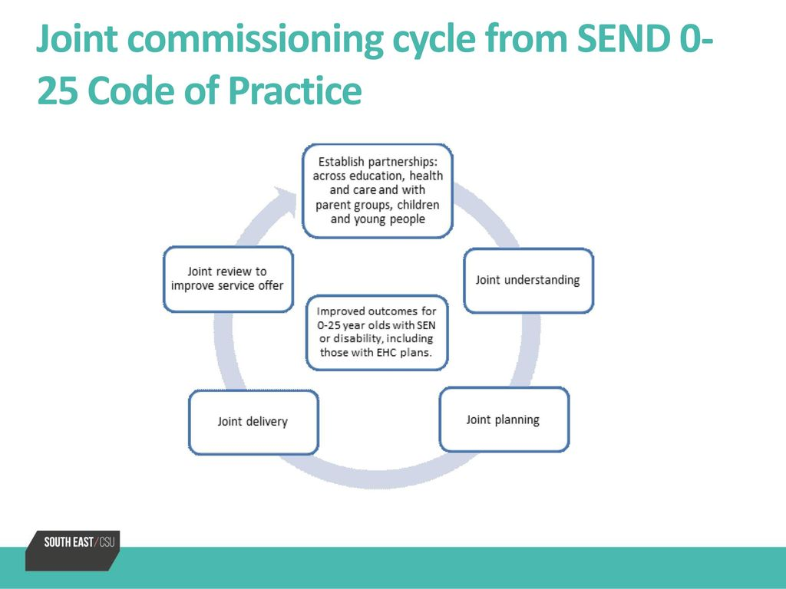](https://www.google.co.uk/url?sa=i&url=https://slideplayer.com/slide/13150947/&psig=AOvVaw0Agrgt2qlT80QKxHoIpMku&ust=1589977244301000&source=images&cd=vfe&ved=0CAIQjRxqFwoTCNDn0Pn0v-kCFQAAAAAdAAAAABAb)

**2.3.2 Joint understanding:**

* Use quantitative and qualitative needs analysis to identify current and future needs of children and young people and their families and understand what is important to children young people and their families.
* Develop ways of gathering more informative commissioning intelligence across partners and from EHCP’s actively sharing information and working to fill in information gaps.
* Understand the development needs of the workforce.

**2.3.1 Establishing partnerships**

* ‘Getting it right together’ - engagement with children, young people and their families
* Joint decision making and governance

**2.3.5 Joint review:**

* Agree a set of outcomes that local area partners can achieve together
* Jointly monitor service delivery against expected outcomes and report on how well it is doing.
* Develop a shared monitoring and performance management framework, which monitors outcomes achieved including those within EHCP’s.
* Work with children, young people and their families to enable them to review services with commissioners.

Sections 2.3.1 – 2.3.5 below describe how partners will work together at each stage of the above joint commissioning cycle. Section 2.3.6 outlines areas which will strengthen how we work together throughout the joint commissioning cycle

**2.3.3 Joint planning:**

* Enable children, young people and their families to have choice relating to the care and services they receive.
* Publish commissioning decisions and provide transparent reasonings for decisions made.
* Ensure effective risk identification and risk management systems are developed and embedded in our joint planning

**2.3.4 Joint delivery:**

* Pool resources where possible to meet current needs and achieve the agreed outcomes.
* Join up frontline practice as far as possible through integrated responses
* Explore how different procurement techniques might be used to improve efficiencies, ensure user involvement and improve outcomes.

### **2.3.1 Establishing partnerships**

* **‘Getting it right together’**

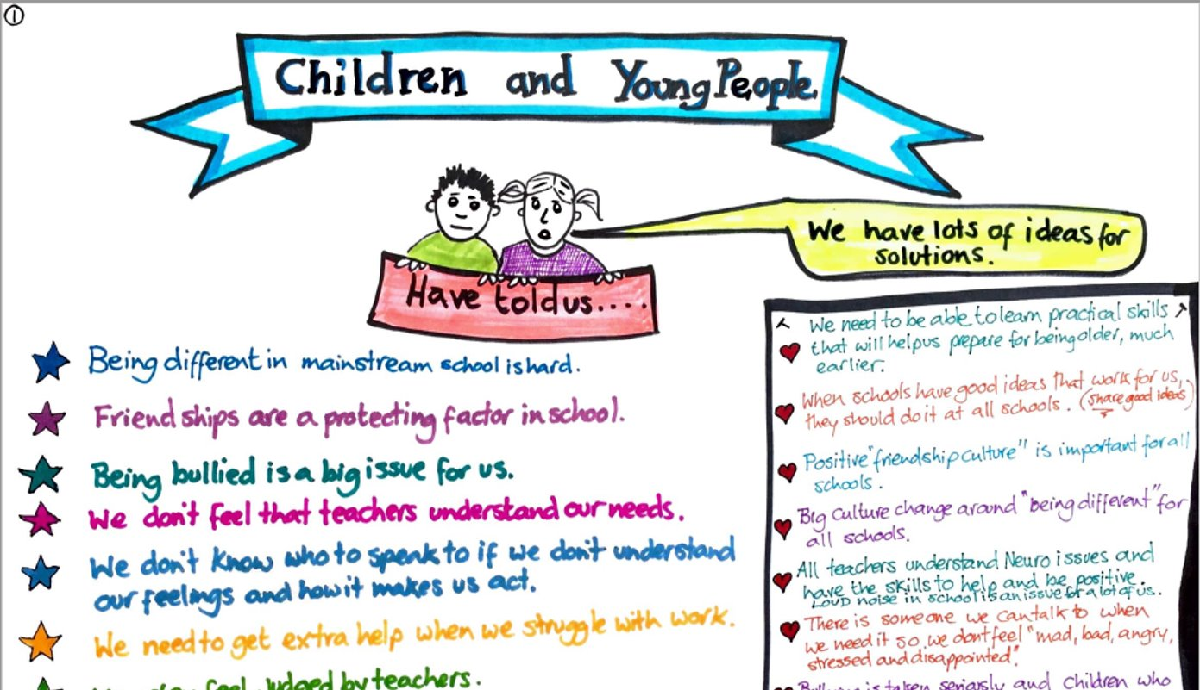

Central to joint commissioning will be engagement with children, young people and their families, ensuring that those who use education, health and care services are involved in developing and commissioning them. This will be done through engaging groups of children, young people, and their families at the earliest stages of service design, development and evaluation. We find that people with ‘lived experience’ of a particular condition can help us to get it right and will tell us what support and services will make a positive difference to their lives.

The Council and CCG have jointly funded an engagement officer to ensure the voice of children and young people and their families is at the heart of everything we do.

We are creating a ‘getting it right, together’ SEND quality assurance framework (see section 2.3.5) which will describe how we will embed this approach across all services. We will gather the views of people using services, we will demonstrate that we have listened and acted and we will tell people what has changed as a result of their ideas and views, through a “You Said, We Did” and “You said, We Will” approach.

‘Getting it right, together’ will be at the heart of all the engagement and involvement we do with all relevant partners, children, young people, their families, and wider communities. We are committed to ‘getting it right together’ and we will work hard to change the consultation culture to be a positive proactive experience.

*Feedback from parents and carers and children and young people, 2019*

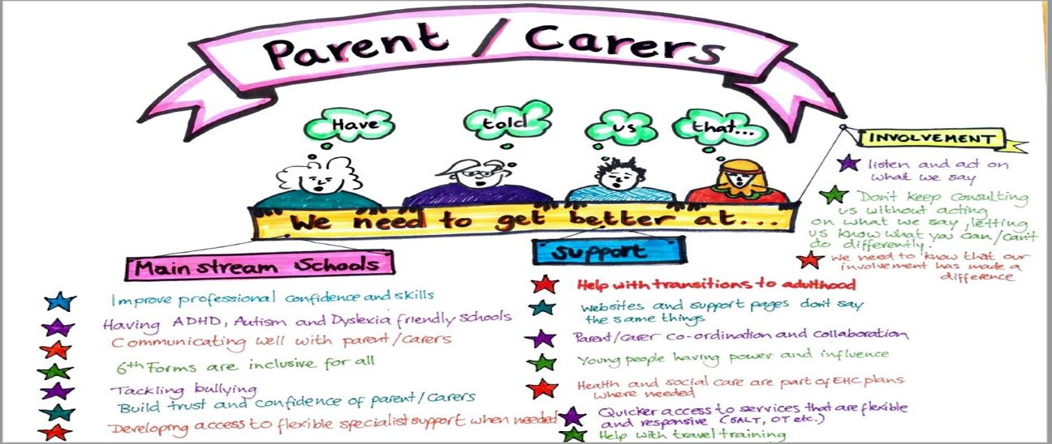

* **Governance**

The **Local Area SEND Executive Board** brings together partners across Newcastle (the local area), who are committed to improving the quality of the experiences of children and young people with SEND and their families.

The Board comprises representatives from: Newcastle City Council; Newcastle Gateshead Clinical Commissioning Group; North of England Commissioning Support; Parent Carer Forum; Newcastle upon Tyne Hospitals NHS Foundation Trust; Cumbria, Northumberland, Tyne and Wear NHS Foundation Trust; Specialist Schools; Mainstream Primary and Secondary Schools; and Newcastle College representing the post 16 sector.

The purpose of the Board is to:

* be responsible for all Council and health partners’ leadership and management matters affecting the implementation of the local area SEND strategy;
* take responsibility for holding partners to account for the work that they do in respect of SEND;
* strive to achieve improvement in outcomes for our children and young people with SEND;
* ensure delivery of the agreed actions on the written statement of action, with focus in 2020/2021.

You can find out more about our SEND Executive Board on our [Local Offer](https://www.newcastlesupportdirectory.org.uk/kb5/newcastle/fsd/localoffer.page?localofferchannel=0). Operational workstreams ensure the business of the Board can be effectively managed and its role and purpose achieved.

* Strategic Intelligence and Commissioning
* Voice
* Getting it right together: SEND Quality Assurance
* Preparing for adulthood

Additional task-finished groups may be established dependant on the work to be achieved.

The**Local Area SEND Joint Intelligence and Commissioning Group** is one of a number of subgroups that reports to the Board and includes representatives across education, health and care, as well as from the Parent Carer Forum, in order to:

* align joint planning, delivery and performance management of commissioning for SEND services in Newcastle, ensuring close cooperation between education, health services and social care
* ensure that commissioning decisions are joint decisions that meet the needs of children, young people and their families, both now and in the future, and that decisions are based on a joint understanding of need through integrated strategic needs assessments
* deliver and monitor progress of the SEND joint commissioning strategy for the local area
* develop market development strategies in relation to commissioning priorities, policy and practice

### **2.3.2 Developing a joint understanding of needs**

We have developed a Local Area SEND Outcomes Framework so that we can understand the difference that SEND services are making to children, young people and families in the city. The Outcomes Framework provides information across education, social care and health, and seeks to strengthen our early warning systems to spot where things are not going as well as they should be and making sure we can quickly intervene. The Outcomes Framework will be published on the Local Offer once finalised and updated regularly.

We will continue to use a combination of both quantitative and qualitative information to identify current and future needs of children and young people and their families and understand what is important to them. We will seek to further develop and strengthen ways of gathering more informative commissioning intelligence across partners, including from EHCP’s and actively sharing information and understanding of the development needs of the workforce.

### **2.3.3 Jointly planning service provision**

Our Local Area SEND Overview Plan 2019-2022 sets out our local areas of focus and associated priority actions for the next three years for all children and young people (0-25) with SEND to ensure:

* We can meet the demand for appropriate places, including consideration of capital investment where appropriate.
* We develop effective channels to deliver early intervention with specialist support, as part of the city’s agreed graduated response to support children and young people with special educational needs.
* We develop expertise in schools, settings and support services which will enable all settings to meet the needs of children and young people with ASD and SEMH, including consideration of capital investment where appropriate.
* We address the gap in mental health support for young people aged 16+

The above areas of focus were agreed following extensive consultation on our priorities and capital plan in the Autumn of 2019. You can read more about The consultation process and feedback received on our [Local Offer](https://www.newcastlesupportdirectory.org.uk/kb5/newcastle/fsd/advice.page?id=CfBPVHrxj4Q)**.**

### **2.3.4 Jointly delivering services**

Details of the SEND systems and services in Newcastle are set out in our [Local Offer](https://www.newcastlesupportdirectory.org.uk/kb5/newcastle/fsd/localoffer.page?localofferchannel=0).

In jointly delivering services, we consider:

* Individual Outcomes – securing education, health and care plans
* Service Level Outcomes – securing good quality provision that meets the assessed needs of children and young people with SEN(D)
* Strategic Outcomes – achieving outcomes for the whole SEN(D) population

Part 3 of this document sets out our immediate joint commissioning plans for 2020 in order to achieve the priorities set out in our Local Area SEND Overview Plan 2019-2022

### **2.3.5 Joint review and monitoring outcomes**

In 2019, we consulted on our [Quality Assurance Framework](https://search3.openobjects.com/mediamanager/newcastle/repository/files/6_draft_qa_framework_v9.pdf) which seeks to provide a comprehensive approach to improving quality and learning from: auditing our Education, Health & Care Plans and annual reviews; listening to feedback about services and the experiences of children, young people and their parents and carers; learning from complaints and compliments; and gaining insights from data.

This Framework seeks to:

* ensure children and young people benefit from consistent high-quality Education, Health and Care Plans (EHCPs);
* ensure compliance with primary legislation and statutory regulations;
* drive consistently high-quality practice across the local area;
* improve the experiences of children and young people with SEND and their parents and carers; and
* improve outcomes for children and young people with SEND.

Following feedback from the consultation process, we have updated our framework, known as our ‘getting it right, together’ SEND framework.

### **2.3.6 Ways in which we will strengthen how we work together throughout the joint commissioning cycle**

We have set out below the actions we will take during 2020 to strengthen how we work together throughout the joint commissioning cycle.

|  |
| --- |
| **We will strengthen our joint understanding by:**   * Further developing our Outcomes Framework,​ ensuring that the child’s voice is consistently featured throughout. * Developing and updating our SEND school profiles​. * Undertaking mapping of and improving our EHCP processes​. * Developing ways of gathering more informative commissioning intelligence from EHCPs. * Completing projections of required specialist places for children with complex needs relating to autism and SEMH. |
| **We will strengthen our joint planning by:**   * Ensuring local area oversight of the use of data so that it supports effective service planning. * Publishing commissioning plans and ensuring transparency in all decision making. * Ensuring our planning enables children, young people and their families to have choice relating to the care and services they receive. * Working towards co-production of high-quality local services with young people, families and the community and voluntary sector with a focus upon family and community resilience. * Exploring how different purchasing techniques might be used that will ensure user involvement and improve outcomes. The timings of commissioning activity across partners will also be assessed and agreed as part of future service planning. |
| **We will strengthen our joint delivery by:**   * Ensuring all contracts have service specifications which include relevant jointly agreed quality standards and performance measures. * Having robust arrangements for reporting to the SEND Board, with clear links to the SEND Outcomes Framework. * Working with partners to ensure services cooperate where necessary in arranging the agreed provision in an EHC plan * Working with partners to ensure a shared understanding of investment in SEND provision, and join and pool budgets where possible |
| **We will strengthen our joint review and monitoring by:**   * Implementing and continuously reviewing our “getting it right, together” framework, with children, young people and their parents and carers * Working together to monitor outcomes across education, health and care, and jointly monitoring service delivery against expected outcomes * Implementing a joint contract monitoring system for SEND service contracts * Fostering a stronger focus on outcomes, i.e. consider EHCPs as micro commissioning documents, outlining a clear set of outcomes that providers are expected to meet * Ensuring that assessment panels and annual reviews include representation from education, health and care, as appropriate, e.g. at key transition reviews or where there are complex issues. They should be transparent and used to consider what a child or young person’s needs are, ensuring these are reflected in their EHCPs. * Embedding quality assurance across the EHCP needs assessment process to check for the consistency and quality of identification of needs, and whether information is presented in a way that provides the information needed by young people and their families and by professionals and services. * Further developing our joint monitoring arrangements, and the outcomes achieved, including those within EHCPs. |

The above ways of working seek to respond to feedback received from parents/carers and children and young people through our “You said, we will” and “You said, we did” approach. Examples include: Young people having power and influence; Health and social care are part of EHC plans where needed; and Communicating well with parents/carers

# **Part 3: Our joint commissioning objectives and priorities**

## **3.1 Our joint strategic objectives:**

Our [Newcastle Local Area SEND Strategy 2019-2022](https://search3.openobjects.com/mediamanager/newcastle/repository/files/2_local_area_send_strategy_2019_2022.pdf) sets out our strategic aims and key principles towards creating an effective local area SEND system for children and young people of Newcastle, and their families. To achieve our joint commitment to the children and young people of Newcastle, and their families, we will ensure that there is:

• Partnership working and co-production with parents and carers, and with children and young people.

• A shared, co-produced strategy, including all stakeholders and partners in its development.

• High quality provision and sufficient capacity to meet the needs of all children and young people so that they remain part of their community.

• A high level of confidence in the system.

• Providers who continuously meet the needs of CYP with SEND effectively.

• Improved outcomes across education, health and care.

• Improved engagement in mainstream education and less reliance on specialist provision; meaning that most children and young people will attend their local mainstream schools/settings.

• Effective and targeted balance of mainstream specialist provision to enable more local inclusion and to cater for children and young people with the highest needs.

• Investment through capital and transformation funding to boost the range of mainstream specialist provision (0-25), creating more mainstream capacity to support all learners with SEND.

• Complete clarity and transparency about services, protocols and processes as part of the local offer.

• Expertise in schools and settings through wider workforce development.

• Consistency in early identification and application of specialist support and intervention at an earlier stage.

## **3.2 Our joint commissioning priorities for 2020-22**

Our joint commissioning priorities for 2020-22 are set out below. Partners are committed to respond quickly to changing needs and therefore partners may agree new joint commissioning priority areas as they emerge. These joint commissioning priorities will contribute to driving forward the specific actions as set out in our Local Area SEND Overview Plan 2019-2022, and seek to respond to feedback received from parents/carers and children and young people through our “You said, we will” and “You said, we did” approach. For example, joint review and commissioning of speech and language and other therapies in response to feedback for “quicker access to services that are flexible and responsive (SALT, OT)” *(You Said, We Did)*.

|  |  |
| --- | --- |
| **Joint Commissioning Priority** | **Expected Outcomes** |
| * Jointly commission a new model for speech and language therapy services through a Section 75 agreement pooled budget arrangement. | * High quality speech and language provision which meets current and future need, including capacity to meet needs of children in mainstream schools/ settings.   *[CYP have their speech, language and communication needs addressed]*  *[There is greater capacity in mainstream schools/settings which results in a reduction in special school placements*] |
| * Commissioning agreements in place for the provision of ARPs developed in partnership with School Heads. | * High quality ARP provision which is quality assured and meets current and future needs of children and young people.   [*Service specifications are in place for all school based commissioned services resulting in clear eligibility, purpose, implementation and accountability]* |
| * Develop and procure a SEN Transport Framework. | * High quality transport and travel support tailored to meet the needs of children and young people. |
| * Develop a SENDIASS joint commissioning agreement. | * High quality provision which meets current and future need. |
| * Joint review of Education Psychology, Occupational Therapy, Physiotherapy, Community Nursing including specifications and performance and quality measures. | * High quality provision which meets current and future need, utilising research-based therapy to enhance the potential of children and young people in the city. Provision which ensures that the physical as well as emotional needs are met to maximise achievement and life chances.   *[Children and young people will have needs identified earlier and support will be put in place]* |
| * Scope options for creating additional specialist capacity as required, including financial implications. | * Optimum and high quality specialist provision to meet current and future needs. * Specialist provision which is evidenced-based and can meet the population needs of the SEND community.   *[The balance of specialist support in the city reflects the level of identified need]* |
| * Outreach support from Specialist Schools and Specialist Teachers which support enhancing skills and capacity in mainstream schools. | * Enhanced specialist skills and capacity within mainstream schools enabling children and young have the widest possible choices.   *[There is greater capacity in mainstream schools/settings which results in a reduction in special school placements]* |
| * EHCPs and reviews are specific regarding all aspects of provision, needs and outcomes achieved. | * More informative commissioning intelligence gathered from EHCPs.   *[Aggregated EHCP data re:*   * *Levels of provision is reported on a quarterly basis and used to inform joint commissioning]* |
| * All SEND commissioning arrangements are underpinned by clear service specifications, and SEND performance and quality measures are embedded in all commissioning arrangements/ agreements | * SEND provision is in place which meets needs and achieves the best possible outcomes for children and young people.   *[A clear understanding of what support, services and provision is available and commissioned]*  *[Commissioning and decommissioning of services will be more responsive to local needs, informed through contract review]* |

1. Including state-funded nursery, primary, secondary and special schools; independent schools; non-maintained special schools and pupil referral units