Appendix 1: Children and young people with education, health and care needs:– avenues for complaints and redress:
The following tables are replicated from the SEND Code of Practice. They summarise the people and organisations who can consider complaints about decisions and provision for children and young people with education, health and care needs.
Parents and young people should use the complaints procedures of local providers (e.g. their early years’ provider, school or college) before raising their complaints with others.

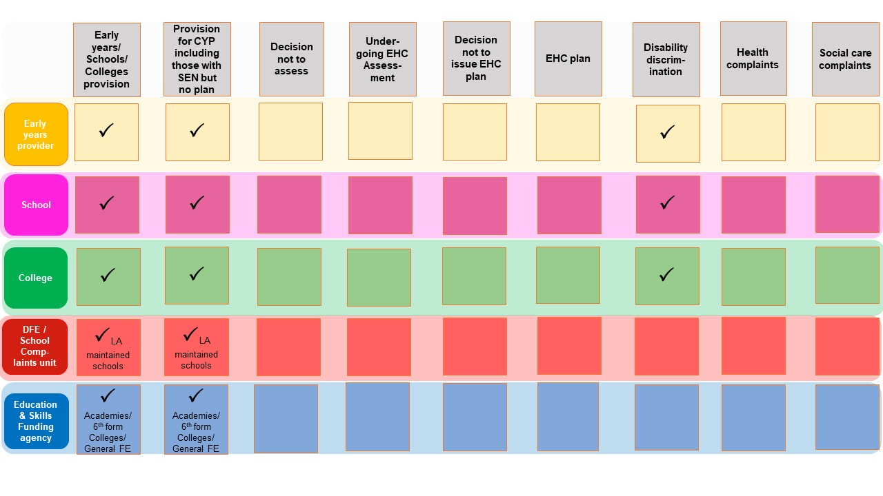

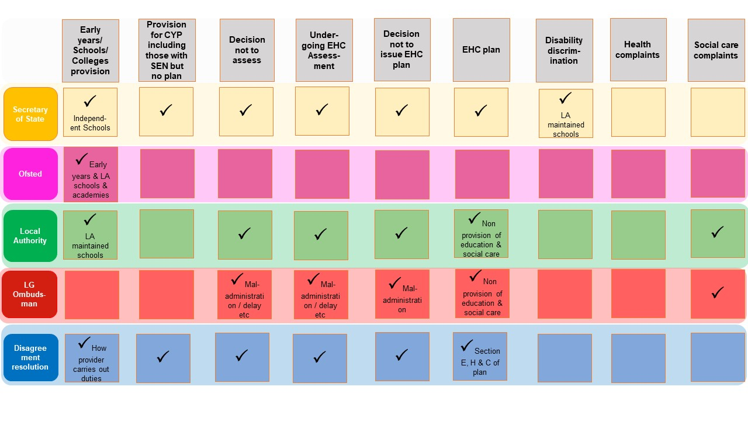

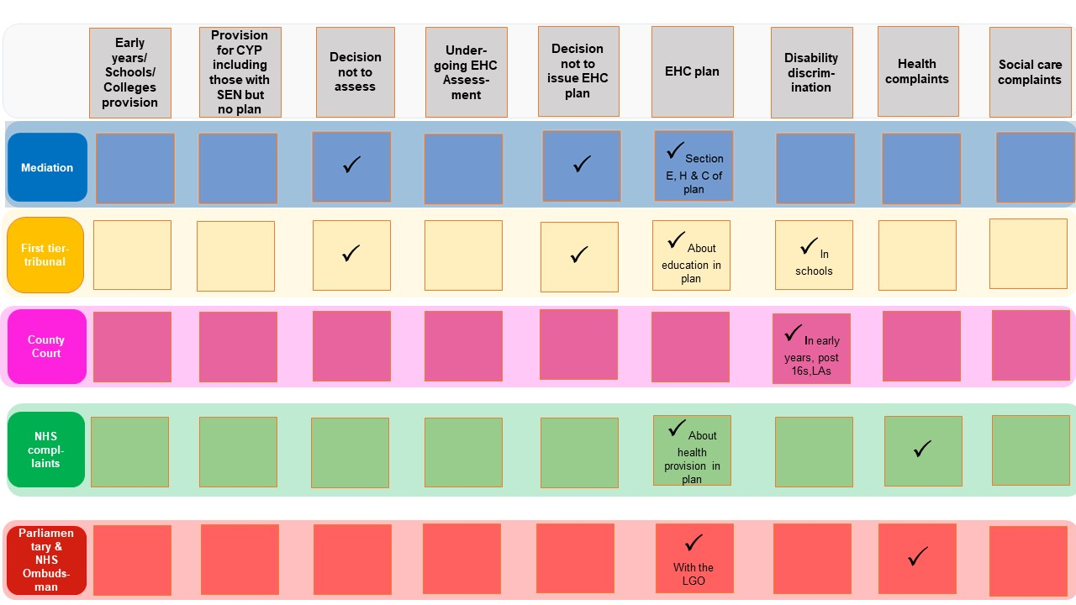

Appendix 2: National SEND Information and Advice Providers

Organisation | Support provided on
 | Education | Health | Social Care | Benefits | Housing
ACE | 
Civil Legal Advice (Legal Aid) | 
Contact a Family |  |  |  |  | 
Down’s Syndrome Association |  |  |  |  | 
Information Advice and Support Services |  |  | 
IPSEA | 
National Autistic Society |  |  |  | 
National Deaf Children's Society |  |  |  | 
SENSE |  |  |  | 
SOS SEN |  |  | 

Organisation | Who can access support? | Website and other info
ACE: Provides independent advice for parents/carers of children aged 5-16 in state schools in England. We aim to help parents and carers understand an increasingly complex education system so that they can help their children to achieve the best possible outcomes | Parents / Professionals | www.ace-ed.org.uk
Civil Legal Advice (Legal Aid): Free legal advice on education law matters paid  for by legal aid. SEN, discrimination and judicial review (e.g. for children not receiving  education/unlawful exclusions etc.) remain in scope. | Anyone financially eligible for legal aid | Face to face advice on an exceptional basis
Contact: Supports families with disabled children across the UK, providing up to date medical information on over 400 health conditions and disabilities, including rare conditions. | Parents / Young People / Professionals | www.cafamily.org.uk  Face to face advice
Down’s Syndrome Association: The aim of the DSA is to help people with Down’s syndrome to live full and rewarding lives | Parents / Professionals | www.downs-syndrome.org.uk
Information Advice and Support Services: IAS Services have a duty to provide information, advice and support to disabled children and young people, and those with SEN, and their parents. They are statutory services and are free, impartial and confidential. | Parents / Children / Young People | In Newcastle: sendiassadmin@newcastle.gov.uk
IPSEA: Independent Provider of Special Education Advice, a charity which offers legal advice, support and training to ensure children and young people with Special Educational Needs and Disabilities (SEND) access the right education. | Parents / Professionals | www.ipsea.org.uk  Tribunal representation
National Autistic Society: The leading UK charity for people with autism (including Asperger syndrome) and their families. We provide information, support and pioneering services, and campaign for a better world for people with autism. | Parents / Young People / Professionals | www.autism.org.uk
National Deaf Children's Society: The leading charity dedicated to creating a world without barriers for deaf children and young people. | Parents / Young People / Professionals | www.ndcs.org.uk  Face to face /  Tribunal representation
SENSE: Give legal advice and assistance to deafblind individuals or their family members and supporters. | Parents / Young People / Professionals | www.sense.org.uk
SOS SEN: A national charity aiming to empower parents and carers of children and young people with SEN and disabilities to access the help they are entitled to, particularly in the education system. | Parents / Young People | www.sossen.org.uk  Face to face /  Tribunal representation /  Parent Workshops

Appendix 3: Useful resources

Guide to the SEND Code of Practice: for parents | Council For Disabled Children

SEND support: easy-read guide for parents - GOV.UK

SEND Complaints: A guide for Young People in education - Mott MacDonald

