**Newcastle SENDIASS**

Annual Report

2023-2024

**Contents**

Introduction 3

Service values and practice 4

Who delivers SENDIASS? 5

Advisory group 6

Casework statistics 8

SENDIASS online 13

Service development plan 14

Case Studies 18

Service feedback 24

Future developments 29

**Introduction**

This annual report aims to provide a formal service evaluation and an informative reflection that will give a sense of the achievement of the service.

We wanted to create a document which provides parents and professionals with information about the service enabling them to have a really clear understanding of what it does, how it helps and who can use it.

We have included feedback from parents, carers and young people as their views are important to us.

The world of Special Educational Needs and Disabilities (SEND) is complex; in this review we will try to present information in a way that doesn’t have any jargon or require any specialist knowledge to understand.

We are here to help so if there is anything in this review that you do not understand, please let us know.

**Service values and practice**

**Newcastle Special Educational Needs and Disabilities Information, Advice and Support Service (SENDIASS)** offers **impartial** and **confidential** information, advice and support to parents, carers, children and young people aboutmatters related to their or their child’s special educational needs and/or disabilities.

**Staff are trained and have accurate and up to date knowledge of**

**· Education, social care and health law relating to SEND**

**· National and local policy and practice in meeting SEND**

**· SEND processes including Tribunal**

Support is tailored to the individual service user, with the aim to build on that individual’s skills, knowledge and confidence to promote independence and self-advocacy.

**The service is free for young people, parents and carers to use.**

**You choose whether or not to use the service – you contact us not the other way around.**

**The service is confidential and impartial.**

The service can be accessed by children and young people independent of their parents. The service has adapted to include a text line and school drop-in clinics to make the service accessible for children and young people.

**Who delivers SENDIASS?**

Newcastle SENDIASS is now jointly commissioned by education, health and social care in line with the national minimum standards. Following the joint commissioning agreement, the service has expanded and restructured. The diagram details the current structure.

**Service Manager**

**Senior Practitioner**

**SENDIASS Officer SENDIASS Officer for Children and Young People**

The service also has one part time business administrator.

Newcastle SENDIASS does not work in isolation. Each local authority has its own service, and they are all overseen by a national co-ordinator at the National Children’s Bureau. The national co-ordinator

* Liaises with government, in particular the Department of Education
* Hosts an e-forum for all SENDIASS staff
* Gathers and publishes benchmarking data for each service
* Provides training on the law, mediation skills and regular updates on SEN policy and practice.
* Provides the National Minimum Standards that all services must adhere to

**Advisory group**

The National minimum standards state that all SENDIAS services must have an advisory group made up of key stakeholders.

**1.7** The Governance arrangements outline a clear management structure, encompassing a strategic manager within the IASS and a steering group or advisory body which includes representatives from service user groups and key stakeholders from education, social care and health.

**1.8** The IASS has a development plan reviewed annually with the steering group/advisory body, which includes specific actions and improvement targets.

Newcastle SENDIASS have formed an advisory group consisting of key stakeholders from education, health, social care and parents/carers. The group meet every academic term to review the progress of the service and feed into the next priorities.

**Autumn Term**

Annual Report for the previous academic year including parent/children/young people evaluations and feedback.

Agree the Service Development Plan for the academic year.



The aim of the group is

* To monitor the continued development of the service in a way that best meets the needs of children, young people with SEND in Newcastle and their parents and carers
* To demonstrate the impartiality of the service and ensure it remains at ‘arm’s length’ to the Local Authority and the Integrated Care Board.
* To ensure that the service impartiality and confidentiality policies are reviewed and monitored and that they are implemented consistently and effectively.
* To evaluate the level to which the service achieves the Minimum Standards for services providing impartial, information, advice and support, as supported by the Department for Education, and is compliant with the SEND Code of Practice 2015.
* To monitor the impact of the service on improving outcomes for children and young people with SEND and their parents and carers, using service user feedback.
* To monitor that the service is engaging effectively with all relevant partners, locally, regionally and nationally.

The advisory group met in June 2024. They looked at the service achievements over this academic year, the continued growth and increase in demand, and agreed the priorities for the service for the next academic year.

**Casework statistics**

This year the service has changed the way we allocate case numbers and record the number of people accessing the service. This change has been directed from the Council for Disabled Children (CDC) who recognised that the amount of work and complexity of work that SENDIASS do is not reflected in the way in which we number cases. As an example, each family accessing the service was allocated a case number which was their number for the academic year. Some of these families would access the service to support them through statutory assessment, they then may come back to the service to support them with a complaint, and then return again to support them with an appeal to the tribunal. All of those pieces of work would only count as one number on our statistics. We now allocate case numbers based on each piece of casework, so one family may end up with several case numbers by the end of the year. This gives us a more realistic reflection of the amount of work the service is doing.

In order to be able to monitor the growth of the service and compare our statistics from previous years we are also counting the number of families who access the service.

The service runs on an academic year, all case numbers are allocated starting in September 2023. We took the figures for this report from the end of July 2024. This academic year the service has provided information, advice and support for 2237 cases, this has been delivered to 1325 parents, carers, children and young people. There are 365 children and young people who have accessed the service independent of their parents; which works out around 25%. This demonstrates the difference that making the service accessible to children and young people has made. On top of this the service also provided a service to 149 professionals and 48 parents and carers from neighbouring local authorities.

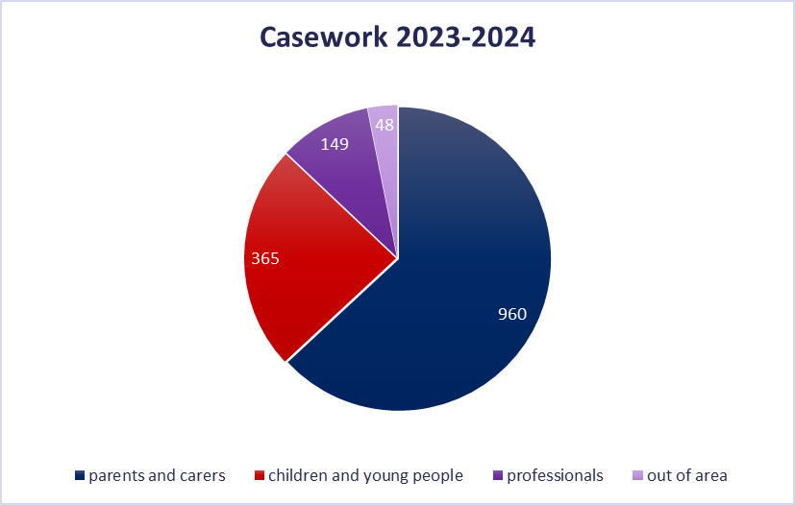

SENDIASS regularly attend events where we can deliver information to a much wider audience. This includes school coffee mornings, training events, team briefings and careers events. It is not possible to capture how many people we provide information for at all of these events; however, we can factor in that we are delivering information to a much wider audience than our records demonstrate. At the St James’ Park careers event there was an estimated 4000 attendees.

The service is seeing increasing demand with the number of cases going up every year. The chart demonstrates real growth in the number of people who have accessed the service. The chart shows a slight dip due to the impact of the pandemic, and then a continued increase from that point.

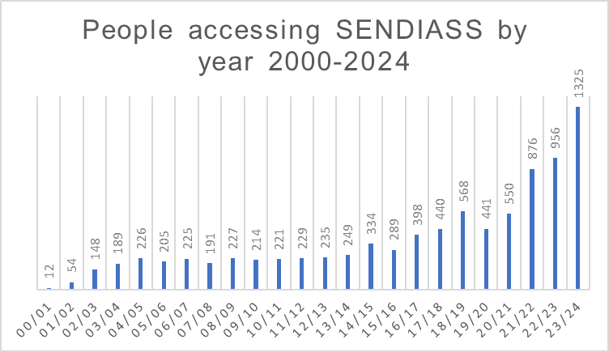

Out of the 2237 cases 680 had an Education, Health and Care Plan in place.

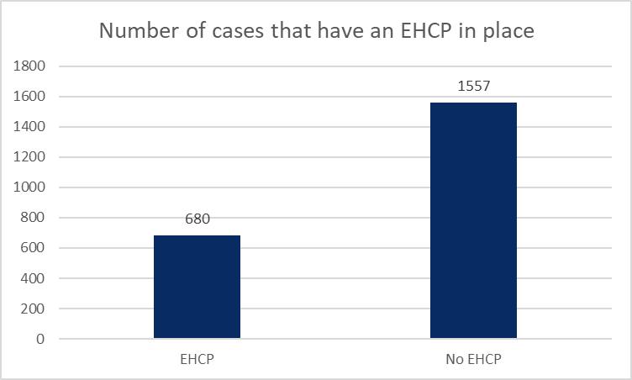

SENDIASS has the role to provide support when things go wrong. This academic year we have seen a rise in the number of cases that would like support to appeal to the tribunal and to submit formal complaints. Of the 2237 cases we have worked with this academic year 166 wanted advice and support to appeal to the first-tier tribunal, and 69 wanted support to submit a formal complaint. Whilst SENDIASS provide the information for individuals to be able challenge decisions through formal process, we also mediate and help to open up communications between parents, schools and the local authority. This means that although 166 people asked for advice on how to appeal to the tribunal, the number of appeals lodged with the tribunal is far lower.

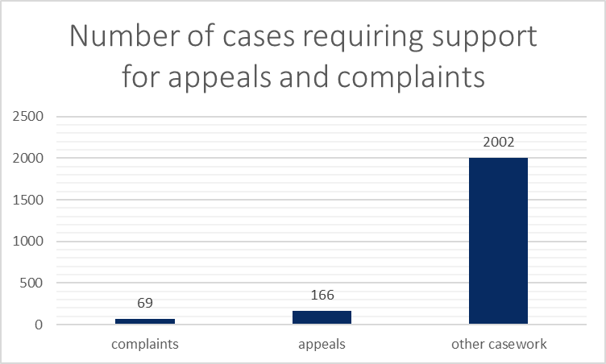

The service provides information, advice and support relating to education, health and social care. The chart below shows which category the case was relating to, with the majority being a combination of education, health and social care matters. This demonstrates how closely linked the three sectors are and how different needs can impact on all areas of a child’s life.

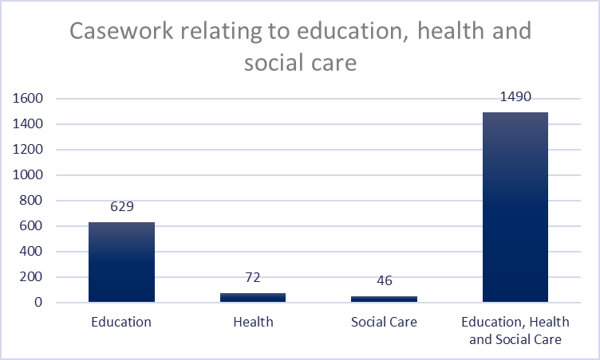

SENDIASS record the complexity of casework using intervention levels set by the Council for Disabled Children (CDC). This helps us to monitor the complexity of casework and the level of support needed, as this can vary massively. The intervention levels are detailed below.

|  |  |  |
| --- | --- | --- |
| **Level 1** | Information | Information and advice about education, health and social care SEND system and processes. Inclusive of initial concern up to appeals. |
| **Level 2** | Information and tailored advice | Service user is able to express their needs and those of their child. They need more tailored information and/or advice specific to their individual need or circumstance than is available at Level 1. |
| **Level 3** | Support | The needs of the individual service users and/or the complexity of their/their children’s circumstances significantly impacts their ability to independently navigate the system.  They are a child or a young person who need/want information, advice or support separate from that given to their parent/carer. |
| **Level 4** | Intensive support | The needs of the individual service users and/or the complexity of their/their children’s circumstances means they are not able to independently navigate the system and/or access justice.  They are a child or a young person who need advocacy/representation separate from or instead of their parent, this includes CYP who are looked after, those who are in residential schools and those in YOIs.  Can include all of the support detailed in level 3 but must also involve:   * Representation for parent, child or young person at meetings, appeals, mediation and CETRs * Ongoing and intensive casework/advocacy that includes representation. |

The charts below show the intervention levels for the casework the service dealt with this year.

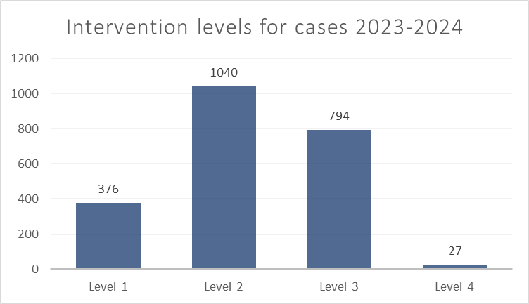

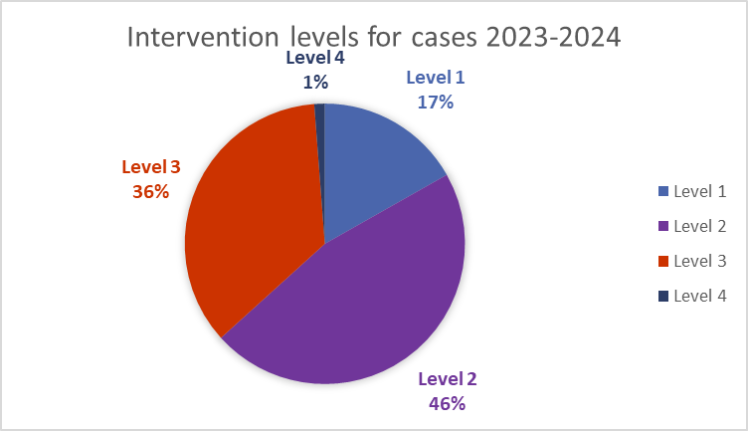

What we are seeing each year is an increase in the amount of time and support needed for casework. 821 cases required intervention at level 3 and above. This demonstrates the level of demand that is put on the service.

**SENDIASS Online**

The service has a stand-alone website. [www.newcastlesendiass.co.uk](http://www.newcastlesendiass.co.uk). This year we have worked to develop the information and resources available on the website. We have written a series of “how to” guides to help parents navigate the SEND processes. We have added additional information pages to the website including:

* What is SEND?
* SEN Support
* Education, health and care (EHC) needs assessment
* Education, health and care plan (EHCP)
* Mediation, appeals and complaints
* Attendance and exclusions
* Elective home education (EHE) and Education other than at school (EOTAS)
* Mental health and emotional based school avoidance (EBSA)

The National Minimum standards specify that SENDIASS must have a social media presence. Newcastle SENDIASS has a Facebook page [www.facebook.com/NewcastleSENDIASS](http://www.facebook.com/NewcastleSENDIASS).

The data below is taken from the Facebook page professional dashboard which shows that in the last 28 days our posts have reached 329 people. This has tripled from this time last year and means the service is sharing information with a wider audience.

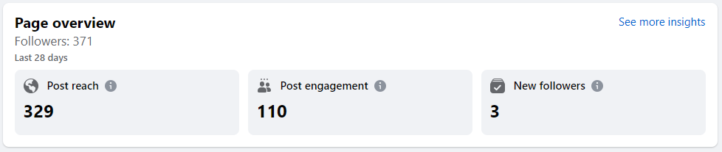

The service creates information videos which are shared via our Youtube channel. [www.Youtube.com/@newcastlesendiass4608](http://www.Youtube.com/@newcastlesendiass4608). The most recent video gaining 161 views. We want to add to our video catalogue, and recognise that it is an accessible way for people to get information.

**Service development plan**

The below table details the objectives that SENDIASS has set to achieve over the academic year 2023-2024. The objectives are all set against one of the national minimum standards.

|  |  |  |  |  |
| --- | --- | --- | --- | --- |
| **Area of work/ minimum standard** | **Objective** | **Expected outcome** | **Evidence** | **Time to be completed by** |
| 1.7  The Governance arrangements outline a clear management structure, encompassing a strategic manager within the IASS and a steering group or advisory body which includes representatives from service user groups and key stakeholders from education, social care and health | To set up an advisory group made up of representatives from stakeholder groups and arrange to meet on a regular basis to review the service and proposed developments. | SENDIASS will be responsive to stakeholders and service users.  Feedback informs and improves future service delivery and practices. | Advisory group will meet 3 times per year, meeting minutes will reflect the discussion regarding service delivery and developments. | Advisory group established by January 2024 |
| 1.2  The IASS is designed and commissioned with children, young people and parents, and has the capacity and resources to meet these Minimum Standards and local need. | To adapt service delivery to increase capacity in line with growing demand.  To look at service delivery for hard-to-reach groups | SENDIASS will be able to meet local need.  SENDIASS will provide an accessible service for all. | SENDIASS will respond to all enquiries within 48 hours.  SENDIASS will see an increase in case numbers based in hard-to-reach communities/ areas of the city. | Service adaptations from Sep 2023  Outreach service set up by July 2024 |
| 3.6  The IASS offers training to local education, health and social care professionals, parents, young people and children to increase knowledge of SEND law, guidance, local policy, issues and participation. | To deliver training sessions to professionals and to parents and carers. | Local authority staff and other relevant professionals will attend a commissioned training session relating to SEND law and policy.  Training sessions will be held for parents and carers on SEND related topics. | Professionals will be better informed and able to support parents, carers, children and young people in matters relating to SEND.  SEND processes will be implemented in accordance with the law.  Parents and carers will be better informed about their rights and the SEND processes.  Qualitive feedback will demonstrate that processes are happening as they should, and that parents and carers feel informed, supported and empowered. | Training sessions to be delivered in the Spring term, by April 2024 |
| 2.2  The IASS engages with regional and national strategic planning and training and demonstrates effective working with other IASSs to inform service development | To set up a peer review system with other IAS services to provide objective feedback, support and challenge about service work and practices. | Objective feedback, support and challenge will be used to improve service practice and delivery. | Changes to service practice because of peer review. | Peer review relationship established by Dec 2023 |

**Service developments and progress**

1.7 – Green

An advisory group of key stakeholders has been established. We had our first meeting where we established the role of the group, discussed the progress and development of the service, and agreed key priorities for the next academic year.

1.2 – Amber

The service is fully staffed and is able to meet local demand, returning all enquiries within 24 hours. The officer for children and young people is providing an accessible service in education settings across the city. The service has a threshold for face-to-face meetings which are only for parents who have capacity issues or have English as second language, all other meetings are attended via Teams. This enables the service to provide an equitable offer and keep up with growing demand.

Newcastle SENDIASS website has been developed to include a catalogue of information pages relating to SEND and SEND processes. This is a helpful resource for both parents and professionals to gain a better understanding, and in turn will help with the service capacity as basic queries will be able to be answered by using this resource. SENDIASS is about empowering individuals; and our aim is that we can provide the advice and information resources to individuals, who can then make informed choices, be actively involved in decisions, and go through the processes better informed.

As a service we would still like to adapt what we do to be more accessible to minority communities. Our vision is to set up outreach clinics in community hubs. We have started having conversations with organisations and schools about how we could schedule these, and have sourced an interpretation service. This is one of our key priorities to take forward next year.

3.6 – Green

SENDIASS commissioned a legal expert to deliver training on SEND law to education, health, and social care colleagues. This was a well-attended event and the feedback we have received has been really positive. We commissioned the same expert to deliver legal training to head teachers and CEOs of academy trusts, this was attended by 78 schools.

We have written and produced information webinars for parents and carers, and have plans to continue to develop our catalogue of resources. The north-east region are working together to provide legal training sessions for parents. These have been organized and will be implemented over the next year.

2.2 – Green

Regional SENDIASS managers attend bi-monthly meetings to share expertise and practice, problem solve, offer peer support and discuss local issues. We have also established peer relationships with Northumberland and Hartlepool service managers. We meet on a fortnightly basis to act as a critical friend, provide challenge and support to improve our services and to provide peer support as an arm’s length service means we are working in isolation. We have found these relationships to be incredibly beneficial and we are reflecting on our policies and practice as we learn how other services handle their caseload differently.

**Case studies**

|  |  |
| --- | --- |
| Working with a school to provide an accessible service for children | |
| Case study  1 | A SENDIASS officer developed a working relationship with a school to provide an accessible service for children. |

|  |
| --- |
| Introduction  SENDIAS services are required to provide information, advice and support to children and young people with SEND, independent of their parents. We have a dedicated SENDIASS officer for children and young people who works with education settings to make the service accessible. |
| Background  Our SENDIASS officer for children and young people approached a Secondary school in Newcastle to facilitate a SENDIASS clinic for us to provide an accessible service. Previously a working group of children and young people helped to design the accessible school clinics. |
| Aims and objectives  Our aim was to provide an accessible service for children with SEND in the school. We wanted children to know that they have the right to access the information, advice and support service for issues related to their SEND.  Our aim is to ensure that children are actively included in decisions about them and their support needs. We want to empower children with SEND to have a voice, to know their rights and to help them navigate the SEND processes.  We aim to increase the school’s understanding of SEND processes, how they can make sure the voice of the child is heard and how they can work to empower and include children with SEND. |
| Approach  The SENDIASS officer met with the school’s Special Educational Needs Coordinator (SENCO) to discuss how the clinics would function, ensuring confidentiality and impartiality were maintained.  The school put up posters advertising the service and promoted the clinic to all children with SEND. The SENCO held a booking system for the students to have appointments and provided a confidential space one morning per week for the clinic to run.  The conversations in the clinic were confidential, but permission was sought to pass on any information that may be helpful, or the SENDIASS officer facilitated conversations the child had with school staff to have their views heard.  Children would often make repeat appointments to update on changes that had been made as a result of the last session, and to raise new concerns.  The SENCO helped some children who were non-attenders to make contact with the service. The SENDIASS officer was then able to meet those children in a space in the community to ensure that they had fair access to the service. They then worked to help the child identify the barriers to school, they advocated for the child and helped them rebuild the relationship with school. |
| Challenge  Holding a clinic within the school it was a challenge to ensure that the service was seen as completely impartial and that children would trust that anything they said was in confidence. This meant that often children would have 2 or 3 sessions before they really opened up about what was concerning them. The SENDIASS officer worked really well to ensure all of the children understood the confidentiality and that they gave permission to share any information with the school. The school respected the confidentiality and did not push the service for information relating to a child.  A lot of children who accessed the service had mental health concerns and wanted to use the service as a therapeutic intervention. The SENDIASS officer had to ensure that her role was clear, and that children were signposted to appropriate therapeutic services for ongoing support. |
| Successes  The clinic appointments were booked and well attended, which meant the children were successfully accessing the service.  The children were able to voice their concerns and felt heard and empowered. They saw the changes that were made as a result and felt like they were being included in decisions relating to their support.  The school were really supportive of the clinics, staff listened to feedback and issues raised by the children, they were willing to adapt and make changes in response. The school actually changed some of their processes as a result of the clinics to help them to better meet the needs of children with SEND.  The good relationship between SENDIASS and the school helped to empower children with SEND and made the service fully accessible.  Children reported the difference that the support from SENDIASS made for them. They had better communication with school staff and felt more confident to advocate for their needs.  Children who were not attending school or engaging with any professionals were able to access the service and were supported to re-engage. |
| Conclusion  The school clinic enabled SENDIASS to provide an accessible service to children with SEND. The relationship between the service and the school helped all to learn from the process and adapt their processes to be more child-centred. Children felt empowered and became actively involved in decisions relating to their support needs. |
| Feedback  Students have reported that they really enjoy working with the SENDIASS officer.  As a school we have found that it has improved our ability to identify areas strength and gaps in our provision.  Despite our robust internal systems for collecting student voice and reviewing provision, we have learned more about some of our students who have felt more comfortable talking about their concerns to someone who is not directly linked to the school.   This has helped ensure we are hearing a more authentic voice from our students and have been able to adapt further to meet needs, where appropriate.  The SENDIASS officer is also able to work out in the community with students with EBSNA (Emotional Based School Non-Attendance), this is an area we are extremely grateful for as a school.  (School SENCO)  The service was excellent, it really helped with my lessons, and I would use it again.  (Child) |

|  |  |
| --- | --- |
| Supporting a parent to have an active role in the EHC process | |
| Case study  2 | A parent disagreed with the LA decision, however they have a language barrier and did not understand the process or how they could contribute |

|  |
| --- |
| **Introduction**  This case involved a child in Reception in a mainstream school. The parent had just received the first draft of their child’s Education Health and Care Plan (EHCP). The parent was signposted to SENDIASS by another parent who had recently used our service. The parent believed that mainstream education could not meet her child’s needs. The parent was having difficulty understanding the technical language and the EHCP process, and asked SENDIASS for help. |
| **Background**  The child has a diagnosis of autism and is non-verbal. The parent and school were led to believe that the Local Authority intended to name the mainstream school again in Section I of the EHCP. The first draft of the EHCP stated that the child’s needs could be met with 1:1 support within the current mainstream setting. The parent believed that her child’s needs could not be met in the current mainstream school, or in any mainstream school. The school agreed with the parent that they could not meet the child’s needs.  The parent asked SENDIASS to read the draft EHCP, along with reports from professionals, and to advise her of her options. |
| **Aims and objectives**  Our objective was to help the parent to understand the EHCP process and the language that is used in the document.  We wanted to support the parent to express her views and to advocate for her child. We wanted the parent to have a good understanding of the professional reports so that she felt empowered to make representations (amendments she would like to be made to the EHCP).  We wanted the parent to feel supported and listened to as she initially felt that she was not a part of the EHCP process. |
| **Approach**  When the parent contacted the service, we spoke at length about her child’s needs and how he was coping in his current school. We spoke about what she believed was working and what wasn’t working. We discussed which parts of the EHCP the parent believed to be inaccurate, in terms of what her child can and cannot do. The parent shared that she believed some of the professional reports were out of date.  The parent asked SENDIASS to read the draft EHCP and the accompanying professional reports. SENDIASS set aside time to read all of the documentation and called parent to discuss. We spoke at length about the contents of Sections B and F of the draft EHCP and what was missing from the professional reports. The parent stated that she felt more knowledgeable after our conversation, and she felt able to consider making some amendments.  The parent contacted SENDIASS again after a few days to discuss her potential amendments. We discussed her views and the evidence she had, and she felt confident to contact the caseworker to have a conversation with them about the EHCP draft.  The parent was pleased with the finalised version of Sections B and F. |
| **Challenge**  The parent initially said that she lacked confidence about the EHCP process. She said that she felt overwhelmed, and she didn’t understand some of the language and how the EHCP process worked. The parent speaks English as a second language, and whilst she did not require an interpreter, she occasionally struggled with some of the educational terms and language. The parent said that she did not feel knowledgeable enough to voice her opinions or to advocate for her child.  SENDIASS needed to help the parent to understand EHCP language and processes, and we also needed to help the parent to feel confident in her new knowledge. |
| **Successes**  The parent’s knowledge and confidence of the processes and language in EHCPs increased after speaking to SENDIASS. The parent reported that she felt more knowledgeable and empowered to advocate for her child’s educational needs. The parent feels confident to contact SENDIASS and ask for information, advice and support when she requires.  The parent no longer wanted her child to attend a mainstream school. The parent wished for her child to attend a specialist, independent placement. As the parent was supported to understand the professional reports she was able to provide the appropriate evidence and advocate for her child’s needs. The LA named a specialist, independent placement in the final version of the EHCP. |
| **Conclusion**  The information, advice and support that SENDIASS offered the parent helped her to feel empowered throughout the process. The parent seemed to grow in confidence as the EHCP went through process. Our involvement helped the parent to overcome her barriers and be actively involved in the process.  The parent achieved her aim of advocating for her child’s needs and being able to present the evidence needed to secure a specialist, independent placement for her child. |

**Service feedback**

The Council for Disabled Children (CDC) set questions for all SENDIAS Services to use to gather feedback about the service. Below are the questions we asked, and the responses gathered.

1. How easy was it to get in touch with Newcastle SENDIASS?

1 - not very easy at all, to 5 - very easy

Average Rating

4.10

2. How helpful was the information, advice and support that we gave you?

1 - not very helpful, to 5 - very helpful

Average Rating

4.20

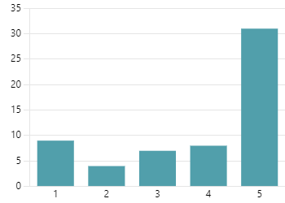

Average Rating

3.81

4. What difference do you think SENDIASS has made for you?

1 - no difference, to 5 - a great deal of difference

Average Rating

4.39

3. How neutral, fair and unbiased?

1 - not very neutral, to 5 - very neutral

5. Overall how satisfied were you with the service we gave?

1 - not very satisfied, to 5 - very satisfied

Average Rating

4.10

6. How likely is it that you would recommend our service to others?

1 - not very likely, to 5 - very likely

Average Rating

4.19



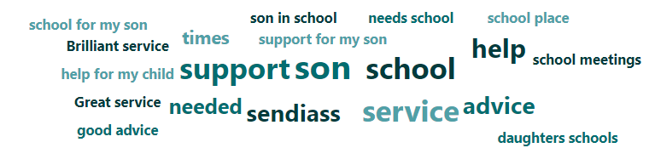

What is interesting from the feedback scores is that while the average score for the difference we made was 3.81, the average score for if people would recommend the service to others was 4.1. This is also reflected on a national level. The reason we are seeing this we believe is due to the current state of SEND provision. There is a lack of specialist places and often people come to SENDIASS for help to secure a place. We can support parents through the process and how to challenge decisions via the tribunal, but ultimately, we are not responsible for decisions or able to change them which is why parents feel that their situation is unchanged.

When we separate out the feedback scores gathered from children and young people, we get a very different picture. For the difference we made all of the feedback gave a score of 5/5.

What people have to say about the service…

Give me good advice and was heard on what I had to say.

Really helpful service that gave me advise when I didn't know where else to turn. They were extremely knowledgeable and were able to guide me on which areas of the EHCP were reasonable and which areas I could push back on for more detail.

Amazing service outstanding help support best advice centre in Newcastle

They are always available when I need them. They have provided great support for my autistic son during tough situations and college meetings, offering valuable advice and updated information.

Brilliant service with excellent information and advice. They really know their stuff.

Great service, staff are supportive and very knowledgeable. Recommend SENDIASS to everyone that I know

What is an awful processes and stressful time for families SENDIASS was phenomenal throughout they were informative, unbiased, trustworthy and professional. I really will never forget how they were, I felt supported. They are so knowledgeable.

SENDIASS Have made a massive difference in our lives. I find myself recommending SEDNIASS on the daily to any parent/carers struggling

Sendiass has been a god send to my son and I over the years, they always get back in touch really quickly. A wealth of knowledge. Compassionate ( as many times I have phoned very upset and diatressed). They have attended school meetings and helped with putting strategies in place. I honestly don't know what I would do without them. Please keep funding them, also more staff is needed as they never stop

Great help to understand how schools can and should make reasonable adjustments for children with additional needs this was a massive help for my child.

The support I have received from SENDIASS has been outstanding. They have enabled me to secure a place in an SEN school for my son after a 19 month fight with the LA. I will be forever grateful for their time, care, information and advice.

**Future Developments**

**Service Capacity and sustainability**

SENDIASS used to utilise volunteers to attend meetings when there was no capacity. Post pandemic the structure and offer has changed so that was no longer required. There is an increasing demand for families that struggle with capacity and literacy skills and are required to fill in paperwork for EHCPs and Tribunals. SENDIASS would like to hire and train volunteers to help families complete paperwork.

The demand for SENDIASS is growing year on year so for sustainability we have to look for different approaches. This year the website has been developed to include information videos, how to documents and some videos. The priority is to grow the video catalogue to reduce the amount of time people will need to spend on the phone. Instructional videos of how to fill in paperwork, as well as what to expect during different processes.

**Accessibility**

SENDIASS would like to become more accessible for all. We are aiming to follow the structure of the children and young people clinics to set up outreach clinics for non – English speaking families and hard to reach communities.

**Information and training**

SENDIASS provide training opportunities for parents and carers, as well as professionals from education, health and social care teams. Over the last year we were able to commission legal training to a high number of professionals. Going forwards there is a plan to work with regional services to roll out this training offer to parents and carers.

SENDIASS used to regularly attend different team’s meetings and running training seminars. This helped with networking and information sharing. SENDIASS want to return to this approach. This upskills the workforce in other service, which helps them to provide the correct information to a much wider audience without placing additional demand on the service.

Newcastle SENDIASS

Woodlands Children’s Centre

Newton Place

High Heaton

Newcastle Upon Tyne

NE7 7HD

**0191 211 6255**

[SENDIASSadmin@Newcastle.gov.uk](mailto:SENDIASSadmin@Newcastle.gov.uk)

[www.newcastleSENDIASS.co.uk](http://www.newcastlesendiass.co.uk)

[www.facebook.com/newcastleSENDIASS](http://www.facebook.com/newcastlesendiass)

[https://www.youtube.com/@newcastleSENDIASS4608](https://www.youtube.com/@newcastlesendiass4608)