**Getting Help (SPA) and Getting More Help (CYPS)**

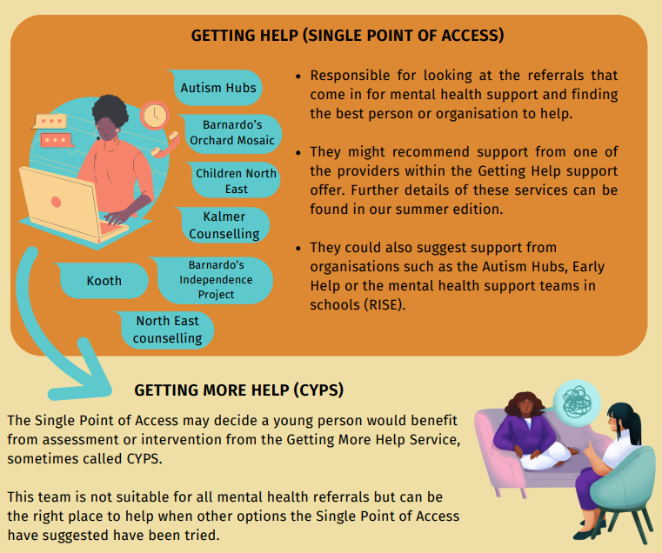

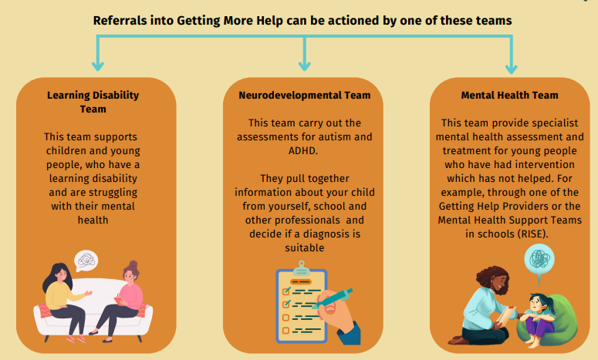

A child/young person can be on both pathways.  The determination can be made at referral by the Single Point of Access, so the neuropathway is diagnostic (unless ADHD) and the Mental Health Pathway is more about assessment/treatment/interventions that require more that 'Getting Help' -for mental health conditions, not necessarily behaviour alone.  A child/young person might be on one pathway and then at a later time be added to the other pathway, it just depends on the family/child's circumstances

