THE INCREDIBLE

YEARS ADVANCED

INFORMATION FOR PRACTITIONERS

# A PROGRAMME FOR PARENTS WITH

CHILDREN AGED 4-12

Incredible Years Advanced helps couples effectively communicate with each other as well as their children. These skills are essential to be able to solve family problems with minimal conflict and to help families appreciate, understand, and support each other more.

# ABOUT THE INCREDIBLE YEARS

Incredible Years is a 12-week course for parents who have a child aged 4-12. It is currently being delivered to couples individually online via Microsoft Teams.

The programme gently guides parents through each step, allowing parents to try techniques at home and feedback any issues they may have encountered. The videos are a particularly effective part of the programme, as this allows parents to see how real-life scenarios play out and how they are managed.

**During the Advanced course couples will learn:**

* Positive parenting strategies - working together to effectively manage children's behaviour
* Effective listening skills
* How to speak up effectively about problems
* How and when to express feelings
* Ways to give and get support
* Problem solving skills
* Avoiding communication "blocks" such as not listening, storing up grievances and angry explosions

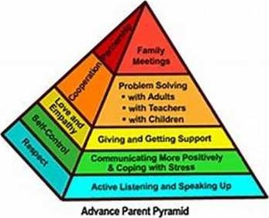



"We are now working together as a team, and the children are seeing this”