For further information:
Please contact your Teacher of Deaf Children and Young People
or visit Newcastle City Council’s Local Offer page:

https://www.newcastlesupportdirectory.org.uk/send-local-offer

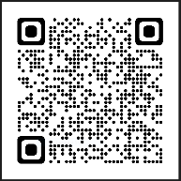

We are based at:
Civic Centre
3rd Floor
Newcastle Upon Tyne
NE1 8QH

Your Qualified Teacher of Deaf Children and Young People is:
Mobile:
Email:

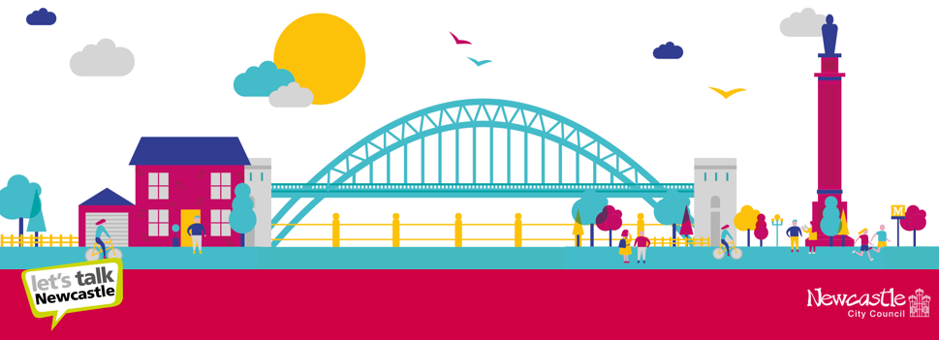

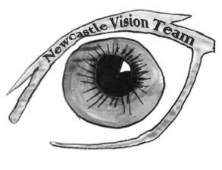
SEND Sensory Service

Civic Centre
Newcastle upon Tyne
NE1 8QH
sensoryservice@newcastle.gov.uk

SEND Sensory Service

Just Diagnosed?

Who we are
We are a team of teachers and support assistants who have undertaken specialist training to work with children and young people who have a diagnosed hearing loss.

What we do
We aim to work with you to give your child every chance of achieving their very best. We work directly with children and young people in their homes or in their educational setting. We liaise with health professionals such as ENT surgeons, audiologists, speech and language therapists. We work closely with other agencies such as educational psychology, social care and various organisations with the voluntary sector.

You are likely to meet one of the specialist teachers soon after your child’s early hearing tests have been discussed with you. You might meet one of us during an audiology or ENT appointment at the hospital, but we aim to contact you by telephone within 2 working days after you have been told about your child’s hearing.
Initially we will try to answer any questions you might have about hearing loss and what the hearing test mean. We will offer to meet with you regularly. We will arrange to see you somewhere that is convenient to you, usually in your home, but sometimes at nursery or in school may be more appropriate.
Having a new baby or young child, you will be very busy! We understand that so we will time our sessions to fit in with you.

Over time, as we get to know each other we can tackle other issues that arise. We can offer support in establishing effective use and
maintenance of hearing aids, cochlear implants and possibly radio aid systems.

We can work with you to establish good communication between you and your child. We can offer you unbiased advice and information so that your decisions are well informed. We can also help you understand the systems and processes of the local authority as your child progresses through the education system.

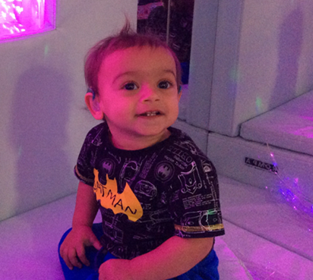
We are not always happy with the title ‘Qualified Teacher of Deaf Children and Young People’ because teaching is not a priority in our work with families. We are interested in a wide range of issues around you and your child.
You are with your baby or young child most of the time – you know your baby better than anyone and are best placed to support their development. Our aim is to provide the support that you need to achieve this.

Useful websites:

Newcastle SEND Sensory Service
SEND Sensory Service (newcastlesupportdirectory.org.uk)
Email: sensoryservice@newcastle.gov.uk

National Deaf Children’s Society
https://www.ndcs.org.uk/
Freephone number 0808 800 888

Disability Living Allowance and the Welfare Rights Service
Newcastle Welfare Rights Service .
Welfare rights | Newcastle City Council
Phone: 0191 277 2627
Monday to Friday, 9:30am to 12 noon

South of Tyne and Wearside Deaf
Children's Society
Email:southtyneandwearside@ndcsgroup.org.uk

