Annex A:
Accelerated Progress Plan for Newcastle following the judgement by Ofsted/CQC that sufficient progress had not been made against the weaknesses outlined by the Inspection

Name of the Local Area | Newcastle
Date of Inspection | 11-13 May 2021
Date of Publication of the Revisit report | 25 June 2021
Accountable Officers from the LA and CCG | Judith Hay, Director of Children, Education and Skills, Newcastle Council  Deanne Taylor, Head of SEND Newcastle City Council  Mark Adams, Chief Officer, NHS Newcastle Gateshead Clinical Commissioning Group  Jackie Cairns, Director for Newcastle System CCG
DfE and NHSE Advisers | Cath Hitchen, SEN, and Disability Professional Adviser, DFE  Chris Brown, Deputy Director of Quality NHS England, and NHS Improvement - North

Governance and Accountability
Governance and accountability structures and processes
The Newcastle local area has recently undergone a transformation in its approach to delivering services. In 2021 'Collaborative Newcastle' formalised our system partnership, putting legal standing around our intentions for commissioners and providers from statutory and voluntary organisations to work together across health and social care, formally reporting via an Executive Group to the Newcastle City Futures Board (formerly the Wellbeing for Life Board). Children and Families is the highest priority for the city and SEND as a key aspect of this work is overseen by the City Futures Board, the Health Scrutiny Committee, the CCG Executive Committee and the CCG Quality Safety and Risk Committee. Our governance arrangements and how SEND fit in are shown in the diagram below:

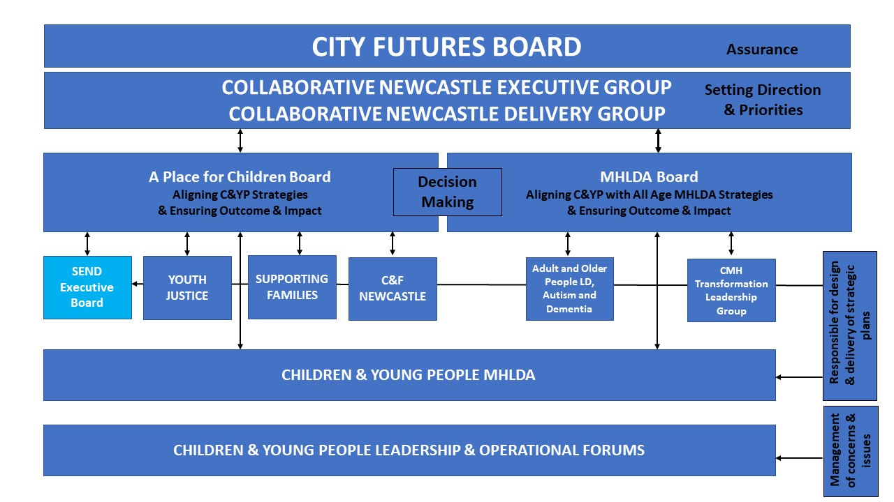
The SEND Executive group workstreams and relationship with other forums are shown below:

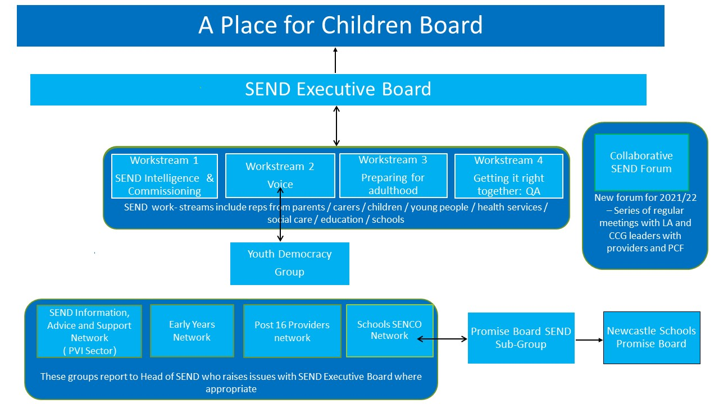
Purpose of the Accelerated Progress Plan (APP)

The revisit by Ofsted/CQC stated that, whilst Newcastle had made sufficient progress in 3 areas, the progress was insufficient in one area. Newcastle plans to accelerate progress in that area through this APP as set out below:
Area of weakness identified in original inspection, judged insufficient progress at the Revisit
Area leaders should establish effective arrangements to identify the impact of the area’s work on improving outcomes for children and young people with SEND.

This APP is part of our commitment to continuous improvement which is being delivered through our SEND improvement plan – Getting it Right Together. Progress against the plan is monitored regularly at our Collaborative SEND Forum meetings. We will report our progress against this APP to the DfE and NHSE within 6-months and then again at 12-months, and as part of these reports the actions and impacts will be risk assessed.

 | Action | Responsible Officers | Timescale for the action | Action RAG
1 | Ensure a solid SEND Graduated Response system in place to identify, meet needs and improve outcomes.
1.1 | Review, strengthen and test SEND governance arrangements. | Head of SEND, NCC, Director of Newcastle System NewcastleGateshead CCG  Parent Carer Forum. | Within 6 months
1.2 | Implement the SEND Collaborative Forum meetings as agreed in July 2021. | Head of SEND, NCC, Director of Newcastle System NewcastleGateshead CCG  Parent Carer Forum.
1.3 | Roll out the newly co-produced SEN Support plan across all educational settings. | Senior SEND Advisor, NCC.
1.4 | Review the graduated response process through the referrals and interventions made in 2020/21. Identify what works well and what needs to improve. | Head of SEND, NCC, SEND Service Improvement Lead, NCC.
1.5 | Relaunch our graduated response. | Head of SEND, NCC.
1.6 | Enhance the universally available and mainstream guidance with co-produced descriptors of need. | Service Manager SENDOS, NCC  Senior SEND Advisor, NCC.
1.7 | Work with all settings to clarify primary needs data recording through census and electronic management system. | Senior SEND Advisor, NCC.
1.8 | Pilot the electronic SEND portal to facilitate the EHC assessment, planning process with schools and families. | Head of SEND SAR Team, NCC  SEND Service Improvement Lead, NCC.
1.9 | Co-produce a new Education, Health and Care Plan (EHCP) template for CYP age 0-25. | Head of SEND SAR Team  SEND Voice Lead, NCC  Parent/Carer Forum.
1.10 | Carrying out a pilot study to test out Rix Wiki and MOMO with families to improve how we gather voice in the EHC process. | SEND Voice Lead, NCC  Parent Carer Forum.
1.11 | Improve the quality of health advices by implementing single point of contact, and health advice champions. | Designated Medical Officer, NewcastleGateshead CCG.
1.12 | Continuous roll out of SEND Training programme to ensure that the health provision ‘is specific, that outcomes in plans are clear, precise and measurable, and plans focus sharply enough on preparing young people for their adult lives’. | Head of SEND, NCC,  Designated Medical Officer, NewcastleGateshead CCG.
1.13 | Work with SENCOs to arrange peer moderation review process for SEN support plans/ EHCPs which aligns to the co-produced SEND descriptors of need. | Senior SEND Advisor, NCC. | Within 12 months
1.14 | Identify schools with high levels exclusion and deliver targeted whole school training through investment in Autism Education Trust (AET). | Head of SEND, NCC.
1.15 | Develop a bespoke Social, Emotional, Mental Health (SEMH) training programme for the city and deliver to targeted schools/ settings. | Head of SEND, NCC  Senior Specialist Educational Psychologist.
1.16 | Implement a clear core and traded offer, following the consultation in 2020/21. | Head of SEND, NCC.

 | Action | Responsible Officers | Timescale for the action | Action RAG
2 | Further develop the SEND quality assurance system ‘Getting It Right Together’
2.1 | Hold event with SEND Executive Board to identify and agree the priority measures to be used to assess progress against the agreed outcomes. | Head of SEND, NCC. | Within 6 months
2.2 | Explore national models and role descriptors for the Designated Social Care Officer (DSCO) function. | Head of SEND, NCC.
2.3 | Produce an outline proposal to set out clear accountability and responsibilities to be undertaken by the DSCO function for Newcastle. | Head of SEND, NCC.
2.4 | Produce a role and person specification for a DSCO. | Head of SEND, NCC.
2.5 | Develop a case for investment to secure the necessary capacity to support the DSCO function for Newcastle. | Head of SEND, NCC.
2.6 | Explore national models and role descriptors for the Designated Medical Officer/ Designated Clinical Officer (DMO/DCO) function. | Director of Newcastle System NewcastleGateshead CCG.
2.7 | Produce an outline proposal to set out clear accountability and responsibilities to be undertaken by the DMO/DCO function for Newcastle. | Director of Newcastle System NewcastleGateshead CCG.
2.8 | Produce a role and person specification for a designated clinical officer. | Director of Newcastle System NewcastleGateshead CCG.
2.9 | Develop a case for investment to secure the necessary capacity to support the DMO/DCO function for Newcastle. | Director of Newcastle System NewcastleGateshead CCG.
2.10 | Implement refreshed DMO/DCO function. | Director of Newcastle System  NewcastleGateshead CCG. | Within 12 months
2.11 | SEND Executive Board and young people with SEND and their parents/ carers to review and test the agreed priority measures to ensure they are appropriate and trace progress against agreed outcomes. | SEND Voice Lead, NCC Parent Carer Forum.
2.12 | Parents/carers and children and young people to design a whole school survey (to be issued bi-annually) to find out whether children and young people feel happy, safe, well cared for, have a voice and are ready for the world of work. SEND Executive Board to formally respond to the results. | SEND Voice Lead, NCC Parent Carer Forum.
2.13 | Ensure SEND Outcomes are included within relevant education, health and care commissioned service specifications with appropriate mechanisms for measuring progress. | Director of Newcastle System NewcastleGateshead CCG  Service Manager: Commissioning (Social Care and Inclusion), NCC.
2.14 | Undertake quality assurance activity as set out in SEND Quality Assurance Framework, Getting it right together | Head of SEND, NCC  DMO, NewcastleGateshead CCG.

 | Action | Responsible Officers | Timescale for the action | Action RAG
3 | Health and Local Authority to collaboratively commission and assure a therapy offer that meets current and future needs, reduces waiting times, and delivers the outcomes and impact that we collectively agree with children, young people, their families
3.1 | Identify and implement interim measures to the occupational therapies and equipment/adaptations pathway to meet immediate needs and support waiting list reduction. | Newcastle Gateshead CCG  Head of SEND, NCC  DMO, CCG.  Commissioning (Social Care and Inclusion), NCC. | Within 6 months
3.2 | Undertake a comprehensive analysis of current and predicted need for occupational therapy support requirements for children and young people. | Newcastle Gateshead CCG  Head of SEND, NCC  DMO, CCG.  Commissioning (Social Care and Inclusion), NCC.
3.3 | Identify with children and young people and their families outcome, impact, and delivery expectations from an occupational therapy support offer. | Newcastle Gateshead CCG  Head of SEND, NCC  DMO, CCG.  Commissioning (Social Care and Inclusion), NCC.
3.4 | Identify specific occupational therapies support required for children with Autism Spectrum Condition to support assessment, diagnosis, and post diagnostic support. | Newcastle Gateshead CCG  Head of SEND, NCC  DMO, CCG.  Commissioning (Social Care and Inclusion), NCC.
3.5 | Identify equipment and adaptation requirements to be built into the occupational therapies support pathway. | Newcastle Gateshead CCG  Head of SEND, NCC  DMO, CCG.  Commissioning (Social Care and Inclusion), NCC.
3.6 | Explore national and international models for occupational therapies to inform the Newcastle model and approach. | Newcastle Gateshead CCG  Head of SEND, NCC  DMO, CCG.  Commissioning (Social Care and Inclusion), NCC.
3.7 | Co-produce a costed occupational therapies pathway for assessment and treatment to deliver the agreed delivery, outcome, and impact measures. | Newcastle Gateshead CCG  Head of SEND, NCC  DMO.  Commissioning (Social Care and Inclusion), NCC. | Within 12 months
3.8 | Present case for change to system leaders via organisational and SEND Executive Board to secure required investment and resources. | Newcastle Gateshead CCG  Head of SEND, NCC  DMO, CCG.  Commissioning (Social Care and Inclusion), NCC.
3.9 | Translate occupational therapies offer into the service specification and contractual agreements required to mobilise the new support offer. | Newcastle Gateshead CCG  Head of SEND, NCC  DMO, CCG.  Commissioning (Social Care and Inclusion), NCC.
3.10 | Commence process for collaboratively commissioning revised occupational therapies offer. | Newcastle Gateshead CCG  Head of SEND, NCC  DMO, CCG.  Commissioning (Social Care and Inclusion), NCC.

Impact measures and milestones to be achieved
- Solid SEND Graduated Response system in place to identify, meet needs and improve outcomes.
KPI reference | By 6 months (End of March 2022) | RAG | By 12 months (end of September 2022) | RAG
1.1- 1.2
- A survey will be carried out that confirms that families and the SEND workforce are aware of the SEND governance arrangements.
- An audit of SEND Executive Board meetings demonstrates appropriate accountability in support and challenge role.
APP 1a 1b and 2 | 1.3  - All referrals to SEND ASAP panel will include evidence of settings using agreed SEN Support plan and provision map.
APP1a 1b and 2 | 1.4-1.7  - A survey of settings will confirm that the graduated response is working well in Newcastle.  - There will be an increase in appropriate referrals to SEND ASAP. |  | 1.4-1.7  - An audit of SEND ASAP referrals confirms that interventions resulted in improved outcomes for CYP.  - A survey of settings confirms that staff can access support and training at the earliest opportunity.  - A survey of Parents/ carers confirms that they know where to go to access help and support.
APP5 |  |  | 1.8  - An audit of EHCPs confirm that all EHCPs record the appropriate primary need of the child/ young person.
APP3  APP4 |  |  | 1.9  - The implementation of the SEND portal contributes to improvements in the timeliness of EHC assessments to be in line with at least national average.
APP5 |  |  | 1.10  - A survey confirms that, at least 75% of parents and carers and children and young people and settings are positive about the new EHCP template.
APP3  APP5 |  |  | 1.11  - Quarterly audits show at least 75% of parental satisfaction in relation to their voice and their child’s voice being heard throughout the EHCP and annual review process.
APP5 and 6 | 1.12-1.13  - Audits carried out each quarter demonstrate a 50% improvement in the quality and timeliness of EHC plans based on good quality advice and clear outcomes. |  | 1.12-1.13  - Audits carried out each quarter demonstrate a 75% improvement in the quality and timeliness of EHC plans based on good quality advice and clear outcomes.
APP3  APP5 | 1.14  - Quarterly audits show an improvement in demonstrating parental and child voice in EHC plans and annual reviews. |  | 1.14  - SENCOS have a better understanding of needs and required provision across the city. Evidence and peer reviews demonstrate appropriate support and challenge.
APP 1a 1b and 2 |  |  | 1.15-1.16  - 100% of targeted schools are accessing the AET and SEMH training.

2. Further develop the SEND quality assurance system ‘Getting It Right Together’
KPI reference | By 6 months (End of March 2022) | RAG | By 12 months (end of September 2022) | RAG
2.1:
- Priority measures are agreed to track progress against the agreed outcomes which will be reviewed regularly at the SEND Executive Board.
APP6 | 2.2-2.3  - Parents and carers will be aware of the DSCO role as outlined on the local offer. |  | 2.2-2.3  - Quarterly audits confirm that the quality of social care advice has improved to at least 75% being rated as good.
APP6 | 2.6-2.10  - Parents and carers will be aware of the DMO /DCO role as outlined on the local offer. |  | 2.6-2.10  - Quarterly audits confirm that the quality of health advice has improved to at least 75% being rated as good.
APP1a APP2b |  |  | 2.11  - The SEND Executive Board will be fully cited on how the local area are doing in respect of their ambition for all children: to have a voice; be safe, happy, and included, be well cared for; and be ready for the world of work.  - We will see a reduction in fixed term exclusions for those with SEND to at least in line with that of national levels. Individual targets will be agreed with schools where appropriate.  - We will see an increase in attendance levels to be in line with national average for those with SEND. Individual targets will be agreed with schools where appropriate.
2.12
- We will have a clear understanding of how our children and young people feel to inform future planning.
2.13:
- We will have a collaborative commissioning policy that sets out how we will embed outcomes into service specifications and contracts.
APP5 and 6 |  |  | 2.16  - Implementation of the ‘getting it right together’ framework confirms that the experience of children and young people with SEND and their families is improving.

- Health and Local Authority to collaboratively commission and assure a therapy offer that meets current and future needs, reduces waiting times, and delivers the outcomes and impact that we collectively agree with children, young people, their families
KPI reference | By 6 months (End of March 2022) | RAG | By 12 months (end of September 2022) | RAG
APP7 | A broad outline of need and desired outcomes from occupational therapy intervention will be available. |  | A comprehensive service specification and contract, including outcomes measures, will have been agreed by all partners and the process for implementation commenced.
APP7 | Interim outcome measures will be agreed to monitor progress which will be reviewed regularly at the SEND Executive board. The primary focus of this will be a sustained reduction in the waiting list for assessment and treatment.
APP7 | Views of children, young people and their families will be captured to ensure that they play a key role in the design of future delivery. This will be evidenced in a "you say, we did" report.
APP7 |  |  | - A final costed pathway for assessment and treatment to deliver the agreed outcome and impact measures will be developed to include agreed baselines and improvement trajectories

Risk Register
Date | Risk | Severity/Impact | Mitigation | Progress following action
30/08/2022 | That schools and settings do not engage with initiatives such, the SEN support plan, and descriptors of need and the graduated response. | High | - Strong head teacher partnerships  - Effective SENCO networks  - Support of SEND Sub-Group  - Regular communications with schools. | Low - No further action required.
30//08/2022 | Lack of effective parent/carer forum. | High | - Effective parent/carer forum  - Respected chairs  - Support from Contact  - Support of SEND Voice Lead. | Low - No further action required.
30/08/2022 | Change of SEND leadership in Local Authority and CCG. | Medium | - Robust SEND system in place which provides continuity. | Low - No further action required.
30/08/2022 | Limited engagement of CYP and PC will mean we are unable to identify impact of accelerated progress plan. | High | - Effective parent/carer forum  - Respected chairs  - Support from Contact  - Support of SEND Voice Lead  - Voice Trainees. | Low - No further action required.
30/08/2020 | Resources diverted and school closures due to further lockdown and COVID. | High | - Strong head teacher partnerships  - Effective SENCO networks  - Support of SEND Sub-Group  - Regular communications with schools. | High – No further action identified.
30/08/2022 | Unable to secure finance to deliver improvements. | High | - Ensure organisational committees and SEND Board are regularly briefed on case for change  - Advise on changes in need and any anticipated investment gap at the earliest opportunity. | Medium – No further action identified.
30/08/2022 | Capacity within teams to deliver change. | Medium | - SEND service review and investment in capacity. | Low - No further action required.
30/08/2022 | Quality of EHCPs do not improve result in increased complaints and tribunals. | Medium | - Regular audits to check quality of plans and advices reviews and ongoing training programme. | Low - No further action required.
30/08/2022 | EHCPs numbers continue to increase at a higher rate than other areas. | Medium | - Caseload review  - Actions to strengthen graduated response. | Low - No further action required.

Scorecard
The SEND Executive Board monitors progress against an agreed outcomes framework. The scorecard below shows the ‘bellwether’ or key performance indicators, which will be closely monitored as they will provide us with overall assurance that our work is delivering accelerated progress or alert us to areas where they are not improving.
KPI Ref | KPI | Baseline | 6 months | 12 months
APP1a | % of pupils who were permanently excluded from Newcastle schools is at least in line with the national average. | 2018-19, 0.39% of pupils with SEND were permanently excluded from Newcastle schools, which was above the national average of 0.29%. |  | Levels are in line with the national  picture
APP1b | % of pupils who were excluded from Newcastle schools for a fixed term is at least in line with the national average. | 2018-19, 13.9% of pupils with SEND were fixed term excluded from Newcastle schools, which was below the national average of 15.7%.
APP2 | Increase in attendance levels increase and are in line with national average for those with SEND. | 2018-19 absence rates for pupils with SEND was 7.8%, which was above the national average of 6.9%.
APP3 | The number of complaints received reduces by 50% in over the year | 2020/2021 Academic year we received 11 complaints. | Reduction of 25% | Reduction of 50%
APP4 | The number of EHCP assessments completed within 20 weeks improves to that of national averages. | In 2020 calendar year, 53.6% of EHCPs were issued within the statutory 20-week timescale (including exceptions), below the national average of 55.6%. | 60% | 80%
APP5 | Quarterly audits show improved compliance of practice against service standards for EHCPs. | Approximately 25% of audits are compliant with standards. | 50% of audits show that quality has improve | 75% of audits show that quality has improved
APP6 | Quarterly audits show improved quality of advice which underpins the EHCPs. | Approximately 25% of advices are compliant with standards. | 50% of audits show that quality has improve | 75% of audits show that quality has improved
APP7 | Reduced waiting lists for Occupational Therapy. | Data is currently been verified to establish the exact waiting times. This will inform the improvement targets. | Interim measures agreed and implemented specifically targeted at a sustained reduction in the waiting list | Service model and outcomes framework agreed and implemented which will deliver assessment and treatment to national guidelines
Annex B: Supporting statement for the Accelerated Progress Plan
Factors accounting for insufficient progress | How we are addressing these
After the original inspection, there were significant leadership changes at the local authority and the CCG, and the parent/carer forum was not in operation. | We now benefit from improved governance an effective parent carer forum and as reported by the inspectors ‘genuine partnership’ arrangements.

Please say here how you will ensure that partners, including families, are fully aware and kept informed of you actions and progress
- Getting it right together framework
- PCF part of the group overseeing the Accelerated Progress Plan
- PCF part of SEND Executive Board
- SEND Executive Board briefing widely distributed
- Local Offer kept up to date
- Regular question and answer sessions for parents carers at the Collaborative SEND Forum.

Please say here what support and challenge you feel would be most helpful over the coming months and when
- The Delivering Better Outcomes Together consortium.
- Council for Disabled Children (CDC) to develop our Outcomes framework.
- Whole School SEND to strengthen our offer.

To be risk assessed for DFE and NHSE monitoring meetings
To be risk assessed for DFE and NHSE monitoring meetings
To be risk assessed for DFE and NHSE monitoring meetings
To be risk assessed for DFE and NHSE monitoring meetings

