For further information:

Please contact your Teacher of the Deaf

or visit Newcastle City Council’s Local Offer page:

https://www.newcastlesupportdirectory.org.uk/send-local-offer

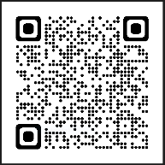

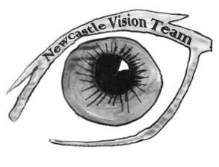

SEND Sensory Service
Civic Centre
Newcastle upon Tyne
NE1 8QH
sensoryservice@newcastle.gov.uk

SEND Sensory Service

Post 16 contact list for young people
who are deaf

Useful contacts:

Audiology Service
Audiology - Newcastle Hospitals NHS Foundation Trust (newcastle-hospitals.nhs.uk)

Access to Work
https://www.ndcs.org.uk/information-and-support/money-and-benefits/other-financial-support/access-to-work/

All Day Concessionary Travel Pass https://www.nexus.org.uk/ticket-information/concessions/disabled-adults

Contacting emergency services
https://emergencysms.net/ or https://999bsl.co.uk/

DSA
Help if you're a student with a learning difficulty, health problem or disability: Disabled Students' Allowance - GOV.UK (www.gov.uk)

Hearing Dogs
www.hearingdogs.org.uk

Knowledge of assistive devices - NDCS
Technology Test Drive | National Deaf Children's Society (ndcs.org.uk)

Hearing Link Services
Hearing Link Services - UK Hearing Loss Charity

National Deaf Children's Society
National Deaf Children's Society | Supporting deaf children (ndcs.org.uk)

NDCS Buzz
Welcome to the Buzz - NDCS The Buzz

NDCS Deaf Works Everywhere Toolkit:
Deaf Works Everywhere | National Deaf Children's Society (ndcs.org.uk)

NDCS Your Future Webinar Series On Careers for Deaf Young People
https://www.ndcs.org.uk/our-services/our-events/events-for-children-and-young-people/your-future-webinar-series-on-careers-for-deaf-young-people/

Newcastle Careers and Guidance Team
www.newcastlecareers.org.uk

North East Regional Cochlear Implant Programme
North East Regional Cochlear Implant Programme - South Tees Hospitals NHS Foundation Trust

Northeast Interpreters Network
Sign Language Interpreters (northeast-bslenglish-interpreters.co.uk)

Personal Independence Payment
https://www.ndcs.org.uk/information-and-support/money-and-benefits/personal-independence-payment-pip/

Royal National Institute for Deaf People
RNID - National hearing loss charity

Sensory Support Services
https://www.newcastle.gov.uk/services/care-and-support/adults/adult-care-services/sensory-support-services

