To get further information:

Please contact your Teacher of the Deaf

or visit Newcastle City Council’s Local Offer page:

https://www.newcastlesupportdirectory.org.uk/send-local-offer

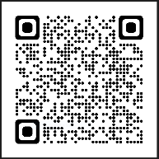

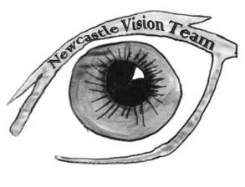

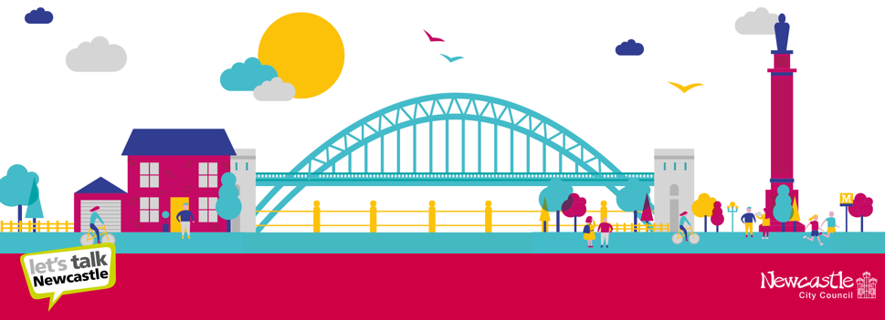
SEND Sensory Service
Floor 3 Civic Centre
Barras Bridge
Newcastle upon Tyne
NE1 8QH
sensoryservice@newcastle.gov.uk

SEND Sensory Service

Post 16 information for young people
who are deaf

Our support for young people who are deaf includes:

- Teaching of key terminology around post 16 choices

- Developing decision-making skills

- Teaching of an audiology curriculum – Personal Understanding of Deafness and support with transition to the Adult Audiology Service

- Signposting to different education and employment options from Year 9 onwards

- Signposting to university Supported Entry Schemes

- Support to young people arranging visits, taster days and completing applications

- Completion of a Transition Profile that is shared during transition, outlining need, support and key strategies, including Exam Access Arrangements

- Deaf awareness training for new providers

- Developing knowledge of online safety

- Developing independence skills

Useful contacts:

Access to Work
https://www.ndcs.org.uk/information-and-support/money-and-benefits/other-financial-support/access-to-work/

All Day Concessionary Travel Pass
https://www.nexus.org.uk/ticket-information/concessions/disabled-adults

Contacting emergency services https://emergencysms.net/ or https://999bsl.co.uk/

Disabled Students' Allowance
Help if you're a student with a learning difficulty, health problem or disability: Disabled Students' Allowance - GOV.UK (www.gov.uk)

Hearing Dogs
www.hearingdogs.org.uk

Knowledge of assistive devices - NDCS
Technology Test Drive | National Deaf Children's Society (ndcs.org.uk)

NDCS Deaf Works Everywhere Toolkit
Deaf Works Everywhere | National Deaf Children's Society (ndcs.org.uk)

NDCS Your Future webinar series On Careers for Deaf Young People
https://www.ndcs.org.uk/our-services/our-events/events-for-children-and-young-people/your-future-webinar-series-on-careers-for-deaf-young-people/

NDCS Buzz
Welcome to the Buzz - NDCS The Buzz

Personal Independence Payment https://www.ndcs.org.uk/information-and-support/money-and-benefits/personal-independence-payment-pip/

Sensory Support Services:
https://www.newcastle.gov.uk/services/care-and-support/adults/adult-care-services/sensory-support-services

