

**SEND Sensory Service**

**Children’s Vision Team**

Floor 3

Civic Centre

Newcastle

NE1 8QH



sensoryservice@newcastle.gov.uk

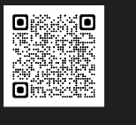Newcastle SEND Local Offer page

[www.newcastlesupportfirectory.org.uk/send-local-offer](http://www.newcastlesupportfirectory.org.uk/send-local-offer)

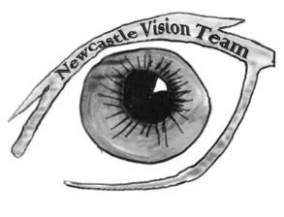

**SEND Sensory Service**

# Newcastle Children’s Vision Team

**Post 16 information for young people**

**who have a visual impairment**

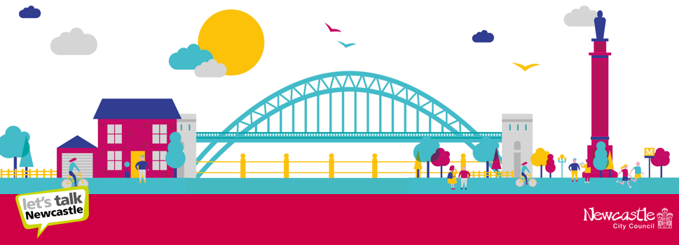

Our support for young people who have a visual impairment includes:

* Promoting self-advocacy and teaching key terminology around post 16 choices
* Completion of a Transition Profile that is shared during transition, outlining need, support and key strategies and including Exam Access Arrangements
* Ensuring access to appropriate modifications and assistive technology
* Teaching of a Curriculum Framework for Visual Impairment, including an understanding of your visual impairment and support towards the transition to Adult Services if appropriate
* Signposting and advice for different education, apprenticeship and employment options, including to higher education, from Year 9 onwards
* Support to young people arranging visits to providers, taster days and completing applications
* Visual impairment awareness training for new providers
* Signposting towards involvement in the wider community through sport, voluntary work and youth groups
* Developing independence skills including travel

Useful contacts:

General support

**Access to Work** [Access to Work scheme | RNIB](https://www.rnib.org.uk/living-with-sight-loss/equality-and-employment/information-for-jobseekers/access-to-work/)

**All Day Concessionary Travel Pass** <https://www.nexus.org.uk/ticket-information/concessions/disabled-adults>

**Disabled Students' Allowance**

Help if you're a student with a learning difficulty, health problem or disability: Disabled Students' Allowance - GOV.UK (www.gov.uk)

**Sensory Support Services:**

<https://www.newcastle.gov.uk/services/care-and-support/adults/adult-care-services/sensory-support-services>

**Visual Impairment specific organisations**

**Guide Dogs** [www.guidedogs.org.uk](http://www.guidedogs.org.uk)

**RNIB** <https://www.rnib.org.uk/>

**Thomas Pocklington Trust**

[Thomas Pocklington Trust - Thomas Pocklington Trust (pocklington-trust.org.uk)](https://www.pocklington-trust.org.uk/)

**Look**

[Look UK – Supporting Visually Impaired Young People to Thrive (look-uk.org)](https://www.look-uk.org/)

This site has lots of helpful information, including a mentoring programme, either to be mentored or training to become a mentor

**British Blind Sport**

[Home - British Blind Sport](https://britishblindsport.org.uk/)

**VICTA**

[VICTA | Children and young adults who are blind or partially sighted](https://www.victa.org.uk/)