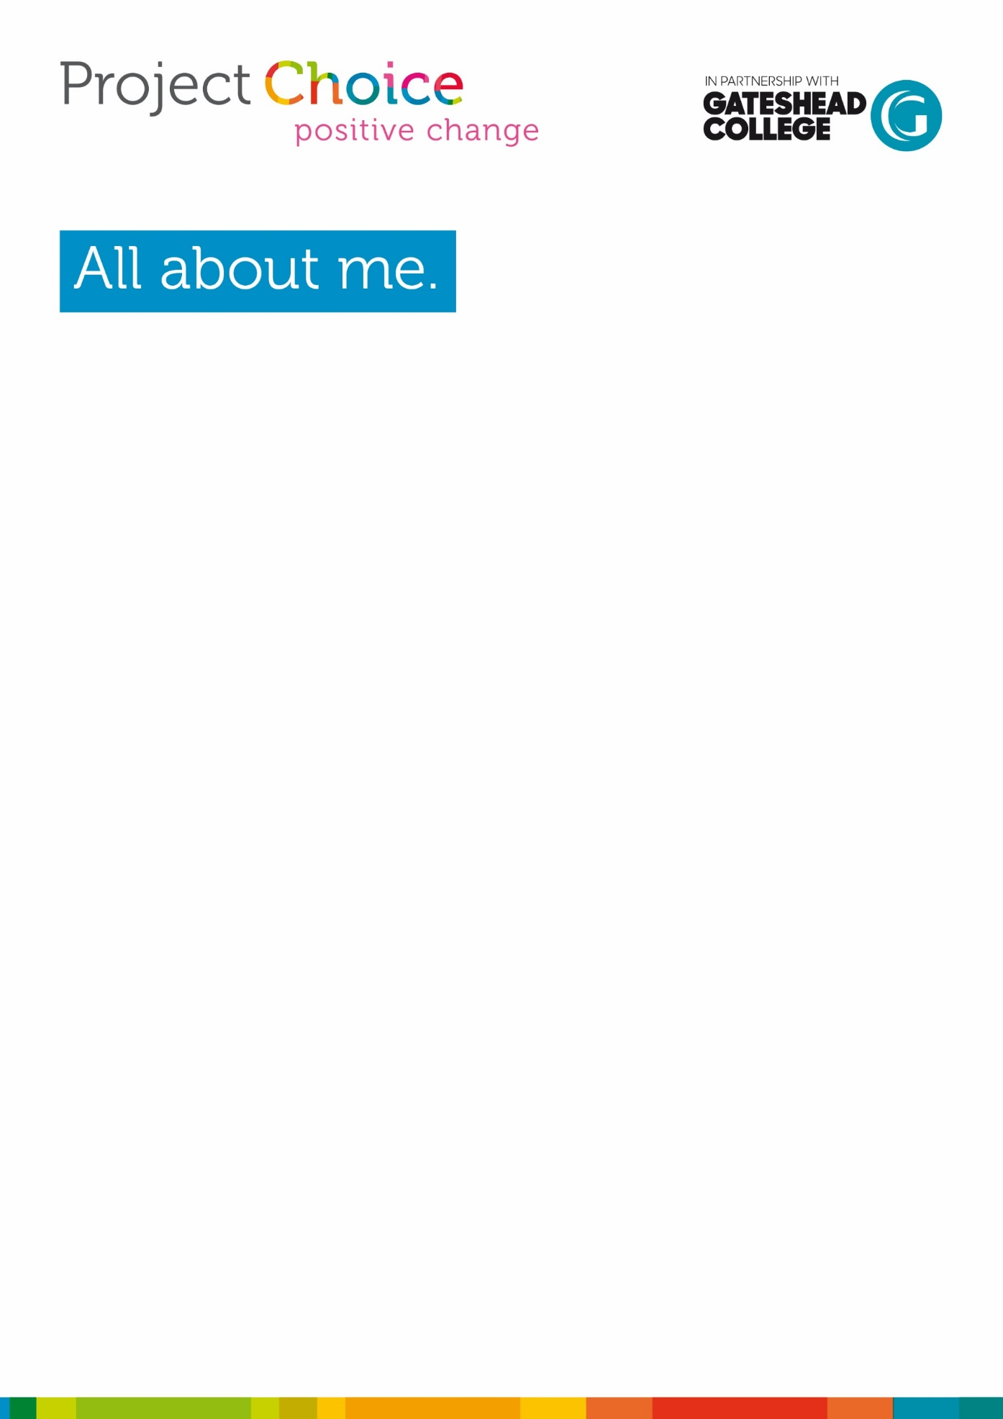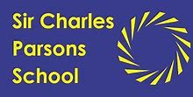****

**Name**:

**Age:**

**Male/Female:**

**School:**

**My likes/interests:**

**My dislikes:**

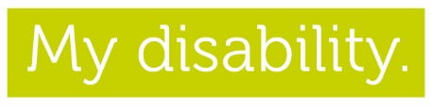

**Disability type:** *e.g. learning disability, learning difficulty, autism etc.*

Learning disability.

**a wheelchair or walking frame etc.):**

None

What am I good at?

**Reading/ writing/ computer skills**

**Communication:**

**Social behaviours (Do I enjoy talking to others or do I prefer my own space? Am I good at interacting with others or do you need support to do this in a positive way etc.):**

**What skills do I own? (Look at the balloon sheet below to help you with ideas)**

**What qualities do I own? (Look at the diamond sheet to help you with ideas)**

**Do I understand the need to follow rules? Why is it important to follow rules?**

**Can I listen to and follow instructions?**

**Do I recognise when I need help? Can I ask for help if I need it?**

**Is *criticism* a good or bad thing? Can it help me to learn and develop my skills? Does it help me learn?**

Interested in the world around me

**Am I interested in learning about the world around me e.g., learning and finding out about work and jobs? What do real people do for work, how do they achieve this? Could this be me in the future?**

**Do I enjoy finding out new things either about yourself or in the world of work? Does this scare me? If so, why?**

**Do I like asking questions? (Are you *curious?*)**

**When I begin my work experience journey what do I think it will be like?**

**What do I want to learn on my work experience journey?**

**How do I want to feel when I take part in a work experience?**

**Have I done any work experience before?**