Learning Disability Questionnaire

About this Questionnaire

This questionnaire will help the Doctor/nurse to get information about you. This information will hep them with your annual health check.

Q.1 | What is your name?

Q.2 | What is your address?

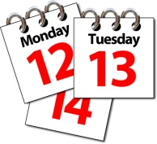  Q.3 | What is your date of birth?

Q.4 | What is your telephone number?  Home  Mobile  Contact number in an emergency

Q.5 | Please tick the box which best describes you:
 | Single
 | Married
 | Separated
 | Divorced
 | Widowed

Q.6 | Have you ever smoked?
 | Yes
 | No
 | Don’t know

Q.7 | Do you smoke now?
Yes

If so how many a day
 | No
 | Don’t know

Q.8 | Do you have a social worker?
Yes

If yes what is their name?
 | No

Q.9 | Do you have any problems with communication?
 | Yes
 | No

Q.10 | Do you use a picture book or electronic prompt device?
 | Yes
 | No

Q.11 | Do you need someone with you to help you communicate?
 | Yes
 | No

Q.12 | Do you have a speech problem?
 | Yes
 | No

Q.13 | Do you have a stammer/stutter?
 | Yes
 | No

Q.14 | Do you use Makaton sign language?
 | Yes
 | No

Q.15 | Do you need an interpreter?
 | Yes
 | No

Q.16 | Do you have a carer?
Yes

What is there name?
 | No
Q.17 | Which best describes your ethnic origin?
 | White
 | Asian or Asian British
 | Black
 | Other

Q.18 | How often do you have a drink containing alcohol?
 | Never
 | Monthly
 | Less than 2 – 4 times per month
 | 2 – 3 times per week
 | More than 4 times a week

Q.19 | What best describes your eating habits?
 | Healthy Diet
 | Diet Good
 | Diet Average
 | Diet poor

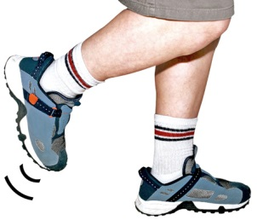  Q.20 | What best describes your exercise habits?
 | Cannot exercise
 | Don’t like to exercise
 | Enjoy light exercise
 | Enjoys moderate exercise
 | Enjoys heavy exercise
 | Don’t know

Q.22 | Do you have any problems swallowing?
 | No
 | Have difficulty swallowing solids
 | Have difficulty swallowing liquids
 | Have swallowing symptoms

Q.22 | Do you have any feeding problems?
 | Yes
 | No

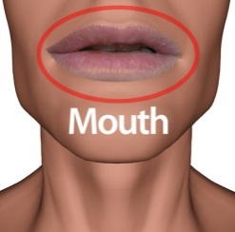  Q.23 | Do you have any mouth symptoms?
 | No mouth problems
 | Sore gums
 | Bleeding gums
 | Good oral hygiene
 | Poor oral hygiene

Q.24 | Are you registered with a dentist?
Yes

When was the last time you saw your dentist?
 | No

Q.25 | Do you have a PEG feeding tube fitted?
 | Yes
 | No
Q.26 | Do you regularly suffer from constipation?
 | Yes
 | No

Q.27 | Do you regularly suffer from diarrhoea?
 | Yes
 | No

Q.28 | Have you seen any blood in you poo?
 | Yes
 | No

Q.29 | Do you have any bowel problems?
 | Yes
 | No

Q.30 | Do you have any bladder problems?
 | Yes
 | No

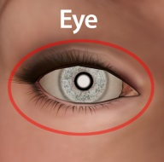  Q.31 | Do you have normal vision?
 | Yes
 | No

Q.32 | Are you registered partially sighted?
 | Yes
 | No

Q.33 | Are you registered blind?
 | Yes
 | No
Q.34 | Are you registered sight impaired?
 | Yes
 | No

Q.35 | Do you suffer from poor vision?
 | Yes
 | No

Q.36 | Do you wear glasses?
 | Yes
 | No

Q.37 | Should you wear glasses but don’t?
 | Yes
 | No

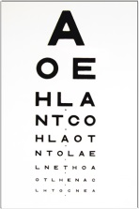  Q.38 | Have you been seen by an optician?
Yes
Please tell us when
 | No

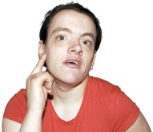  Q.39 | Do you have normal hearing?
 | Yes
 | No

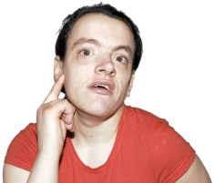  Q.40 | Do you have hearing difficulties?
 | Yes
 | No

Q.41 | Are you deaf in one ear?
 | Yes
 | No

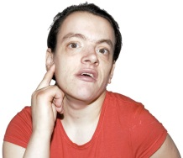  Q.42 | Are you deaf in both ears?
 | Yes
 | No

Q.43 | Are you partially deaf?
 | Yes
 | No

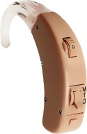  Q.44 | Do you wear a hearing aid?
 | Yes
 | No

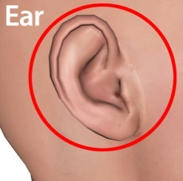  Q.45 | Have you been seen by an audiologist? This person looks after your ears.
Yes
If so please tell us when
 | No

Q.46 | Do you have epilepsy?
 | Yes
 | No

Q.47 | If you have epilepsy, is it well controlled:
 | Yes
 | No
 | How often do you have a fit?
 | Last 12 months no seizures
 | No seizures on treatment
 | 1 – 12 seizures per year
 | 2 – 4 seizures a month
 | 1 – 7 seizures a week
 | Seizures every day
 | Lots of seizures a day

Q.48 | When did you have your last fit?

Q.49 | Do you have any problems sleeping?
 | Yes
 | No

Q.50 | Please tell us which statements best describes you:
 | I am fully mobile
 | I am mobile outside of my house but need an aid
 | I am mobile in my house
 | I need a walking aid in my house
 | I am confined to a chair
 | I have impaired mobility
 | I am housebound
 | I am temporarily housebound

Q.51 | Do you have a paid job?
Yes
Is this full time yes/no
 | No

Q.52 | Are you retired?
Yes
Is so were you retired on medical grounds yes/no
 | No

Q.53 | Are you unfit for work?
 | Yes
 | No

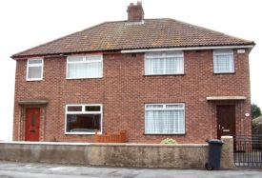  Q.54 | Please tell us which statements best describes how you live?
 | I live alone
 | I live with family
 | I live in a residential home
 | I live in a nursing home
 | I live in Independent Supported Living

Thank you for completing this questionnaire.

Can you please send it to:

