The Big Handbook



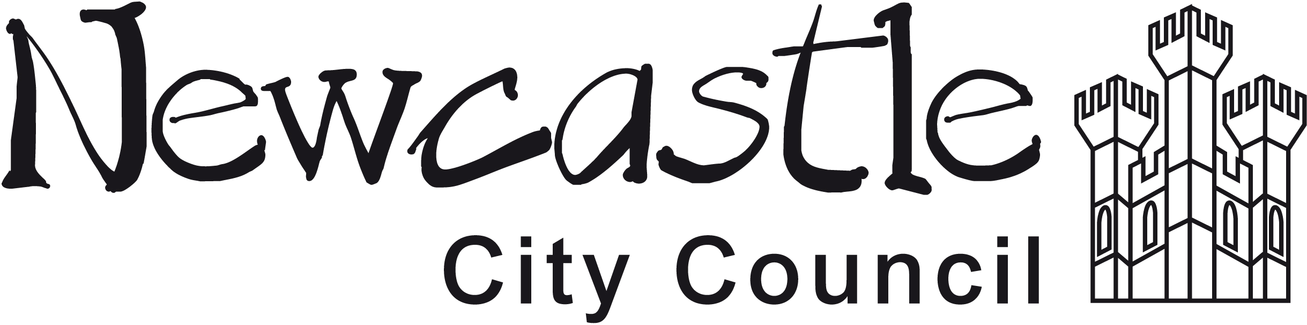
A Guide to Social Care Personal Budgets in Newcastle Children with Disabilities Service
December 2015 Version

Support Planning
Newcastle City Council is committed to Child Centred Support Planning for children and young people with disabilities. The council has worked with many partners through the years to support good planning for families who have a Social Care Personal Budget. The Northeast Special Needs Network (NSNN) and Skills for People (particularly the Pass it on Parents group there) have helped to train staff and plan with families. Social workers mostly plan with families and the NSNN have been commissioned by the council to plan with some families too.
This handbook has been written to explain, in an easy way, the pathway children and their families will follow through Social Care Personal Budgets. The information in this guide is based on the council documents which explain all of the steps in more detail, these can be found at;
www.newcastle.gov.uk/social-care-and-health/looking-after-children/children-with-disabilities/individual-budgets

This handbook is an updated version of the original booklet which was written by Tim Keilty in his time at Skills for People. All graphics are by Tim Keilty.

Contents

Free and Low Cost Services for Your Child Page 4

A Brief Introduction to Social Care Personal Budgets Page 6

The Social Care Personal Budgets Pathway in Newcastle Page 9

Assessment Page 10

Support Planning Page 14

Getting the Plan Agreed Page 17

Going Live Page 19

Review Page 20

Audit Page 21

Approve Next Year’s Budget Page 22

Support Available to Help With Social Care Personal Budget Page 23

Frequently Asked Questions Page 26
Available to Every Child in Newcastle
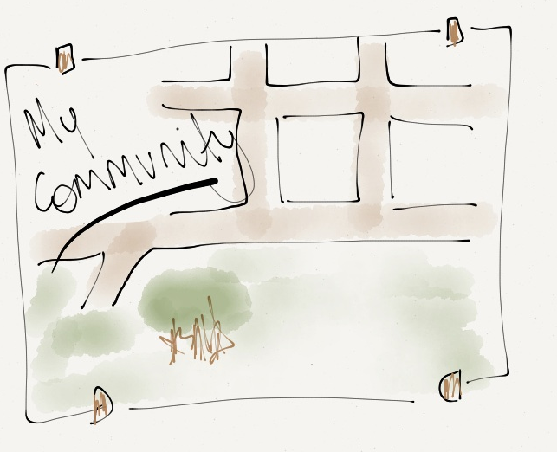

Sometimes there is no need for paid support when these services are combined with the support the family and community can offer. The support and services the council offers to children with disabilities and their families are set out in the Local offer. The local offer web pages can be found at:
http://www.newcastlefis.org.uk/kb5/newcastle/fsd/localoffer.page?familieschannel=3

The following are free services we will always offer you:

Welfare rights advice - The council employs welfare rights benefit advisors who will ensure that you get the maximum benefits you are entitled to. You can find them at:
http://www.newcastle.gov.uk/benefits-and-council-tax/welfare-rights-and-money-advice/useful-contacts

Information Advice and Guidance – the council has an information service for all families and whose staff are sensitive to the issues of disability. This is called the family information service. Social Workers, Connexions workers, the Northeast Special Needs Network and Pass it on Parents are always willing to inform you how to find out about activities happening in the city that may benefit your child.

Low cost services available to your child
Get Connected – is a group of arts, sports, music and dance providers who together can find a low cost or no cost activity for your child. Each organisation has a key worker who can provide you with information about how your child can get involved in these opportunities.

Music
The Sage Gateshead has some opportunities to join music groups, find music lessons that work for a disabled child and help children to connect to musical events and groups. Contact the Sage by phoning the Accessible Learning Strand Leader 0191 443 4658 or Email accessible.learning@thesagegateshead.org
Dance and Arts
In Dance there are opportunities to join in with dance classes where the child will be welcome and supported across the city and there are specific dance projects so that all all children have opportunities to join in. Disabled children who enjoy arts are helped to find an activity that suits them. Contact Lynn Campbell- by phoning 07906854092 or by email at lynncam5@aol.com

Sports
Sports works have good links throughout sports clubs in the city and will connect disabled children to their sport of choice. Contact – Jamie Cairns at Sports works by phoning 07903249493 or Email Jamie at jamie@sportworksltd.co.uk
Social Inclusion Youth Club
The National Autistic Society supports children and young people with an autistic diagnosis to meet together in a club and try out activities and events in the community. Contact Michaela Docherty by Phoning 07442498589 or email michaela.docherty@nas.org.uk
Check it out
Services change all the time so remember to check the Local offer web pages for the most up to date information. If a child is eligible for support they will start the journey of social care personal budgets.

Why Personal Budgets for Children with Disabilities?
Newcastle Council has offered eligible children social care personal budgets for 3 years before the Government made it law. This is because families tell us that personal budgets help to bring choice and control back into their lives. Councils and the NHS now must provide Personal Budgets to eligible children as part of their duties set out within the Children and Families Act 2014. Newcastle City Council’s full Personal Budget policy can be viewed at:
http://www.newcastlefis.org.uk/kb5/newcastle/fsd/advice.page?id=Td6m1aBXvsI
Not every child will be eligible for a social care personal budget. Social workers will always look first to community resources, Get Connected and activities that support the child in mainstream services which other children use. The council will look to these resources first before deciding whether a social care personal budget is needed. If a disabled child has a significant disability and needs one to one support at all times they will be usually entitled to a social care personal budget. If a child has significant needs below one to one support they still may receive funding if paid funding is required to support the child to make sure they are able to achieve the priorities set out in the Children and Young Peoples Plan.
How much funding a family receives depends on the needs that are agreed in the child’s assessment. Newcastle city council makes an indicative offer based on four bands of needs for support.

- Small support
- Some support
- Lots of support
- Exceptional support

In simple terms more funding is awarded at higher the level of needs and less funding is provided to children with lower levels of needs. The bands, what they mean and how they are evaluated are described in the Children with Disabilities Access to Services document. A table of funding (the RAS funding table) about how the bands relate to initial funding offers is on the social care personal budget city council website. There is a short description of the bands shown below in the assessment part of this guide.
The council is aiming for every family to be close to the funding set out in the RAS funding table by April 2018, bearing in mind the council’s key responsibility to meet eligible children’s assessed needs and give those families a short break.

Social Care Personal Budgets

In the past children with disabilities have had their support organised on their behalf by social workers, often in the form of a number of nights at a short break service or a number of hours of paid support from a Personal Assistant or a provider.

Social care personal budget are a way in which the council shares the decisions about support with children and their families, with the belief that if people themselves have more control of the resources available to them they will find solutions and support that work best for them.

Social care personal budget are not from a new pot of money, social care personal budget are just a fairer more transparent way to spend the money that Newcastle Council has available to spend on support for children with disabilities.

Your journey through Social Care Personal Budgets is described in the next pages.

The Social Care Personal Budget Pathway in Newcastle

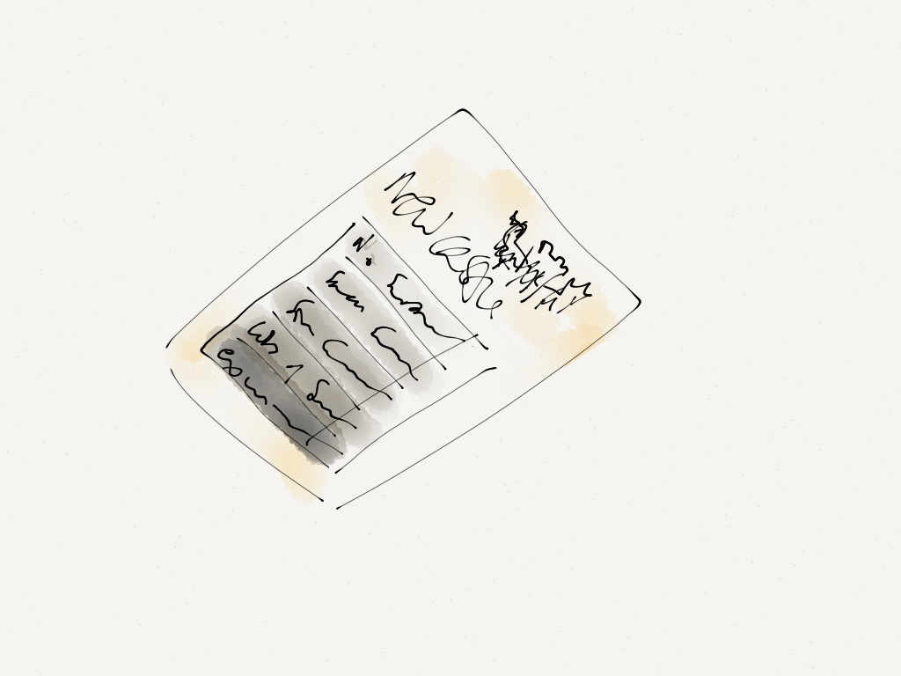

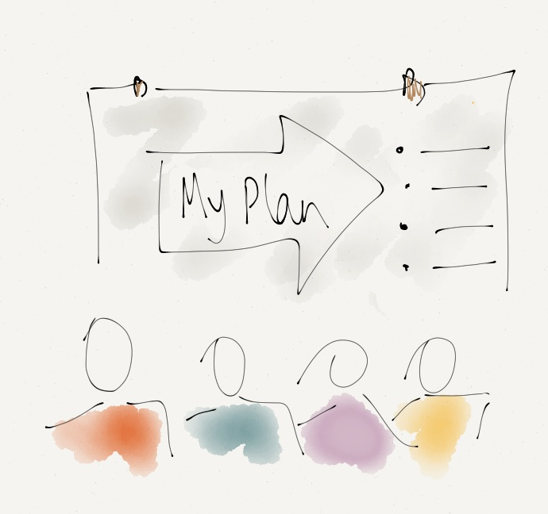
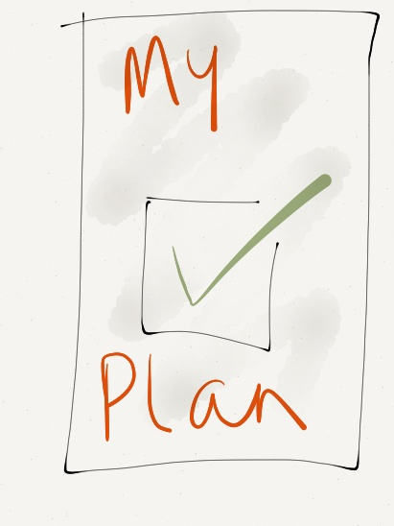

Assessment


Support Planning

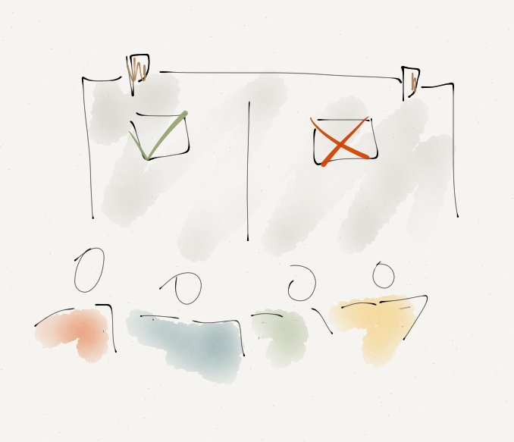
Getting the Plan Agreed



Going Live

Review

Audit

Approve Next Year’s Budget

Assessment

A social worker will work with children and their families to carry out an assessment. This assessment will look in detail at:

- If the child is eligible for funding
- Who the child is, their skills, talents and interests
- The support they need
- Build up a picture of the child’s life
- Begin to identify the community links that could work well for your child

As part of this assessment when children are age 7 or over is something called the Resource Allocation Questionnaire (example on page 11) The Resource Allocation Questionnaire is used to support the assessment and helps the council understand how much funding it could allocate. For children under 7 the assessment is all that is needed to complete

At the end of the assessment and the Resource Allocation Questionnaire, you will have an idea about how much support and funding your child will receive.

One of the questions, scoring matrix and guidance notes in the Resource Allocation Questionnaire
To Join in Activities with Children my age
No additional support required | Some Support | Lots of Support | Exceptional Support
0 | 14 | 21 | 27

No additional support is required- when a young person is supported to get involved in their hobbies and leisure interests by their family and face few problems in doing so. A young person can accept the guidance and support from adults leading activities most of the time and can take part in the activity with other young people. The young person has few fears or worries about going out and getting involved in activities with people they know well.
Some Support is required – When a young person needs 1:1 support for a short period of time (in addition to the usual support provided to young people within the group) to introduce them successfully into the activity. Other adults who support the activity or club require training and/or support to ensure that the young person is included.
Lots of support is required – when a young person needs to be continually supported throughout the activity. For example it is not enough for a parent to be nearby, a supporter needs to participate in the activity alongside the young person, making clear what they need to do or supporting them physically. The young person can only participate successfully in an activity if they have an individual worker alongside with them and who knows them well.
Exceptional support is required- When a young person needs 2 supporters to be with them throughout the activity. The support needs to be from people who are very aware of the young person’s needs and have specific skills, for example in knowing how the young person communicates and/or in behavioural support.
Or
Where a young person, as a result of challenging behaviour, may pose a risk to themselves or others and this severely restricts the places they can visit and activities they can take part in.
Or
Where the procedures that are required to maintain the young person’s health require such care that they can only be delivered so slowly that they take several hours each day and this has a huge impact on the young person’s ability to engage in activities

The analysis section of the assessment brings together the social workers conclusions about the child’s level of needs and the results of the Resource Allocation Questionnaire, this will show clearly a band of support. This will inform how much funding will be offered as an ‘indicative’ budget. The indicative budget is the council’s view, after assessing the child and family, of how much funding should be provided to meet the child’s needs it takes account of the RAS questionnaire but is based on the assessment as a whole of which the questionnaire is just one part. The indicative allocation is a fair share of the money available to spend on social care for children with disabilities.

Social Care Personal Budgets are a new way of allocating council money fairly, but the council’s legal duties have not changed. Their key responsibility is to meet eligible children’s assessed needs and give those families a short break. The council will always discuss an indicative budget with this in mind. This indicative budget is the figure that people start with when planning support.

Newcastle use something called ‘bands of support’ to work out what a child’s will be. A brief guide of what bands of support are based upon is in the table below.
No support | ...shows that the young person needs no additional support or that this statement is not appropriate for the young person.
Small support | ...shows that the young person needs either very occasional support or needs temporary support to retain their usual level of ability and confidence.
Some Support | ...shows that the young person needs some additional support on a continual basis.
Lots of Support | ...shows that the child needs specialist support which is usually 1:1 support
Exceptional Support | ...shows that the child has complex needs and usually requires 2:1 support
Support Planning

Once you’ve got your indicative budget, you can start to work out how that budget could be used. The support plan offers you the chance to think about what a really good life for the child would be now and in the future and explains how you will use the budget to make some of this happen. The support plan tests that the budget can meet the child’s needs.

There is a lot of support available to make your support plan.

- You can get support and information to make your own
- Your social worker can make your plan with you
- You can have an independent support planner from the Northeast Special Needs Network to help you

However you choose to do it, support plans follow some simple questions:

Good information about the child

- Every child has qualities and makes a contribution to others (through their smile for example). Write down the child’s, friendships, gifts, skills hobbies, interests and what the child enjoys doing.

What’s working well in life now and not working?

- This gives you the chance to work out what’s going well in life that needs to continue and what isn’t going so well and needs to change. You can then prioritise what the focus of the plan will be.

What is hoped the plan will achieve in the next year?

- This is a really clear statement of what the plan hopes to achieve.

What are the child’s support needs and how will they be met?

- The detail of how the child will be supported

The Action Plan

- Write down who needs to do what, when to make the support happen

The Child’s Views

- How was the child involved in the plan?
- How can we help the child be in control of the plan?

Finance

Newcastle City Council have produced some finance sheets which help you to show how the budget is being spent, and if you choose to take the money as a direct payment, how you want the payments to be organised.

Getting the Plan Agreed

Once the support plan is complete you will then tell your social worker that the plan is ready for approval. The decision maker (usually the social work team manager) considers the approval of your plan. If your plan meets the three priorities of the Children and Young People’s Plan well:
- Safe
- Equal
- Achieving

And provides you with a good short break and is within budget then it will be approved.

If there are issues with your plan the social worker may talk again with you and suggest changes.

If you are unhappy with either the changes proposed or think the funding is not enough to meet your child’s needs then an opportunity will be made for you to talk this over with your social worker and the decision maker.

Going Live

Social care personal budgets have been designed to put children and their families in more control of their support, being in control of your support doesn’t mean you have to take control of the money.

Through the support planning process, you will have decided exactly how you want to use your budget; there are options about how you choose to take the money.

- You can take the budget as a direct payment, set up a separate bank account and manage it yourself.

- Have the budget paid to an ‘agent’ like Disability North.

- Have the budget paid to a trust fund.

- A support provider can hold your money as an ‘Individual Service Fund’ and agree to work to your support plan and only spend your budget on support for you.

- The council can hold your money and arrange your support based on your support plan and your social care personal budget.
Using your Budget and the choices when buying support
Remember that there are lots of kinds of support you can spend your money on.
A group of support providers have a partnership with the council. The council has checked that these providers have important policies in place and the providers have agreed to promote inclusion. While the Council works to make sure this partnership is useful to families, choice of provider is not limited to the providers in this partnership.

A family can choose staff for the child through employing personal assistants with the social care personal budget. Disability North will provide all the advice needed about how to employ a Personal Assistant.

The budget can be used for a wide range of activities that benefit the child for example the budget can be used to support youth and community groups to welcome the child into the activity they want to take part in. This may involve funding training for staff, paying for an additional staff member or paying volunteers expenses or for equipment to ensure that the child can take part in activities.

Support can also include activities transport, accommodation, day trips, short breaks, equipment or small adaptations. What a family can buy and cannot buy is covered in greater detail in a document called “Guidance at the Audit of a Social Care Personal Budget. (Financial Guidance for Families who receive Social Care Personal Budgets)”

A break down of how much employing a P.A. will cost and details of the providers in the partnership are included in the book ‘Child Centred Support Planning in Newcastle’.
Review

3 months after your plan ‘goes live’ you will have the chance to look back on how things have gone. The review will be organised by your social worker and will be held in a way which makes it comfortable and easy for children to get involved. The review will be based on how the support plan is working and how it is helping the child, stay safe, be equal and achieve and supporting the family.

The review may be held with a big poster on the wall or around a table, however the meeting takes place it will follow the same questions,

- What have I tried?
- What have I learned?
- What am I pleased about?
- What am I concerned about?
- What will I do next?
- How will I share what I have learned?

The first review after 3 months will help you get a really good start and iron out any difficulties early on. After the first review you will have a review every 6 months.

In between reviews you can always speak to a social worker if there are problems or there are any issues you want to talk over or if you need advice. You should always talk to a social worker if after the plan has been agreed you want to make big changes to it.
Audit

Newcastle council need to check how money has been spent from people’s social care personal budget, they want to make this as easy as possible for families.
How much you will be involved in the audit depends on how you choose to take your budget.
If you choose your social worker to organise your support for you, they will do the majority of your audit, you will have to keep receipts for things you buy with money from your social care personal budget.
If you choose a provider to organise your support as an ‘Individual Service Fund’ they will take care of your money.
If you take your budget as a direct payment you will have to keep invoices, and receipts for everything you spend out of your social care personal budget. Your social worker will explain this to you, and they will provide you with a file to make this audit as easy as possible for you.

Approve Next Year

When you have your review after 12 months and your audit, you will get your budget again for the next 12 months, you will not have to do your support plan again unless there are big changes but you will have to update your financial summary sheet and work out how you want to have your budget paid.

The future
Your child’s needs will be re assessed every 2 years, or sooner if their needs change in the meantime. Your support plan should change as your child changes and grows older.

Support available to help with your budget
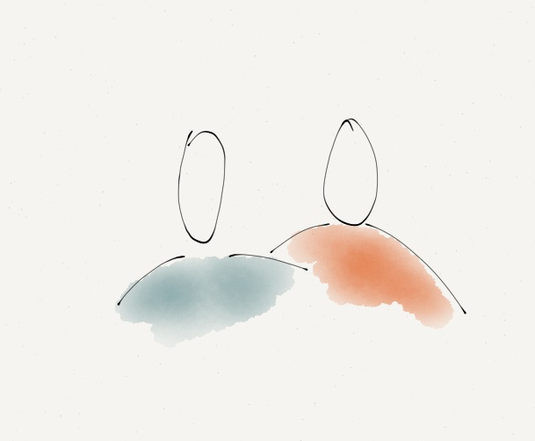
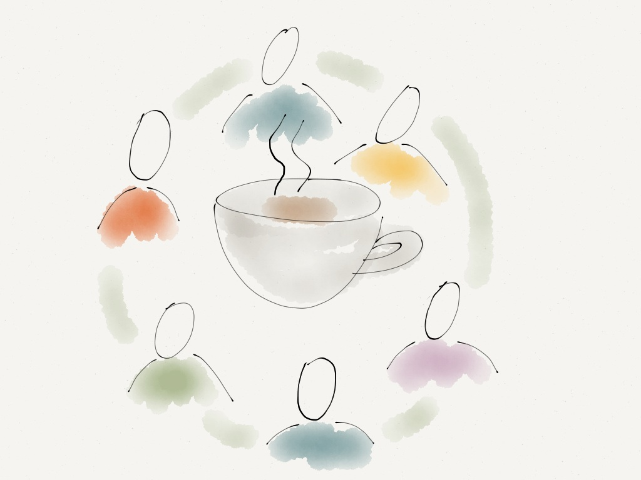


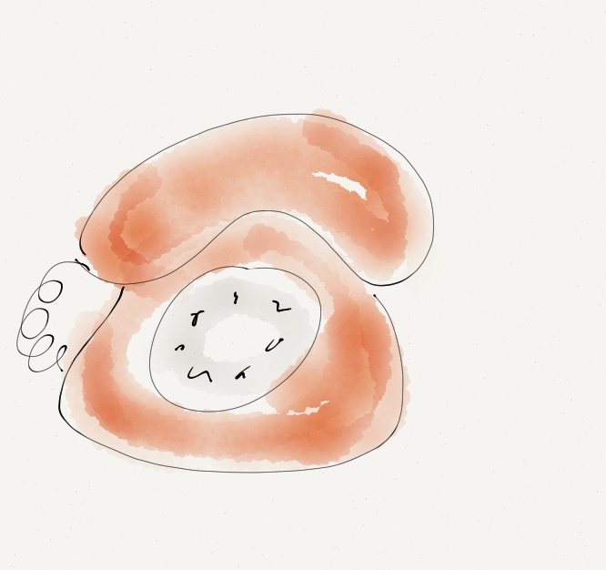

Name | How can they help | Contact Details
Children with Disabilities Service Newcastle City Council | Social work support. Assessments for Eligibility. Help to do a support plan.  Information, Advice and support about all aspects of your social care personal budget. | The Civic Centre, Barrass Bridge, Newcastle Upon Tyne,NE1 8PU  Phone 0191 277-4700 to speak to a duty social worker  Web www.newcastle.gov.uk/social-care-and-health/looking-after-children/children-with-disabilities/individual-budgets
The Local Offer | The council publishes on line all the available services they know about and provide. This provides very useful information about activities and resources that you can use in your support planning | You can access the directory at  http://www.newcastlefis.org.uk /kb5/newcastle/fsd/ localoffer.page?familieschannel=3  phone 0191 277-4133  email fis@newcastle.gov.uk
Pass it On Parents | A community of parents who have experience of Social Care Personal Budgets sharing their knowledge, experience and tips with other families. | phone 0191 281 8737  Email: passitonparents@skillsforpeople.org.uk  Web www.skillsforpeople.org.uk  Twitter @passitonparents@skills for people  Facebook passiton Newcastle Skills for People  Skills for People, Key House, Jesmond  Newcastle upon Tyne, NE2 3AT
Disability North | provide direct payments advice and support including information you need to know about how to budget for, employ and manage personal assistants | The Dene Centre, Castle Farm Road, Gosforth, Newcastle Upon Tyne, NE3 1PH  phone 0191 284 0480  email; reception@disabilitynorth.org.uk  website www.disabilitynorth.org.uk
Northeast Special Needs Network | supports families with disabled children/young people from birth to 25 years and has a team of advice workers  Help to do a support plan. | Northern Counties Site, Tankerville Terrace, Jesmond, Newcastle upon Tyne, NE2 3BB  phone Admin: 0191 281 2485  Family Advice Workers: 0191 281 2255 Web www.nsnn.org.uk  Email: admin@nsnn.org.uk

Frequently Asked Questions



Social Care Personal Budgets and your questions answered.
Many people ask similar questions when they are finding out about social care personal budgets. We have written some frequently asked questions – many of these answers are drawn from an organisation which supports Personal Budgets nationally called In Control and our own experiences in Newcastle. Many of the answers provided below are expanded within our social care personal budgets web pages. You can find detailed information about how social care personal budgets work on the web page:
www.newcastle.gov.uk/social-care-and-health/looking-after-children/children-with-disabilities/individual-budgets

1) ‘What is a social care personal budget?’
A social care personal budget is when you know how much money you will be entitled to from the council after the assessment of your child. This means you can choose the support that you want as long as this provides good outcomes for the child (Safe, Equal and Achieving) and it provides you with a short break. The plan you write should make sense to your child and your family, instead of being a list of available services. It is about people having more control over their lives through a greater control over the money that funds support. The laws about Personal Budgets were changed by the Children and Families Act 2014 to give all eligible children a right to a Personal Budget in Education and Health services too. Who is eligible for education and health budgets in Newcastle is set out in our Personal Budget Policy which you can find at http://www.newcastlefis.org.uk/kb5/newcastle/fsd/advice.page?id=Td6m1aBXvsI
This document is mainly about social care personal budgets
The key elements of social care personal budgets are that:
- The support is controlled by the individual
- The level of support is agreed in a way which is fair, open and flexible
- Any additional help needed to plan specify and find support is provided by people who are as close to the individual as possible
- The way that social care personal budgets are arranged should be with an approach that puts children and their families in control and organises support solutions that make sense to them
2) ‘Where does the money come from?’
There is no new money to go into social care personal budgets. The amount of money available comes from the budget central government and council tax payments supply to be used to provide children with disability services. This funding has not increased since the introduction of social care personal budgets. This is also true of Personal Health and Education Budgets.
In creating a system in which people have more control, it is essential that money is used more effectively and more fairly. Social care personal budgets are a way of helping local authorities to use money better so more people can get support in a way that suits them. When people use social care personal budgets it is likely that they will tend to spend more effectively, partly because they understand their own needs and circumstances better than a large organisation can. So, our understanding is that social care personal budgets in children with disability services are therefore not part of any “cuts” programme. They are just a better way of using the same money and so can be more efficient but won't save money. Instead it will allow the available money to be spent more fairly, to provide better results for children who need them.

3) “Will families who are supported now by the council get less funding than they did before?”
Some families will receive more funding than before, some will receive less funding and some will stay about the same. This is because the council only offers a social care personal budgets as part of a reassessment of the child’s needs. The reassessment will consider how much funding child needs now and this will often be different than what the child required two years ago. Newcastle wants to make funding fairer and is clearer now about how much funding is required to support disabled children. On our social care personal budgets web page you can see the funding table which helps us to make fair decisions about how much funding to provide to each family depending upon their needs.
4) How does the assessment work and how does the council make sure it clearly reflects the child’s needs?
A social worker will work with children and their families to carry out an assessment. This assessment will look in detail at:
- If the child is eligible for funding
- Who the young person is, their skills and talents and interests
- The support they need
- Build up a picture of the child’s life
- Begin to identify the community links that could work well for your child

As part of this assessment is something called the Resource Allocation Questionnaire and the Matrix of Needs table.

- The Resource Allocation Questionnaire is used to support the assessment by considering the barriers to the outcomes the child needs to achieve.

- The Matrix of Needs considers the child’s needs and what support they require to meet them

At the end of the assessment both the matrix of needs and the Resource Allocation Questionnaire will inform the conclusion of the assessment and you will have an idea about how much funding your child will receive if the child is eligible for a social care personal budget. The eligibility of children is explained in the “Access to Services” document and this is also available as a download on the social care personal budgets web pages.

5) Are people really be allowed to spend their money in a way that makes sense to them?
In the young person’s support plan social workers will want to see how the Children and Young People’s Plan outcomes will be supported. The three priorities of the plan that we all need to support children to achieve are to:
- Be safe
- Be equal
- Achieve
In addition the social worker will want to understand how the plan supports the family to have a short break from their caring responsibilities.

It is very important that people are allowed to spend their money flexibly. One role of the Council is to work out who is the best person to control the social care personal budget. Often this will be a family member or someone close to them that they trust. Sometimes it may be a professional like the child’s social worker. If you choose or decide with the council that someone else should manage your money we want to make sure that you and your family still have the major say in how the money is spent. The way that the money is spent should make the most sense for the person who needs support. We recognise that this is an area that we may find difficult as it involves challenging changes to traditional thinking
If the local authority imposes general restrictions that say 'you can't spend your money like this...' then we will give a very good reason to back up those restrictions. Good practice is to ensure that funding is spent which drives forward the priorities of the Newcastle Children and Young People’s Plan 2015-20 but gives families freedom to meet those priorities in their own way.
In exceptional circumstances we may have reason to think it is right to agree a specific restriction on how someone's money is spent. This could be if there is a good reason for example to safeguard the child (if we are sure that their safety is threatened) but such restrictions will not be generalised and applied to everybody.
6) Can it only work for people who can manage their own money and support?
There are lots of different ways that people can use a social care personal budget without managing the money directly. People do not have to deal with the cash directly themselves to be in control of what their money is used to buy. There are at least five different ways for people to control a budget including:
- taking the money as a direct payment
- Children’s Services managing the budget on your behalf
- an Independent Living Trust
- a broker, for example a voluntary sector organisation
- a provider placing your funding in an Individual Service Fund

People can take the degree of control they are comfortable with and they can still get a professional to manage the money. Similarly it is not necessary for the person to manage the support. They may have someone they can ask to do this, or they may use a part of the money to pay someone to do it. The important thing is that the person has as much control as they want and that the money works to provide good support for the child.

7) Are personal social care budgets another burden for families?
Many families tell us that social care personal budget have provided a new opportunity to have a better balance in their life. Some families say that taking the social care personal budget as a direct payment creates more work and money management can be stressful. Other families have found having the Budget in their bank account is a great relief because they can respond quickly to changes in their child’s needs. All families should expect to be supported by the council to weigh up what is the right way for them to manage the money and receive good support with the choice they make. Families can take the amount of direct control they are comfortable with.
8) Do social care personal budgets only work for people with more expensive support packages?
Social care personal budgets in the Newcastle have worked very well for children with complex support needs but not everyone using a social care personal budget has an expensive support package. The benefits of social care personal budgets do not disappear for people with more modest packages.
After an assessment the social worker will discuss an indicative budget with you to begin planning. You will be able to see if there is too much or too little money to make the budget work for your child and family when you begin the planning. If this is the case we will discuss this further with you before the budget is finalised.

9) Will children and young people be isolated and more at risk of abuse by using a social care personal budget?
Personal Budgets passed into legislation after extensive research commissioned by the Department for Education and safeguarding was one of the areas of research. There is no evidence to suggest from this research that children who use social care personal budget are less safe than when they were in the old traditional system. If a social care personal budget is done well, children should be safer due to a closer involvement of families in monitoring the support their child receives.
The council’s duties to protect children and ensure that government money is well spent do not change. Social care personal budget have come from a desire to support disabled children to be more included and less isolated within their communities. There are good reasons to think that people will be less isolated in their communities as more families may use their budgets on accessing everyday community opportunities. In Newcastle we have increased the safeguards in social care personal budgets by insisting that everyone who works with children needs a Disclosure and Barring Service check and by promoting training and development for personal assistants.
Social care personal budget should be organised to minimise the risk of abuse by:
• putting the person in control of their life
• making sure people who love the person are enabled to be part of the person's life
• designing an agreed system of support and safeguards that fit the person’s preferred lifestyle.
Being known to many people in a local community can be the best safeguard for vulnerable children and young people. Families working on very individual plans should mean that the child’s safety is explored in detail. There is, however, no room for complacency and no system can be 100% safe.

10) Do social care personal budgets only work well for people who have strong support from family or friends?
If a young person needs help, they are likely to but do not have to choose to use family and friends to help them. For people who have good networks of family and friends this is a common way of organising things because it is natural to turn to those most trusted to help with issues that are very personal. Not everybody makes this choice. Some people like to get help from people they pay or with whom they have a more independent relationship.
Some people do not have strong networks or close family or friends. This does not mean they cannot have control of the support they need. If they do not have these networks they can use other options.
These might include:
• other families or peer supporters
• paid independent brokers
• volunteers
• service providers
• social workers
It is the job of the council to make sure people know about all these options and to help people access the option they prefer. Some people will help as part of their job. A good support plan aims to help children to keep or make a network of friends.

11) Are social care personal budgets different from Direct Payments?

A Direct Payment is a way of managing the funding of your social care personal budget. When you use a direct payment the council provides you with cash instead of a service; the person then purchases their own support directly.

A social care personal budget is more than this. Having a social care personal budget means you know how much money you can spend, you know what outcomes you are aiming to achieve, and can decide exactly how and when that money is spent.
Social care personal budget and Direct Payments are not the same thing, nor are they competing ideas. Newcastle will review every family who receives paid support and show this funding as an annual sum. Families can then decide if they want this sum as a direct payment or if they want their social worker to organise their social care personal budget and manage the funding on their behalf. There are also other organisations like Disability North who will manage your budget on your behalf.
Recent work in Newcastle with children young people and their families shows that high numbers of people do choose to manage their Budget as either a Direct Payment or Indirect Payment. Some people choose to mix and match - part Direct Payment, part services organised by the local authority. This is fine if it is what the person chooses.

12) Is a ‘support plan’ just another name for a child care plan?

Care is defined as ‘to provide, look after, watch over’ (Chambers Twentieth Century Dictionary). Providing care is sometimes led by professional decisions. A care plan is written by a professional based upon their assessment of a person’s needs. It usually comprises a mix of services selected from a list of services specially set up for disabled children with social care needs.

Support is defined as 'to back up, to nourish, to strengthen' (Chambers again). A support plan is a plan that recognises that people are active citizens and families sometimes need extra back-up, to play a part in their community. A support plan says things about the child, who they are and what they want from life. It goes on to say how they might practically go about making their plan real over a period of time. Often, they will realise their plan by making use of ordinary resources in their own local community.

When people plan, they need to reflect on what they have learned. They need to review and, often, change their plan. When people plan their own support, they can reflect and review all the time and in their own way. However, the local authority also has a role in enabling and enlivening the review process and ensuring that people's support plans are working well. For example when you are writing the support plan the Children with Disabilities Service should provide you with comprehensive information about free and low cost services that are available to support your child to be included. Children’s services will keep a record of your plan and reviews within the council so that you can remember what has been achieved and plan next steps.

13) Do people misuse the money?
There is no evidence either from Direct Payments or from our experience of social care personal budget that this is a significant problem and instances of fraud are very rare. Funding is allocated to vulnerable people because they have particular needs, and so it is legitimate for public servants to ask whether the money is doing its job - whether those needs are being met or not.
If a person’s needs are not being met, then it may be that the person needs extra help to think about what needs to change. This might happen as part of the review process (or in a lot of cases even before the review). It is legitimate for public servants to ensure that any funding for children is used to support a young person to work towards the Newcastle Children and Young People’s Plan 2015-20 but we will not dictate how the money should be spent to achieve this. There are occasions when the local authority will need to make sure that the social care personal budget works to ensure children are safe and well.
If someone does not want to manage (or finds they cannot) manage the Budget themselves, the local authority will act as their representative or find another person to do so.
14) What if the social care personal budget isn’t enough?

The Resource Allocation System (RAS) produces an indication of how much funding will be allocated to each family which should only be viewed as definite once the young person’s plan has been agreed. It is the planning process itself that tests whether the allocation is reasonable. The key question here is: can a plan be developed that allows a person to achieve the outcomes identified in the assessment? This question decides the reasonableness of any allocation. In practice, if the amount of money is seen not to be enough, the council will either allocate more funds, or work actively to show how a plan can be developed that achieves the agreed outcomes within the allocation.

15) ‘What will happen when the young person is over 18 - will their social care personal budget continue?’

Adult Services have Personal Budgets too. It is very similar to the system the Children with Disabilities Service uses but the young person receives another assessment before they are 18 and you will complete another questionnaire about the young persons support needs. The Adult Services budget is different and may be less or more than the children’s social care personal budget. Before the young person is 18 you should have an opportunity to meet with a worker from adult services to talk all this through.
16) What if people do not use all of the funding in 12 months?
We believe that whoever receives the money is responsible for using it to do the best for themselves or the person they are managing the money for. We also are clear that public money should be used well for the purpose it was intended. In practical terms to be flexible to disabled young people and be fair to council tax payers we have decided that if there is over 10% left at the end of the year, then the additional money over 10% of the total budget will be returned to the council.
17) What records should people keep?
The Council is interested in the outcomes that you achieve for example, are you getting the life you have set out in the support plan? The Council will want to check if you’ve used money legally and so you have to keep some records. It depends if you are controlling the money or if someone else is doing that for you.
If you are controlling the money then you have to keep bank statements, basic accounts of what you’ve received and what you’ve spent. If you are employing personal assistants or other staff, then you have to keep a record of payroll and have employment documents like insurance certificate, a contract etc. You have to keep receipts for all the money that is spent. Childrens Services will provide you upon request with a file to manage your funding
If someone else is looking after your support money, they have to keep those records. If a provider organisation is doing it, they have to have a separate account for your money. The same is true if the council manages your money.

18) If someone receives a social care personal budget, does this count as income, and does it affect their eligibility for Benefits such as DLA?"
No. Budgets will not affect welfare benefits as they are not classed as income to the person. In any case, Welfare Benefit such as, Incapacity Benefit, Employment Support Allowance and Disability Living Allowance are not means tested. What this means is that if someone receives a social care personal budget this does not affect their eligibility for any of these benefits.

19) Can I have education and health personal budgets too?

If the child is eligible for a health and education personal budget they can hold these as well as a social care personal budget. How Education and Health Personal budgets are organised is set out in the Newcastle Personal Budgets policy which is on our web pages at
http://www.newcastlefis.org.uk/kb5/newcastle/fsd/advice.page?id=Td6m1aBXvsI

20) If I want a social care personal budget now how long will I have to wait?
Social care personal budgets usually take about 3-4 months to complete from when we receive the referral.
21) When I have a social care personal budget what can I buy?
Families have used their social care personal budget in lots of different ways, including spending funding on:
- support workers and Personal Assistants to support their child
- small adaptations and equipment
- overnight stays
- day trips
- weekends away
- supporting learning like guitar and golf lessons
- transport costs

Some families have felt in the past that there has not been enough choice for disabled young people. We think this is changing now; there are free and low cost opportunities in dance, music, sports, and the arts. We have funded specific services like the National Autistic Society Inclusion club. There are workers in each of these organisations who will support your young person to get connected.
Voluntary organisations provide a variety of services to disabled children too. We have developed the Family Information Service to be able to offer information that suits your child. We have worked with our support providers to make sure that they can support social care personal budgets too. There is now a children’s provider partnership with 7 provider agencies committed to provide personal care and support to disabled children. We also believe that families are experts about their children and most times families will design creative and imaginative plans. Where we can see that the plan works well for the child, we will support it.

22) If I am not happy managing a social care personal budget how will the council help me?
We have reassessed everyone’s finance and now show this as an annual sum. We are sure that this is an open and honest way of explaining to families how much funding they have received. We do not intend to return to measuring support in overnight stays and amounts of hours again as we think this was too restrictive but if you remain unhappy with your funding there will be plenty of opportunities to make your case to your social worker and their manager.
The children with disabilities service will make sure that a social worker can organise your support if you decide at any point that you no longer wish to manage the budget. We will as quickly as possible arrange for the service to be switched over to the council to manage your budget if this is what you want. You always have a right to complain to the council at any point in the process and your complaint will be considered very carefully.


For more information about Social Care Personal Budgets contact;
The Duty Officer
Children with Disabilities Service
Wellbeing, Care and Learning Directorate
The Civic Centre,
Barrass Bridge,
Newcastle Upon Tyne,
NE1 8PU
Tel: 0191 2774700 Fax: 0191 2774701
Website address www.newcastle.gov.uk

For information about the support planning hub contact;
Skills for People
Key House
Tankerville Place
Jesmond
Newcastle Upon Tyne
NE2 3AT
Tel: 0191 2818737 Fax: 0191 2120300
Website address www.skillsforpeople.org.uk

Skills for People is an independent organisation, a company limited by guarantee

registered in England under no. 3487635 and is a registered charity no. 1069993

